**CHAPTER ONE:IRON AGE PERIOD IN CENTRAL AFRICA (200-1500AD)**

**WHAT IS MEANT BY THE TERM “IRON AGE”?**

* Iron Age is the period in the development of human communities when a person first used iron tools, cultivated plants and reared animals for subsistence purposes.
* This period comes after the Stone Age period when people used stone tools.

**Explain what is meant by the following terms**

1. **Archaeology**

The study of dug out materials (artefacts or fossils) that have a special historical interest or value.

1. **Artefacts**

These refer to ancient remains or findings that are excavated and preserved e.g. beads, pottery, charcoal, fossils.

1. **Fossils**

These refer to animal or plant part excavated and/or preserved for a special historical interest or value e.g. bones, grains, etc

1. **Excavation**

This refers to digging and removal of the top layer of the earth in order to find the remains which are supposed to be studied.

1. **Radio Carbon Dating (Carbon 14 Dating) Method**

This refers to the main and most reliable method of dating or estimating the age of the artefacts. It is done in laboratories whereby 14 radio-active substances are tested and dated.

**ORIGIN AND SPREAD OF IRON AGE SKILLS**

* The Bantu speaking people was the group of people associated with the Iron Age period. They migrated into Central Africa who either displaced the Stone Age hunters or simply absorbed them into their communities through peaceful co-existence.
* Iron Age ideas, skills and practices started in Asia along:

1. Euphrates and Tigris Rivers in Mesopotamia.
2. Indus and Ganges in India
3. Hwang He Rivers in China

* This period comes after the **Bronze Period** when bronze tools were used.
* Iron Age ideas later spread to North Africa. They first spread to Egypt and more importantly, **Meroe**, in Sudan. The Assyrians warfare facilitated the spread of these ideas and skills spread to **Nok**, in Nigeria.
* By the First century (100AD) the iron skills spread into Central Africa through the Equatorial and the savanna forests to countries like Zambia, Malawi and Zimbabwe.

**HOW IRON AGE IDEAS, SKILLS AND PRACTICES SPREAD TO OTHER PARTS OF AFRICA**

**Iron Age Ideas spread in Africa through the following ways**

1. **Migration**

There was a north-southwards movement of people from Asia to North Africa then to Central Africa in search of food, settlement, pasture and trade items. This movement made interaction of different people with different skills, hence the spread of the Iron Age skills.

1. **Trade**

Short and long distance trade made people to exchange the material culture like pottery, iron tools, beads and other trade items. Through trade people also exchanged the skills and practices on how to make these items.

1. **Warfare**

Some group of people waged war on other communities whom they hoped to conquer or control. The defeated were forced to adopt the culture of the conquerors. In war superior weapons often are assimilated or copied, The Assyrians conquered Egyptians and immediately dominated North East Africa and introduced iron to the area.

1. **Intermarriages**

Intermarriages enabled clans to share hidden skills and practices.

**CHANGES BROUGHT IN BY IRON AGE PEOPLE IN CENTRAL**

When the Iron Age people came to Central Africa, the affected the life of this region in the following ways:

1. Introduced settled way of life instead of nomasdism
2. Introduction of agriculture
3. Improved hunting strategies by using metal arrows and pangas.
4. Introduction of use of fire. They used fire for
5. warming themselves
6. lighting their settlements
7. hunting by pushing the animals into any direction to trap and catch them
8. for roasting or cooking meat, self defence against wild animals during the night

Fire was being made by striking two pieces of flint (hard stones) together.

1. Introduction of improved metal weapons for defence against enemies and wild wildlife.

**MAJOR IRON AGE SITES IN CENTRAL AFRICA**

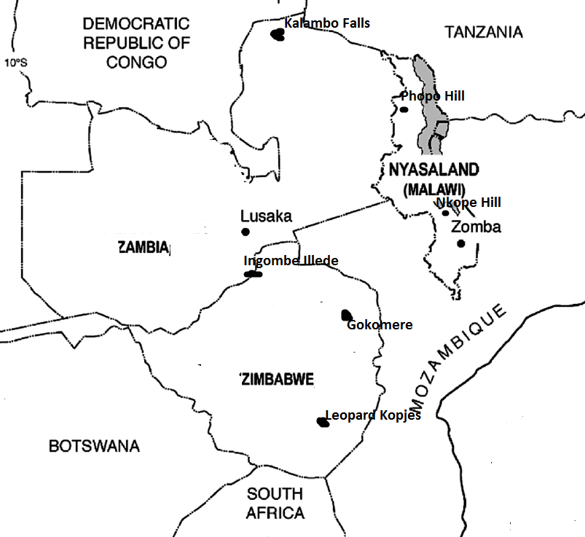

**IRON AGE SITES IN MALAWI**

1. **Phopo Hill (200AD-505AD)**

* This is the earliest site in Malawi and it is 24 km from Rumphi Boma, near Lake Kazuni
* The dates of occupation range between 200-505AD.
* **The artefacts found at Phopo Hil Iron Age site included the following:**

1. Fired channeled pottery
2. Slag heaps
3. Iron fragments
4. furnaces
5. shell beads
6. Bones of fish/animals
7. Arrows spearheads
8. Mud walls + burnt dagga

* **Activities associated with the artefacts found at Phopo Hill Iron Age site**

1. Smelting iron due to the presence o f iron fragments, furnaces
2. Settled life
3. Fishing and hunting
4. Trading with East Africa

**Similar sites to Phopo Hill having similar artefacts**

1. Mwamasapa
2. Mwaurambo
3. Mbande Hill
4. Bwanje
5. Mphunzi Mountain
6. Vinthukutu
7. **Nkope Hill (300AD-800AD)**

* This site is in the Southern region of Malawi. It lies 40Km north of Mangochi near Cape Maclear within the Namkumba Peninsular.
* **The artefacts found in Nkope Hill include**

1. Fragments of stamped and channeled pottery
2. Iron objects, pieces of melted copper
3. Glass beads, polished pieces of turtle and cowrie shells
4. Bones of fish
5. Burial sites

* The activities associated with the artefacts found at Nkope Hills included the following

1. Smelting iron
2. Trading with East Africa.
3. Fishing
4. Settled life
5. **Mwamasapa in Karonga District**

* This site has artifact which include remains of pole and mud huts, pottery, iron objects such as axes, hoes, and knives, glass beads and remains of grain seeds.
* One significant feature of the pottery found at Mwamasapa Iron Age Site differences from others found in Malawi. The pottery is thin, gourd shaped with a long neck.

**IRON AGE SITES IN ZAMBIA**

1. **Kalambo Falls (300AD-1300AD)**

* It lies to the north of Zambia at the Southern Coast of Lake Tanganyika on the Zambia-Tanzania boarder.
* The site was occupied between 300AD and 1300AD.
* The following artefacts were excavated at the Kalambo Falls included the following: dimple based and channeled pottery, painted rocks, grinding stones, iron workings, copper objects, remains of pole and mud huts, animal bones , bows and arrows.

The activities associated with the artefacts found at Kalambo falls site

1. Pottery making due to presence of dimple based and channeled pottery
2. Smelting due to the presence of iron workings and copper objects
3. Cultivation of plants due to the presence of grinding stones
4. Settled life due to the remains of pole, mud huts and painted rocks.
5. Hunting/pastoralism due to the presence of animal bones and bows and arrows.
6. **Ing’ombe Illede (690AD-900AD)**

* It is found near the confluence of Kafue and Zambezi rivers.
* Artefacts found at Ingombe Illede golden beads, glass beads, clay furnaces, iron hoes, hammer heads, copper wires, axes, gongs, iron razors, fired pottery, fish books and cowrie shells
* The following are the activities associated with artefacts found at Ingombe Illede

1. pottery making due to the presence of fired pottery
2. Smelting due to the presence of axes and iron
3. **Kalomo**

* This is the site in the Kalomo District of Zambia.
* Artefacts found at Kalomo included pottery remains and pieces of iron ore.

**IRON AGE SITES IN ZIMBABWE**

**PRE-COLONIAL KINGDOMS IN MALAWI**

1. **GOKOMERE (200- 900AD)**

* It lies to the north central part of the country near the Great Zimbabwe Ruins.
* It was occupied between 200AD and 900AD.
* The artefacts found at Gokomere Iron Age Site include

1. Pottery with channeled or stamped design
2. Glass beads
3. Clay furnaces
4. Iron remains
5. Cattle and human bones

* The activities that are associated with artefacts found at Gokomere Iron Age Site

1. Pottery making due to presence of channeled and stamped pottery
2. Long distance trade due to glass beads
3. Smelting due to the presence of the clay furnaces and iron remains
4. Pastoralism due to cattle bones
5. Settled life due to human bones
6. **ZIWA MOUNTAIN(300AD-500AD)**

* It lies to the South East of Harare near Sabi River on the Mozambique-Zimbabwe border**.**
* It was occupied from around 300AD to 500Ad.
* Artefacts excavated at Ziwa Iron Age Site included

1. Pottery with channeled or stamped designs.
2. Glass beads
3. Clay furnaces
4. Iron remains
5. Copper and gold workings
6. Cattle and human bones

* The artefacts found at Ziwa Iron Age site suggest that there was

1. pottery making due to the presence of channeled and stamped pottery
2. Long distance trade with the East Coast was also practiced because of the availability of glass beads.
3. Smelting and simple mining due to iron, copper and gold workings
4. Pastoralism due to cattle bones
5. Settled type of life due to the excavation of human bones
6. **LEOPARD KOPJES(700-1400AD)**

* It is located in the Leopard Kopjes and Khami settlements in Zimbabwe.
* The artefacts found at Leopard Kopje iron age sites include the following

1. Pottery
2. Gold items
3. Simple stone walling
4. Skeletal remains

* The artefacts found at Leopard Iron Age site suggest that there was

1. **Pastoral farming and agricultural industry**
2. pottery making due to the presence of channeled and stamped pottery
3. Pastoralism due to cattle bones

**REASONS IRON AGE PEOPLE SETTLED NEAR SWAMPS OR WATER RESOURCES**

1. To carry out the fishing activities
2. To cultivate along the fertile shores
3. To graze their livestock on abundant green pastures
4. To hunt animals easily by driving them into muddy swamps
5. To be supplied with fresh water for domestic use.
6. Transportation

**WHAT MADE SOME SITES TO HAVE SIMILAR ARTEFACTS**

1. Long distance trade made people to exchange items under barter trade hence the similarities
2. People have common areas of origin. They all migrated from the same equatorial regions of the Congo basins.
3. Migration from area to another to do trade made people to share the skills and practices for the mass production of items hence the similarities.
4. Intermarriages exposed people of different clans or tribes to different skills

**SOCIO-ECONOMIC ACTIVITIES ASSOCIATED WITH IRON AGE PEOPLE**

1. Farming
2. Fishing
3. Hunting and pastoralism
4. Involved both long and short distant trade
5. Pottery making
6. Iron smelting and working
7. Use of fire
8. Building of simple huts
9. Ancestral religion
10. Settled life in communities that needed leaders
11. Governance i.e sharing of land for cultivation, trade etc

**FACTORS THAT LED BANTU MIGRATION INTO CENTRAL AFRICA**

1. Rapid population growth in the Shaba-Katanga areas led to shortages of pasture land as well as arable land.
2. Lack of fertile land due to the introduction of new food crops by the Portuguese.
3. War equally contributed to the migration of people as conquered chiefs migrated to new lands in order to maintain their leadership and independence.
4. Succession and inheritance disputes after the death of a leader.
5. To escape from being punished after unsuccessful rebellions.
6. Slave trade forced people to leave their lands for safety
7. Social and domestic problems e.g. witchcraft, family quarrels etc.
8. A desire to control a large area for trade.

**IMPORTANCE OF IRON AGE CULTURE TO CIVILIZATION**

1. It acted as the origin of farming that replaced gathering
2. It acted as the beginning of settled life in small communities that led to the formation of pre-colonial kingdoms

It led to the emergence of small organized political systems, **i.e**. centralization due to trade activities, division of land, management of farms and livestock.

1. It improved the hunting skills and defence due to the presence of iron weapons
2. It promoted trade in the form of barter.

**HOW IRON AGE CONTRIBUTED TO THE DEVELOPMENT OF PRE-COLONIAL KINGDOMS IN CENTRAL AFRICA.**

1. The spread of the Iron Age skills and technology like farming, smelting etc led to a settled type of life in order to take care of their crops and livestock and make their weapons for defence purposes.
2. The growth of a long distance trade made people to migrate into new lands to look for trade materials but settled there e.g. the Balowokas, the Kazembe, and the Maravi etc.
3. The introduction of new food crops by the Portuguese e.g. maize m, cassava and groundnuts led to abundant food production and the attraction of people into the area.
4. The migration of people due to overpopulation in other areas, loss of fertile land, succession disputes etc led to break away and formation of new kingdoms.

**FACTORS LEADING TO FORMATION OF PRE-COLONIAL KINGDOMS IN CENTRAL AFRICA**

1. The spread of iron working skills and technology e.g. smelting, farming etc.
2. The growth of long distance trade with the east coast through the Zambezi.
3. The introduction of new food crops by the Portuguese e.g. maize, cassava and groundnuts.
4. Migration of people looking for new settlements of kingdoms
5. Good leadership and centralized administration.
6. Geographical reasons. For example other areas had good abundant natural resources.

**CHAPTER TWO :THE MARAVI KINGDOM**

**LOCATION OF THE MARAVI KINGDOM**

The early boundaries of the Maravi kingdom were restricted to the Mankhamba-Manthimba area. At the peak of its power, the Maravi Empire occupied the area from Bua River in the north to the lower Zambezi in the south then from the Luangwa valley in the west to the Indian Ocean in the East.

**ORIGIN AND MEANING OF THE WORD MARAVI**

* Maravi means “frames of Fire”. It was a name of the Kingdom and its people. The name was adopted upon their settlement at Mankhamba near Mtakataka-Mua area in Dedza district. At the South western tip of Lake Malawi.
* The name itself has a lot of speculations

1. **Flames of bush fires**

People got settled at Mankhamba and Manthimba in Mtakataka during the dry season. Flames of bushfires kept on burning during the day and night due to the hunting activities. They burnt the bush to drive away wild animals. The land was therefore called Maravi because of these flames.

1. **The splashes of the Rising Sun**

The Maravi area was at the south western tip of Lake Malawi. The rising sun kept on splashing beautiful colours on the waters of Lake Malawi that intensified the beauty of the land.

1. **The Iron smelting activities**

The maravi were skilled iron smiths. Flames of fire kept on emanating from the great number of small furnaces during the smelting activities. The area was therefore called the land of flames (Maravi).

**THE MAP SHOWING MARAVI KINGDOM**

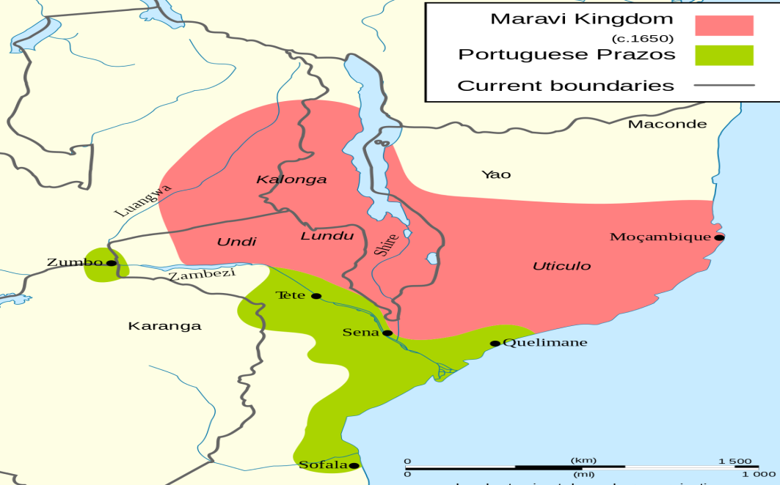

**ORIGIN AND SETTLEMENT IN MALAWI**

* The founders of the Maravi Kingdom originally came from Uluba-Katanga area in eastern Zaire (Democratic Republic of Congo). They were the Banthu speaking people that enterred Malawi in different clans. The notable clans were the **Banda and Phiri**.
* The Banda clan produced religious leaders while the Phiri clan produced political leaders entitled the Kalonga.
* The first person to lead the Maravi out of Zaire towards Malawi was Mazizi.
* Mazizi was succeeded by Chinkhole who adopted the title of Kalonga. He led the group to Kaphirinthiwa (Dzalanyama Range) in the Western part of Lilongwe District.
* Kalonga Chinkhole was succeeded by Kalonga Chidzonzi who led the group from Kaphirinthiwa up to their settlement at Manthimba around Nadzipuu River near Mtakataka in Dedza at the South-Western of Lake Malawi.

**Kaphirintiwa** was the place west of Lilongwe. The Phiri and Banda clans claimed that God created all beings from there. As proof, foot prints of people, animals and birds are found on a big stone.

* Later Manthimba became the headquartersof the kingdom in Mtakataka.
* Mankhamba became a centre for the ancenstral worship in Mtakataka.

**MAIN REASONS FOR THE MARAVI MIGRATION INTO MALAWI**

1. To look for trade items such as ivory
2. For an easy acess to iron tools for farming.
3. To be free from fighting among families.
4. The need for grazing areas for their livestock

**WHY THE PRO-CHEWA ACCEPTED BOTH THE BANDA AND PHIRI CLANS or EXPLAIN HOW THE MARAVI ESTABLISHED THEIR RULE OVER THE LOCAL PEOPLE?**

Pro-Chewa refers to an earlier group available in Malaw before the Chewa groups of Banda and Phiri.

They accepted the two groups because

1. 1. The Banda and Phiri clans had a good cenralised political system.
2. They had economic services of great value and tool making.
3. They were peace loving people
4. They had knowledge in medicine and magic to heal and protect them from diseases, spirits and witchcraft.
5. Besides, marriage between Kalonga (Phiri) and Makewana Banda clan un ified the two clans or made the co-existence more friendly.

**FACTORS THAT LED TO THE RISE & GROWTH OF THE MARAVI KINGDOM**

1. **Agriculture**

* Mankhamba had fertile soils for the cultivation of food crops. The sufficient food attracted the many people to settle in the area and promoted population growth hence the rise of the kingdom.

1. **Centralised government**

Kalonga as the overal leader controlled the affairs of the kingdom through his chiefs. This promoted unity and loyalty among people and their king.He created highly centralised kingdom but he gave limited autonomy to some of his trusted relations such as Undi, Lundu and Kaphwiti whom he sent to manage provisional or regional governments.

1. **Population growth**

This proved clan leadership to be a failure. A king opted for a better political organisation that strenghthened the kingdom.

1. **Trade**

Trade used by early Kalongas to increase amounts of power around their headquarters. They trade with the Arabs and the Portuguese in ivory, iron tools, slaves ect for guns, beads and cloths. This attracted the people to settle in the area and empowered the king for effective administration.

1. **Iron tools and weapons**

These improved agriculture by producing abundant food that attracted people to settle in the area. The iron weapons improved security for a peaceful existence.

1. **The policy of decentralisation**

Undi, Lundu, Kaphwiti extended the boundaries of the empire and incorporated all people to the Maravi Kingdom. It led to the vastness of the Kingdom.

1. **Intermarriages between the Pro-Chewa, Band and Phriri clans.**

This created a peaceful environment for the formation of the Maravi Kingdom through unity and loyalty.

1. **Religion**

This acted as an incentive to the formation and rise of the kingdom as leaders were regrded as the representatives of their ancestors. The kings had spiritual powers that made them to be feared and respected by their subjects. There were three cuts at different places of worship. These included

1. **The Mlira Cult at Mankhamba (Dedza District)**

This wass the centre for the ancestral worship in Mtakataka

1. **The Makewana Cult at Msinja (Lilongwe District)**

This acted as the central shrine in the kingdom where a chief Priestess Makewana was serving. Makewana Banda was a rain maker.

1. **The Mbona Culta at Khulubvi of Lundu (Nsanbje District)**

**IMPORTANCE OF RELIGION IN THE KINGDOM**

1. It promoted unity among people who had common beliefs and traditions
2. It encouraged loyalty to the king and other rulers within this vast Kingdom
3. It strengthened the position of the subjects recognised him as their leader with supernatural powers thus earning him support and loyalty.

**POLITICAL ORGANISATION**

The Maravi Kingdom was highly centralized with **Kalonga** as its overall leader.

Kalonga had a Queen mother **Nyangu** who was either a sister or a mother to him.

Nyangu bore the successors of Kalonga and acted as a prime advisor to him.

They were also paramount chiefs, royal officials, territorial chiefs and village headmen.

The succession and inheritance patern was matrilineal. The Kalonga was succeeded by his nephew (Nyangu’s son). Nyangu was succeeded by the daughter of the Kalonga.

**MARAVI POLITICAL HIERARCHY**

1. **KALONGA**

* Kalonga was the paramount chief of the Maravi Kingdom.
* Kalonga played the following roles in Maravi Kingdom

1. He was a guardian of religion
2. He controlled trade
3. He had a powerful army that had bows and arrows
4. He had absolute powers in the entire Kingdom
5. Within his palace, the Kalonga had titled (royal) officials who were collectively called Ankhoswe (guardians)
6. **ANKHOSWE (ROYAL OFFICIALS)**

* The following were the royal officials in the Maravi Kingdom

1. **Khombe**

He acted as the army commander

1. **Mfiti zamilandu/Abwalo**

These were legal specialists (Lawyers)in the laws of the land.

1. **Mkomba**

Hes a public relatins officer and executor of criminals.

1. **Katumbi/Malimba**

These messengers and the in-charge of drums for summoning chiefs to meetings.

1. **THE TERRITORIAL CHIEFS**

These controlled districts.They were cousins or nephews to the Kalonga. They represented Kalonga’s interests in their chiefdom.

1. **TRIBUTARY CHIEFS**

These were paying chiefs who collected tributes for territory chiefs and the Kalonga. They also sold the mzinda to village headmen for the initiation of young boys and girls.

1. **VILLAGE HEADMEN**

* These were heads of families.
* The following were the responsibilities of the Village Headmen:

1. to organise Nyau ceremonies

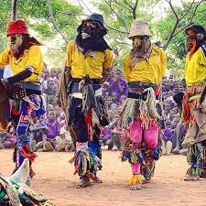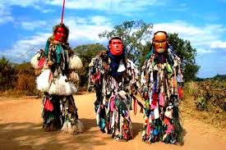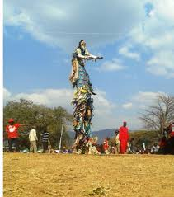

1. to regulate hunting expeditions
2. to collect payments from villagers after buying mzinda for young initiates.
3. to allocate land for the growing of food crops

**EXPANSION OF THE MARAVI KINGDOM**

* The Kingdom expanded not only through wars but also due to the breakaways of certain chiefs around 1550AD when Chidonzi was Kalonga.
* The breakaways led to the growth of the kingdom by extending the borders to other territories and incorporating the subjects into the Maravi Empire.
* The following are the reasons why certain chiefs broke away from Kalonga Chidonzi:

1. Succession disputes e.g Undi
2. Magic and supersitution e.g. Kaphwiti
3. Overpopulation at Masnthimba and Mankhamba
4. A need to control trade with the Arabs and the Portuguesde
5. Unheathy conditions at Mankhamba eg mosquitoes, high temperatures.

**UNITING FACTORS AMONG PEOPLE IN THE MARAVI KINGDOM**

1. **Trade**

All the people were linked by trade with the Portuguese along the Zambezi under the Kalonga.

1. **Religion**

All people worshipped a High God Called **Chauta** whose messenger was a large snake called **Thunga** (python) who acted as a husband to Makewana and **Chauwa** her daughter at Msinja. They all regarded Msinja as their central shrine for worship.

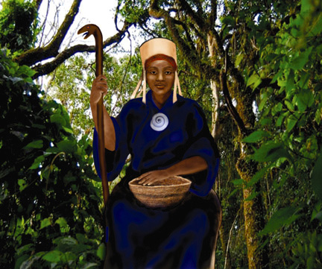



A lithograph of Makewana and the Snake (Rain making)

**DUTIES OF MAKEWANA AT MSINJA**

1. To call the rain when the snake paid her a visit.
2. To make the soil fertile for the farmers
3. To grant success to hunters
4. To limit flood damages
5. All members in the kingdom recognised the Kalonga as their Senior despite the breakaways and the breakaway chiefs maintained the title of Kalonga.

**FACTORS FOR THE DECLINE OF THE MARAVI KINGDOM**

1. **Internal factors**
2. The kingdom was too vast to be ruled by one king
3. Weak defence as the kingdom had no standing army to repel attacks.
4. The succession disputes intensified hatred , disunity and breakaways that weakened the kingdom.
5. Decentralisation led to ineffective administration as competent leaders broke away. The Kalonga torelated decentalisation to extend his aea of influence. But those to whom he delegated power, became power-hungary and established their own autonomous territories.
6. The civil wars, e.g by Kaphwiti and Lundu disrupted the peace and unity that was prevailing in the kingdom.
7. **External factors**
8. Loss of power to control trade. The Portuguese trade directly with lesser chiefs that defied Kalonga’s administration.
9. Growth of slave trade by the YAO, Bisa and the Swahili disrupted peace and promoted depolution in the kingdom. The rulers lost their power and prestige through this situation. **Kalonga Sosola** died at the hands of the Yao raiders in the 1860’s.
10. The invasion by foreign groups e.g. the Arabs, Portuguese and Ngoni devasted the empire wih their superior weapons and fighting tactics.
11. The Makua-Lolo nationalism of 1740 against Lundu took much lnds in the Luangwa Valley and the Lower Shire thus limiting the expansion of the Kingdom.
12. Colonisation of the Malawi area by the British ended up the kingdom’s organisation as the area beame the British Protectorate.

**IMPACT OF THE MARAVI KINGDOM ON THE INDIGENOUS PEOPLE**

1. Promotion of trade with the Portuguse and the natives, e.g. the Tonga, Tavara and Nsenga.
2. Introduction of European manufactured goods through contacts with the Portuguese and the Arabs. This led to the social advancement and prosperity of the indigenous people.
3. Formation of a strong political empire due to the presence of guns. This influenced other tribes to form theirs as a defence against them e.g Makua and Nsenga.
4. Promotion of unity by incorporating the conquered people into the kingdom. This was possible through religious practices ontrolled by the Kalonga and other spritual leaders.
5. Intensified pastoralism and cultivation. This was made possible through contacts with the Arabs and Portuguese especially in terms of domestification of animals among indigenous people.
6. They facilitated the contacts with Europeans in trade who exposed the interior of Africa to the overseas coun tries.
7. It provided a model for good political organisation for other pre-colonial states in Central Africa.

**CHAPTER THREE : THE TUMBUKA-NKHAMANGA KINGDOM**

* This kingdojm was located in the present daay district of Rumphi between Chitipa Wenya to the North West , the Mzimba Ngoni in the South and the Luangwa Valley to the West.

**ORIGIN OF THE TUMBUKA**

* The Tumbuka came from Tanzania at a place known as Upangwa.
* The original clans of the Tumbuka were the Luhanga, Mkandawire, Kachali, Kumwenda, Mzumara, Msowoya, Harawa, Nyirongo, Nyanjagha,Nyirenda and Mhango.
* The Leading clans in politics were the Luhanga and Mkandawire. The Kachali controlled the religious affairs and produced priests. They were later joined by three other groups of the Phoka, Kamanga and Henga.
* The Tumbuka kingdom was established by uniting all the clans.

**COMMON UNIFYING FACTORS AMONMG THE TUMBUKA**

1. Simple agriculture i.e. cultivation and pastoralisation
2. Barter system of trade.
3. Common language, that is, all clans spoke Tumbuka
4. Religion- All clans worshipped the ancestral spirits of the Chikang’ombe Cult near the Chikang’ombe Hills. **Mwandadambi** of the Kachali clan acted as the priest.

**EARLY TUMBUKA POLITICAL ORGANISATION BEFORE THE BALOWOKA**

1. It had a decentralised system of government. It had no hierarchy.
2. It had no army of its own as it was established in a peaceful area. During a political crisis, the Luhanga and the Mkandawire intervened to form a common front

**FORMATION OF THE TUMBUKA- NKHAMANGA KINGDOM**

* The history of the Tumbuka changed with the arrival of the **Balowoka** who were the Nyamwezi , long distant traders from Tanzania.
* The Balowoka entered Malawi after crossing over Lake Malawi at Mtawali and settled among the Tumbuka in 1750AD,
* The Balowoka Nyamwezi to Malawi in 1750AD were led by **Kakalala Msawira Gondwe**, the first Mlowoka.
* Mlowoka means ‘to cross over”
* The prominent Balowoka clans included Katumbi, Mwalweni, Mwamlowe,Mwahenga, Mwazizi, Mwachande and Mwafulirwa.
* The strategy the Balowoka used to establish themselves among the Nkhamanga population was the peaceful infiltration when settling among the locals. They did not engage in wars or any kind of conflict. They first came as traders.

**REASONS FOR THE BALOWOKA MIGRATION INTO MALAWI**

1. They were looking for ivory and leopard skins in the Tumbuka area for trade.
2. They were looking for a peaceful land to settle in after tribal conflicts in Tanzania.
3. Drought made them to look for food and land for cultivation.

**CREATION OF THE TUMBUKA-NKHAMANGA KINGDOM**

When the Balowoka came among the Tumbuka it was easy for them to build trust among the indigenous as they first came as traders. Slowly they began to assume leadership roles as the locals began to look up to them for guidance and assistance.

**FACTORS FOR THE ESTABLISHMENT OF THE BALOWOKA OVER THE TUMBUKA**

The following are the measures that were undertaken by the Balowoka in an attempt to attain power in the Nkhamanga area:

1. **Allegiance to local chiefs**. This exposed Mlowoka to the rulling class and gained political influence over them.
2. **Gifts**.- The Balowoka gave blue-black cloth turbans to the chiefs. The local people were given iron hoes and beads. This made the clan heads and their followers to remain friendly to the Balowoka.
3. **Intermarriages between the Balowoka and the Tumbuka**. For example, Kakalala married into the Tumbuka prominent clans of the Luhanga and Mkandawire, He Therefore became directly connected to the political systems of the Tumbuka.
4. **Trade-** The were controlled the strategic trade centres rich in ivory. They therefore acumulated wealth and powers to control the area.
5. **Tactfulness** in approaching village headmen with the initiative of introducing a royal emblem (the black cloth turban) which dignified their status.This then made the chiefs to be regared as the most important people in the area.
6. The adoption of the Tumbuka language and the Chikang’ombe cult unified the two groups and exalted Kakalala as a hero politically.

The most important element in the religion of the Tumbuka was the rain making process. This had two fatures namely rain-calling and rain-chasing. The former was symbolised by wearing a black cloth around the head, which signified call for rain. Rain-chasing involved wearing a white cloth around the neck translating into a desire to have the rains stop.

**POITICAL ORGANISATION OF THE TUMBUKA NKHAMANGA KINGDOM**

* Mlowoka established the Tumbuka-Nkhamanga kingdom by assimilating the Tumbuka common activities such as religion, trade and language.
* The Tumbuka were manipulated and controlled by the Balowoka.
* The chieftainship of the Tumbuka-Nkhamanga kingdom was created by Kakalala’s son, **Gonapamuhanya** who took the title of **Chikulamayembe** mening **“the carrier” or ‘ accumulator of hoes”.**
* **Gonapamuhanya** was the first Chikulamayembe and he was succeeded by **Mjura** and later by **Chilongozi.**
* **Politically ,** Chikulamayembe used clan heads (chiefs) to control the kingdoms as he was busy with trade.

1. **Mwamlowe** controlled the lakeshore regions
2. **Katumbi** controlled the Henga Valley
3. **Mwahenga** controlled the Central Henga Valley

* **Economically,** he used the economic agents to control the sources of ivory and safeguard the trade routes with **the Bisa, Yao, Ngonde** and the **Swahili Arabs**.
* The economic agents were purerly the **Balowoka** themselves who managed to turn around the Kingdom in to a commercial entity.

**DUTIES OF THE ECONOMIC AGENTS AND CLAN HEADS (SUB CHIEFS)**

1. To collect ivory for the king
2. To assist the king in distributing gifts
3. To settle disputes
4. To safeguard the trade routes

**FACTORS FOR THE DECLINE OF THE TUMBUKA-NKHAMENGA KINGDOM**

1. **Poor and loose political organisation-** Leadership was under chiefs not the Chikulamayembe. This paved way for breakaways e.g. Katumbi and Mwahenga.
2. **No defense**- The kingdom had no army for defence against external attacks.
3. **The Balowoka’s monopoly in trade was lost**- When the external traders especially the Swahili Arabs, started trading directly with the local people. The Swahili Arabs began to directly deal with whoever had ivory or slaves to sell. This weakened the economic position of the Chikulamayembe around the 1830’s.
4. **Slave trade**- The Swahil Arabs brought in a lot of confusion the kingdom as they thrived on the confusion for their slave trade. One of the slave raiders was Mlozi bin Kazbadema based in Karonga who became powerful.
5. The **Ngoni of Mbelwa** invasion in 1855 Killed **Chikulamayembe Mjura** . They took some of the Tumbuka and Balowoka as captives. This then ended their dynasty till 1907 when the colonial government re-instated it. Chikulamayembe Chilongozi was the one who was restored to the throne as the last king.
6. The establishment of the British protectorate in Nyasaland effectively ended the authority of the kingdom.

**ACCOUNT FOR THE IMPACT OF THE TUMBUKA-NKHAMANGA**

1. Introduction of the centralised political systems among the Tumbuka near Thulwe Forest.
2. Promotion of trade whereby more items were involved as the area was exposed to more long distance traders such as the Swahili Arabs.

**EXPLAIN THE WEAKNESSES OF THE NKHAMANGA KINGDOM**

1. It had no army
2. Political powers were under chiefs as the king was busy with trade.
3. Easy breakaways as sub-chiefs had more powers to rule and form their own kingdoms, e.g. Katumbi and Mwahenga.

**CHAPTER FOUR: THE EARLY CHRISTIAN CHURCH**

* The founder of the Christian faith is Jesus Christ, the son of Mary and Joseph the carpenter.

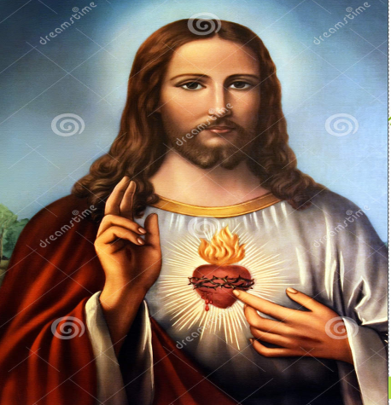 Jesus Christ

* Jesus Christ was born in Bthlehem of Judea in about 6BC when Herod the Great (37BC-4BC) was the king of Palestine.
* He was born when Augustus Caesar was the RRoman Emperor and Pontius Pilate was a Roman Governor in Palestine.

**TEACHINGS OF JESUS THE CHRIST/TEACHINIGS OF CHRISTIANITY**

1. God is their father
2. He himself is the son of God
3. He is promised Messiah who was sent by God to save the lost
4. The Love of God on all people is limitless
5. There is eternal life after death especially to the righteous
6. All people are equal before God.
7. All his followers must be humble and persevere during the persecutions.
8. they should be merciful and love their enemies.
9. They should not crave for earhly riches but long for eternal life.

**BIRTH OF EARLY CHRISTIAN CHURCH**

1. **Palestine**

* On Pentecost day, 3000 people were converted to Christianity. These people were from North Africa, Asia and the Mediterranean lands.
* The believers in Jesus Christ were first called Christians at **Antioch** in Syria.

1. **In the entire Roman Empire**

Christianity was spread by Christian Missionaries throughout the Roman Empire

* St Peter spread Christianity in Jerusalem, Samaria and other places.
* St Paul Spread Christianity in the Mediterranean lands including Ephesus, Corinth, Galatia, Philippi, Thessalonica and Rome by 56AD.

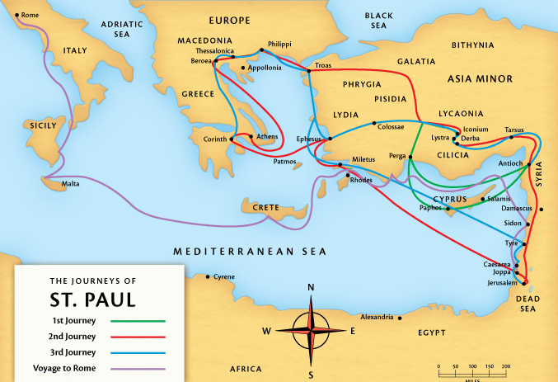

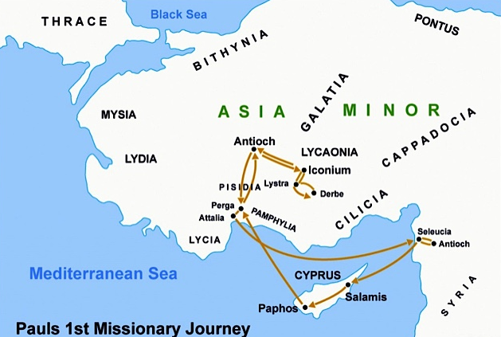

* St Mark established Christianity in Antioch in Syria, Egypt in North Africa,
* St Athanasius established Christianity in Ethiopia
* Church priests such as Clement of Alexandria, Origen and Tertullian patronized the church and defended it from the false teachings.
* Most of the activities of the Apostles are recorded in the fifth book of the New Testament known as the Acts of Apostles.

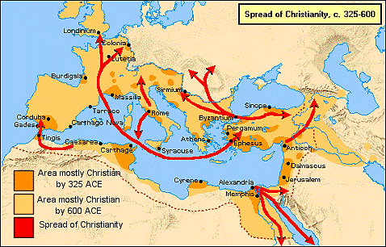

**REASONS FOR RAPID SPREAD OF CHRISTIANITY**

1. **The effects of the Pentecost**

* The Holy Spirit empowered the Apostles and believers to bear witness to Jesus Christ as the Messiah and Son of God.
* He made them to speak out boldly about Jesus among Jews, Greeks and the Romans who failed to resist the Gospel. As the result many people were converted to Christianity.

1. **The Roman Peace (Pax Romana)**

* It made travel easy of preachers throughout the Roman Empire because of good road networks that linked strategic areas within the empire.
* It enabled early Christians to preach freely and convert many to Christianity.

1. **The public life of Jesus Christ**

The miracles performed by Jesus gave people hope that he was the promised Messiah who was sent by God to liberate them from worldly infirmities that block them experiencing His presence.

1. **The Activities of the Apostles, missionaries and early Christians**

Their prayer life, good morals, preaching and miracles impressed the pagans who were later on converted to Christianity

1. **Influence of Hellenism**

* Hellenism is the Greek culture. Such culture include Greek language known as **the Koine Greek** and the Greek philosophy
* The Greek language was highly used in the Roman Empire. The Old Testament was translated to Greek language. This assisted Paul and other Greek speaking Missionaries to explain and preach the Gospel easily within the Empire.
* The Greek philosophy gave birth to the new Christian terminologies that made pagans to easily understand some Christian teachings like Christ 9the anointed one) and Lord. This made many to convert to Christianity.

1. **The influence of Judaism**

* Christians used the Jewish scriptures (Old Testament) during their prayer sessions before the compilation of the New Testament to justify the Messiah ship.
* The early Christians worshipped in Jewish synagogues before establishing worshipping places (churches)
* The background of Christianity from Judaism made the Jews in diaspora to welcome Christianity as a true religion.

1. **The falsity of pagan gods**

The belief in many gods among people in the Roman Empire brought in a vain hope as the gods failed to provide true answers to the problems of life. This was completely different from Christianity which provided immediate solutions to people’s problems of life such as instant healing of the sick, raising of the dead and feeding of the hungry.

1. **The persecution of Christians.**

* The persecution of Christians first began in Palestine when the Hebrews and Hellenists regarded Christianity as a rival movement to Judaism. Some believers were tortured, jailed even killed. For example, Stephen who was stoned to death. This made many Christians to disperse to other areas like Samaria, Gaza, Joppa, Caesaria and Antioch, hence the spread of the Gospel to other areas.
* By 64AD, Christians were persecuted in the entire Roman Empire. The persecutions led to the fast spread of the religion in the following ways:

1. The migrations further dispersed Christian teachings to the new areas.
2. They exposed believers as men of courage who stood against evil people and became torch bearers of the truth. These encourage non-believers to follow the Christian way of life.
3. **The legalization of Christianity**

* In 313AD **Emperor Constantine** issued decree of Milan (freedom of worship to the Christians). This freed the Christians in the Roman Emperor.
* In 394AD, **Emperor Theodosius** declared Christianity as the only religion of the Roman Empire. Christians were therefore, free to worship and preach in the Empire. Many people became Christians.

**WHY WERE THE CHRISTIANS PERSECUTED IN THE ROMAN EMPIRE**

The following were the main reasons why Christians were persecuted:

1. They refused to worship Roman Emperors or gods.
2. The Romans wanted to suppress all the ant-Roman elements among Christians in the empire (Judaism).
3. The Christians boycotted Roman events and activities. For example, they refused to join in the Roman armies as killing is an evil practice. They were therefore regarded as enemies of state who did not mind the earthly rulers.
4. The Christians were accused of involving themselves in incest, cannibalism and being members of secret societies. To survive persecutions, Christians met in secret places that were usually underground called **Catacombs.**

**Catacombs** were secret underground passages where the Christians were meeting for prayers during Christian persecutions in the Roman Empire. The diagrams below show **Catacombs.**

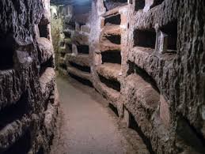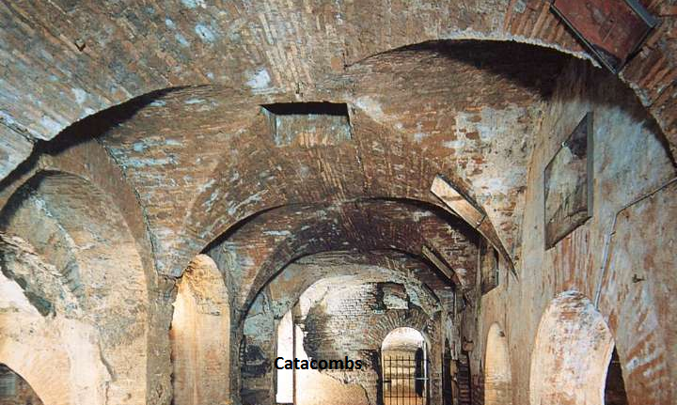

1. Christians were accused of establishing the kingdom of Jesus on earth that was against the Romans. They refused to worship the sun god on Sunday but consecrated the Sabbath as their day of worship.
2. The Christians were against the worship of idols which angered idol makers and sellers.
3. Christians were regarded as atheists.
4. By performing miracles and wonders, Christians were accused of being sorcerers who could overthrow the Roman Empire.
5. The Christian message of love and forgiveness did not appeal to the Romans because it was a sign of being dishonest and weak to love one’s enemy and pray for the persecutors.

**THE ROMAN EMPERORS WHO PERSECUTED CHRISTIANS**

1. **EMPEROR NERO (54AD-68AD)**

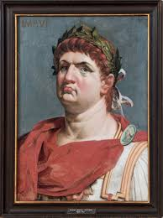 **Emperor Nero**

* He was the first Roman Emperor to persecute Christians.
* To speed up the ant-Christian campaign, he accused them of setting ablaze the city of Rome in 64 AD. To deal with them accordingly

1. He killed Christians by crucifying them
2. HE threw women, men and children to beasts during the Roman festivals to amuse the spectators.
3. He killed St Peter and St Paul in Rome in 64AD.
4. Poured tar on believers and set them ablaze at night to act as torches.
5. **EMPEROR DOMITIAN (96AD)**

* He was the first Roman Emperor to call himself lord and god. He therefore, ordered people to honour and worship him as a god. Christians went against his command as they believed to have one and only true invisible God. Domitian accused the Christians of plunging the Empire into total poverty.

1. **MARCUS AURELIUS(161-180AD)**

* He wanted to reform and strengthened Paganism in the Roman Empire. He forced Christians to curse the name of Jesus Christ and burnt them to death. For example, Speratus and Polycarp, the Biship of Smyrna, North Africa were burnt to death.

1. **EMPEROR SEPTIMUS SEVERUS (202-211AD)**

* He prohibited all Roman citizens from becoming either Christians or Judaists. He was called the anti-Christ who searched for and condemned the Christians to death. He killed Perptua and Felicitas of North Africa**,**

1. **EMPEROR DECIUS (250AD)**

* He decreed that all people except the Jews should offer sacrifices to the statue of the emperor. The command was called the Edict of Sacrifice. Those who disobeyed to offer the sacrifices to the statue were put to death.

1. **EMPEROR VALERIANUS (260AD)**

* He confiscated church buildings and arrested its office bearers. He murdered Cyprian, the bishop of North Africa.

1. **EMPEROR DIOCLETIAN (303AD-305AD)**

* He put forward an allegation that Christians intensified the weaknesses of the Roman Empire. Rome was hit by acute economic problems and wars. He attributed all these to Christians as the ones who provoked the fate.
* To revive the Empire, he issued a decree to:

1. destroy all Christian churches
2. arrest all church officers including the Bishops
3. burn all Christian books including Bibles
4. force Christians to offer sacrifices to pagan Roman gods and statues of the emperors
5. declare all Christians as outlaws; they were stripped of their Roman citizenship. They were therefore to be killed anyhow.

**THE END OF THE PERSECUTIONS IN THE ROMAN EMPIRE**

* The period of persecutions came to an end during the rule of Emperor Constantine**.**

**EMPEROR CONSTANTINE (306-337AD)**

* He was the first Christian Roman Emperor**.**

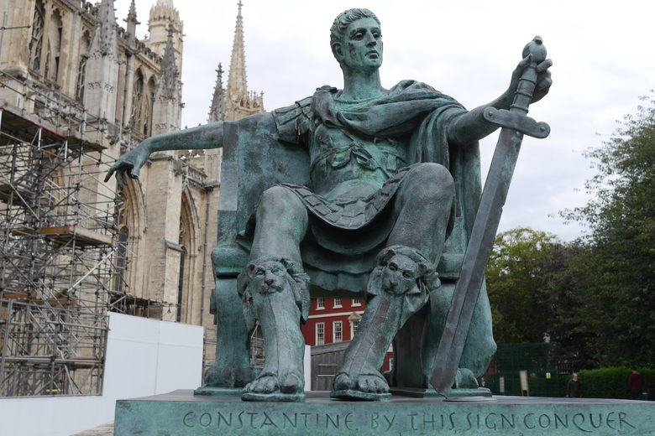

* He succeeded his father as an emperor in York in 306AD. His opponent to the throne was Maxentius who lived in Rome.
* He defeated Maxentius at the battle near Milvian. To win much support and defence; to foster unity among people in the empire, he included Christians.
* As he was preparing to attack Maxentius in 312AD at the Milvian Bridge, Constantine claimed to have had a vision of a flaming across that had an inscription **“in hoc signo vincere” meaning “by this sign, conquer”. He adopted the cross as an emblem that led to his victory.**
* In 313AD, Constantine issued a decree that was called the **Edict of Milan.**
* The **Edict of Milan** had the following points

1. Freedom of worship was tolerated in the entire Roman Empire
2. The Christian persecutions came to an end.
3. All Roman citizens were allowed to become Christians.
4. The emperor himself became the defender of Christian faith
5. Churches were built for Christian worship and pagan temples were closed.
6. The Christian Sunday was recognized as a day of rest from any type of work
7. The Bishops and preachers were paid by the state.

**EMPEROR THEODOSIUS**

* In 394AD, Emperor Theodosius declared Christianity as the only religion of the empire. This was how Christianity was legalized as the only religion of the Roman Empire.

**THE ORGANISATION OF THE EARLY CHURCH**

* During the post-Apostolic era or the Medieval Period, an office of a priest was established. He was under direct control of a bishop.
* The church had five main organizational centres which were Rome, Jerusalem, Constantinople, Antioch and Alexander. The Bishops from these centres had a final say on church issues. They acted as fathers of the church (patriarchs).
* The Patriarch of Rome became the father (Papa/Pope) of all churches.

**HOW DID THE BISHOP OF ROME ADOPT THE NAME “POPE”?**

* The Pope is the head of the Roman Catholic Church throughout the world. The Pope regarded himself as the successor of Peter the Apostle, the first Bishop of Rome.

**The two reasons why Peter became the first Pope:**

1. **Jesus had chosen him to lead the church**

This is confirmed in the Bible as Jesus proclaimed him “the rock on which I will build my church” And on the other instance Jesus gave him “keys of the kingdom of heaven”. (Mathew 16 verses 18-19).

1. **Peter’s martyr death in Rome**

A martyr is a person who dies because s/he refuses to give up Christian beliefs. This showed how a link was established between Jesus and the office of the Pope. The link is known as **apostolic succession** according to the Catholic doctrine.

**REASONS THAT LED THE BISHOP OF ROME TO BE CALLED THE POPE**

1. To act as a caring father in matters concerning faith and morals
2. To sustain the apostolic seat of Jesus and the Apostles as a pastor, missionary and an administrator.

**THE CHURCH AND STATE DURING THE MIDDLE AGES**

The fall of the Western Roman Empire in 476AD paved way for the Pope and his bishops to fill the power vacuum in the empire. They began to deal with both church and state affairs. The Papal seat became a court of appeal and the new rulers of Europe recognized him to claim both religious and political powers.

**HOW THE CHURCH INFLUENCED LIFE IN THE MIDDLE AGES**

1. By spreading the Gospel and converting many people to Christianity throughout Europe and the world at large.
2. By preserving the Roman civilization that was destroyed that was destroyed the dark ages by putting up fine buildings, art, learning etc.
3. By promoting unity in the Roman Empire under the Leadership of the Pope who united the Eastern and Western Roman Empires.
4. By helping people to live better socially after dealing with offences that were against the church law and personal relations.
5. By promoting education in mission stations whereby Latin became the main subject.
6. By acting as a watch dog to the government whereby bishops and some influential Christians became the king’s spiritual advisers.
7. By taking care of the aged, the sick, the poor and the orphans when there were no hospitals and governments to deal with such circumstances.

**THE MONASTICISM**

* **Monasticism** means a way of life whereby religious people isolated themselves from any secular life and society with an intention of being devoted to meditation, prayer and work with the aim of attaining spiritual purity.
* **Monasteries/Convents/Nunneries** are separate places where the religious people lived.
* **Monastery** was a separate community for religious men (monks)
* The head of a monastery was called **an abbot (Abbot means father)**
* **Nunnery** was a separate place for religious women **(Nuns).**
* The head of a nunnery was called **Abbess**

**VOWS OF THE MONKS AND NUNS**

1. **Poverty -** not to own any personal property
2. **Obedience -** to observe the rule
3. **Chastity-** not to marry

**ACTIVITIES OF THE MONKS AND NUNS**

1. Spending much of their time in prayer and meditation in order to attain spiritual growth.
2. Working manually, for example rearing animals and cultivating plants.
3. Giving hospitality to travelers, poor people
4. Taking care of the aged, the sick and the orphans.
5. Studying, teaching and writing books that were kept in libraries.
6. Sculpture and painting.

**NOTABLE GROUPS OF MONKS**

1. **The Benedictine Monks**

* These followed St.Benedict, the founder of Monte Casino Monastery of Italy.
* While in isolation, they spent much of their time in prayer and work for **“to work is to pray” “Laborare est orare”**

1. **The Cistercian Monks**

* The order was established at Citeaux in France in 1098 AD. By 1112AD, Bernard of Clairvaux became its head and promoted a more ascetic life where monks ate very little and meditated individually in rooms.

1. **The Mendicant Monks**

* They were forbidden to own personal property but either worked or begged for their living.
* There were two groups of the Mendicant Monks (Friars/brothers)

1. Franciscans

They had no dwelling place and were mobile preachers.

1. Dominicans

They were highly educated, attended to the sick and aged people.

**CHAPTER FIVE: ISLAM**

* Islam means **“submission o the will of God”**
* It is a religion that started in 622AD in Mecca by Muhammad bin Abdullah
* The believers of Islam are called **Moslems**
* Moslems are people who voluntarily submit to the will of God.
* The Islamic holy book is called the **Quran** and God is known as **Allah.**
* The sacred places of worship of Moslems are called **Mosques.** The central mosque is in Mecca, the birth place of Muhammad.

**MUHAMMAD AND THE BIRTH OF ISLAM RELIGION**

* Muhammad was born on 20th August, **570AD**
* He was the son of Abdullah and Amina. They all belonged to the **Quraysh** tribe of Mecca.
* Muhammad means “an honest person to be praised”
* Abdullah died before Muhammad was born and Amina died when he was 6years old.
* He brought up by his grandfather **Abd al-Muttalib** who died after two years of adopting Muhammad. Then he was later adopted by his uncle Abu Talib.
* At the age of 25, he was employed by a rich widowed woman Khadija who by then was 40 years old. The two got married. Muhammad managed the lady’s business transactions and frequently travelled on a caravan to Syria.
* In 610AD, he had a vision from God through Angel Gabriel in a cave at Hira. He became the God’s prophet
* He associated himself with the Jews and Christians of Mecca. He preached against the pagan worship that was being promoted by the Arabic rich merchants who worshipped the **black stones at Kaaba** in Mecca.

**WHY DID THE RICH ARAB MERCHANTS HATE THE TEACHINGS OF MUHAMMAD IN MECCA BY 622AD?**

Muhammad condemned the idol worship of Black stones at Kaaba.They rich Arab merchants earned a lot of money from the pilgrims who paid offerings to the gods at Kaaba.

**THE BIRTH OF ISLAM AS A RELIGION**

* Before Islam began, many Arabs made pilgrimages to Arabia to worship at the temple of Kaaba,
* Muhammad denounced the worshipping of pagan gods. This triggered anger among the Meccan Arabs who plotted to kill him.
* To escape from the assassination, Muhammad and his followers fled to Medina on **16th July, 622**.

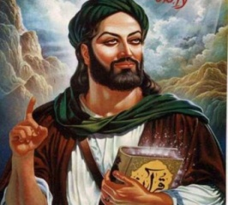Prophet Muhammad

* The fright of Muhammad from Mecca to Medina is called **Hegira.**
* The importance of **Hegira to Muslims** is that it marked the birth of Islamic religion or it marked the actual year when Islam was born as a religion because it transferred the faith from Mecca to Medina.
* Muhammad died in **632AD** and was succeeded by a number of his followers who were the very first converts to Islam. They were no prophets but mere successors and were titled **Caliphs.**
* The first caliph was **Abu Bakr** who was followed by **Umar, Uthman** and **Ali** in succession. These men and some followers had a hand in the spread of Islam worldwide.

**WHY WAS MUHAMMAD WELCOMED IN MEDINA IN 622AD?**

* The area had problems of poor leadership and tribal wars. This promoted clan leaders to invite Muhammad for participation and governance.

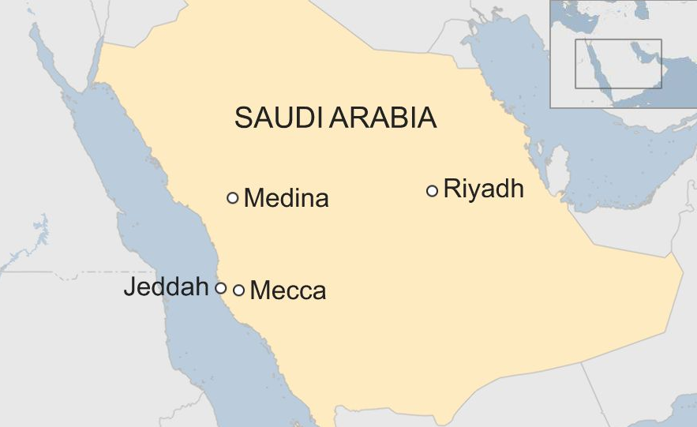

**THE INFLUENCE OF JUDAISM AND CHRISTIANITY ON ISLAM**

The two religions that influence on Muhammad to start Islam were Judaism and Christianity of the Jews. They had the following influence on Islam:

1. **A belief in one God.**

* Both the Christianity and Moslems believe in one God, Yahweh for the Christians and Allah for the Moslems.

1. **A belief in the common ancestry**

Christians do believe that Abraham is their ancestor in faith; it is from him that Jesus Christ was born as an offshoot from David. Moslems also regard Abraham (Ibrahim) as their ancestor through his first born son Ishmael.

1. **A common area of origin among the three religions**

Judaism, Christianity and Islam are all religions from the Middle East. Islam, therefore, copied a lot from Christianity and Judaism, for example, the Jewish feast of Atonement which they turned into the Fast of Ramadan; mid-day prayers, the use of the Jewish sacred scriptures 9the Old Testament), rituals of cleanliness, dress and many more.

1. **The direction of prayer while facing to Mecca (the Qublah)**

The Jews who lived in other places away from Palestine strictly followed Judaism. To be united with their fellow Jews at prayer in Palestine, they faced towards the Jerusalem Temple.

When Muhammad and his followers reached Medina in 622AD, they joined the Jews who were in diaspora; they too faced towards the Jerusalem Temple.

When the Jews and Muhammad separated in Medina, the Prophet ordered all his followers to worship while facing Mecca.

1. Parallelism in the Sacred Scriptures

The Jewish sacred scriptures cover the entire Old Testament of the Christian Bible. Muhammad after being enlightened by Waraqa, Khadija’s cousin and a scholar of the Christian and Jewish Holy books knew a lot about the Old Testament. Most of them are written in the Quran. For example, the story of Lot and his wife, Abraham, Ishmael, King David, Solomon, Mary the mother of Jesus (Maryam,Issa), Joseph (Yusuf) , Angel Gabriel etc

**THE TEACHINGS OF ISLAM (PILLARS OF ISLAM)**

The five pillars of Islam included the following

1. There is only one True God and Muhammad is his last messenger (Shahada).
2. Praying five times a day while facing Mecca (Salat).
3. Alms giving to the poor (Zakat).
4. Fasting during the month of Ramadan (Sawn0. Muslims are forbidden to take alcohol, eat or copulate from sunrise to sunset)
5. Making pilgrimages to Mecca (Hajj) once in a life time.

**WHAT ARE THE BASIC BELIFS OF ISLAMIC RELIGION?**

The following are the basic beliefs of Islam:

1. **A belief in one God Allah**

They believe in the creator of the universe and is not compared with any being.

1. **A belief in life after death**

* The righteous will be rewarded while sinners will be punished and consumed by the fire of hell

1. **A belief in the existence of angels**

They believe that Angels are God’s messengers. They include **Gabriel** (the mediator of revelations), **Mika** (the sustainer), **Israfic** (announcer of the last day) and **Izra** (one who takes souls at the time of death).

1. **A belief in the sacred scriptures**

* Moslems believe that God spoke to his messengers (prophets) and the massages were compiled in books for example the Torah of Moses, the Gospel of Jesus and the Quran which is the last book of God’s messages.

1. **A belief in prophets.**

* Moslems believe that God sent messengers to communicate his Will on people. Muhammad being the last messenger to be sent by God.

1. **A belief in the day of judgement**.

* The Moslems believe that the world will end and God will judge all people according to their deeds.

1. **God controls history.**

* God responds to people’s prayers. Whatever happens on earth is guided by Him.

**SIMILAR BELIEFS AND TEACHINGS BETWEEN ISLAM AND CHRISTIANITY**

Both believe in

1. life after death
2. existence of one True God
3. existence of angels
4. Rewards and punishments in the afterlife.
5. sacred scriptures emanating from God
6. presence of prophets as God’s messengers
7. equality of all people before God
8. fasting

**WHAT ARE THE DIFFERENCES BETWEEN ISLAM AND CHRISTIANITY?**

1. Christians regard Jesus as the son of God while Moslems regard Him as mere prophet. They consider Muhammad as the last and greatest prophet.
2. Moslems believe that one can directly go to heaven after dying in a holy war while Christians regard righteousness as a yardstick to salvation.
3. Polygamy is accepted in Islam while Christianity promotes monogamy.
4. Christians paste pictures or statutes of saints and Jesus in their churches while such practices are regarded as idol worship or abomination in Islam.

**THE SPREAD OF ISLAMIC RELIGION TO OTHER AREAS**

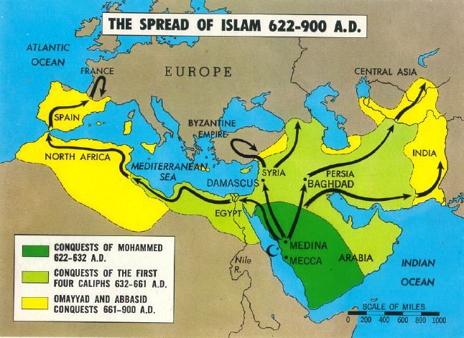

1. **IN ARABIA AND THE NEAR EAST**

* Islam was spread to Arab and the Near East **through Jihads (Islamic Holy Wars)** against the rich Arab merchants in the wars of **Badr** (625AD0, **Uhud** (625AD), and **the Ditch** (627AD).
* In 634AD, **Abu Bakr** captured Iraq, Syria and part of the Eastern Roman Empire.
* **Umar** captured Damascus in 635AD and Jerusalem in 637AD.
* A Confederation of Islamic Community was formed to unite all Muslims worldwide and promote its fast spread.

1. **IN EUROPE**

* In 732AD the Moslems fought against the Franks at the battle of Tours and the Moslems were defeated. The Franks were led by Charles Martel.
* Then they changed their strategy and spread Islam through **education.** They built primary, secondary and universities. They built university at **Cordova in Spain**. Learners were converted to Islam through mere admiration of the Arabic as well as the Islamic civilization.

1. **IN NORTH AFRICA**

* Islam spread through **Jihads**. They called North Africa states **Al-Maghrib.**
* They conquered Carthage in 690AD and conquered Morocco in 711AD. They united them to form the Almoravid Empire that aimed at spreading Islam through conquests.

1. **IN EAST AND CENTRAL AFRICA**

* It spread through slave trade, education and the influence from Islamic missionaries of Ulama along the East Coast of Africa (Tanzania)

1. **IN WEST AFRICA**

* Islam spread to West Africa through wars under the Almoravids. It also spread through trade and education as they built trade centres and schools. For example, they built a university at Timbuktu.

**FACTORS THAT LED TO THE FAST SPREAD OF ISLAM WORLDWIDE**

1. **The influence of Islamic holy wars (Jihads)**

A belief among Muslims that one can go directly to heaven after dying in a holy war encouraged many to join Islam.

1. **Education**

Centres of higher learning for example, Cordova in Spain; Timbuktu and Go in North Africa attracted non- Muslim learners who were later on indoctrinated with Islamic way of life.

1. **Trade**

A need for foreign goods and fame attracted African kingdoms like Ghana, Mali, and Egypt etc to cement trade ties with the Arabs by following the Islamic religion.

1. **An influence of kings and clan heads over their subjects.**

Most leaders in Africa, Saudi Arabia and Asia encouraged their subject to follow Islam in order to gain favours from the Arabs.

1. **An influence from Islamic missionaries on local people.**

The Sheikhs and the Mwalimu (Islamic teachers) preached on people, built mosques and instructed them on how to live as Muslims.

1. **Similarities between the Islamic beliefs and Arabic culture**

The similarity between beliefs and some cultural practices led many people to get attracted to join Islam.

**CONTRIBUTIONS OF ISLAM TO THE MODERN CIVILIZATION**

* **Language and literature**

Islam has maintained Arabic as the language of the language of the religion.

* **Architecture**

The world has copied the building of four-cornered houses and dome shaped structures from the Arabs.

* **Dress**

The Muslim dress of putting on robes and for men with a loose pair of trousers, a shirt and a cap9hijab for women; turban for men) has influenced many societies.

* **Forbidden foods**

Moslems are forbidden to eat pork.

* **Islamic law**

Most countries in Africa, Asia and the Middle East apply Sharia/Islamic law to discipline law breakers and promote conformity in Islamic communities.

* **Education**

The Moslems have established schools including universities, for example, Cordova in Spain and Timbuktu in North Africa where boys and girls learn to read and write in Arabic.

* **Science**

The Moslems were involved in astronomy whereby they catalogued over 1,000 stars, estimated the distance between the earth and the sun, and the movement of the Galaxy.

* **Mathematics**

They introduced the Arabic numerals such as 0, 1, 2,3,…. instead of Roman numerals

* **Medicine**

They developed medicine for small pox.

* **Trade**

The Moslems are good traders throughout the world,

**CHAPTER SIX: RENAISSANCE**

**Define the term Renaissance.**

* Renaissance is a period of rebirth or revival of learning that started in Europe more especially in Italy.
* The rebirth of learning revived the ancient Greek and Roman civilization that were destroyed during the Dark Ages period.

**WHY DID RENAISSANCE BEGIN IN ITALY?**

**MAP OF ITALY SHOWING MAIN RENAISSANCE CITY-STATES**

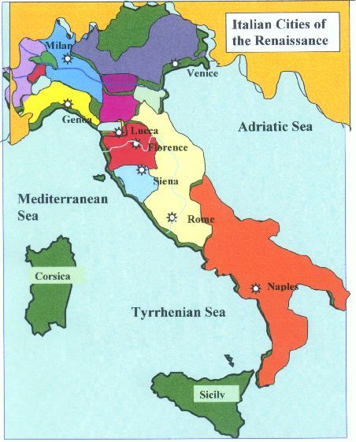

1. **Assimilation of Greek and Arabic knowledge**

* It adopted the classical Greek and Arabic knowledge that had long been lost to Europe. There was rediscovery of ancient texts that had been forgotten by western civilization.

1. **The fall of the Eastern Roman Empire**

* The fall of the Eastern Roman Empire after Constantinople was captured by Ottoman Turks in 1453AD led to a sharp increase in the movements of Greek scholars to Italy to Italy with some of their books.
* As a result renaissance had to start in Italy where many scholars flocked to and were able to find jobs as teachers of Greek with many nobles and church leaders among their students.

1. **Trade**

It had rich commercial cities like Florence and Venice that attracted people of different skills to settle in the area. These people promoted a rich cultural and artistic heritage. Apart from benefits of trade, availability of different people meant that Italy was exposed to new ideas from different civilizations.

1. **The presence of Rich Princes**

* Italy had rich princes from Venice, Milan, Genoa and Florence. For example, Lorenzo de Medici who encourage learning by donating a lot of wealth to the learning sector.

1. **Peace in Italy**

* There was peace in Italy as compared to other parts of Europe. The Greeks, Jews and inhabitants of the Mediterranean lands occupied. Peace made other civilizations to be established in Italy.

**OUTSTANDING CHARACTERS AND THEIR CONTRIBUTION DURING RENAISSANCE**

**WRITERS**

1. **PETRARCH (1304-1374)**

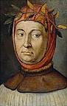

* He is the **father of Italian** renaissance literature
* He introduced humanism and encouraged people to study literature, latin language and logic as well as Rhetoric.
* He wrote poems that were attributed to his wife **Laura** in a style as the **Sonnet** (a form of poem with 14 lines and regular rhymes)

1. **NICOLO MACHIAVELLI (1467-1527)**

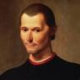

* He wrote a book called the **Prince.**
* **Nicolo Machiavelli is famous for his book the Prince.**
* He argued in his book, the Prince that it is justifiable for leaders to use any method to maintain their positions.
* According to Machiavelli, it matters less whether cruel or deceitful means were used because success or failures matters more in politics rather than right or wrong.

1. **MIGUEL DE CERVANTES (1547-1616)**

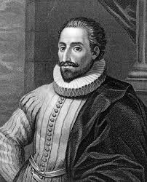

* He was a Spanish ex-serviceman who wrote a novel called **Don Quixote** where he criticized the feudal life and his society.

1. **DANTE**

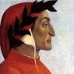

* He came from the city of Florence in Italy.
* He wrote **Divine Comedy**
* Divine Comedy had three imaginary segments: Hell, Purgatory and Heaven

1. **BOCCACCIO**

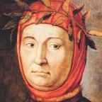

* He wrote **Decameron**.
* Decameron refers to the popular stories.

1. **WILLIAM SHAKESPEARE (1564-1616)**

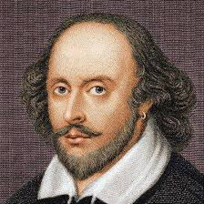

* He was the playwright from London.
* He is the greatest of all English writers.
* He wrote tragedies like **Macbeth, Julius Caesar, Hamlet, Romeo and Juliet**.
* He also wrote comedies like **Henry V and A Midsummer Night’s Dream.**

1. **JOHN MILTON**

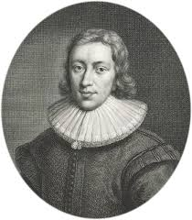

* He was an English playwright.
* He a long poem called the Paradise Lost.
* Paradise Lost describes the disobedience for Satan to God.
* Paradise Lost explains how God expelled Stan from Heaven**.**

**PROMINENT ARTISTS OF THE RENAISSANCE PERIOD**

1. **DONATELLO**

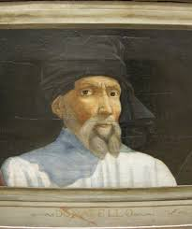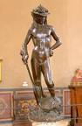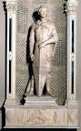

**Donatello David St George**

* He was a sculptor who curved figures of **David** as a shepherd boy and **St George in armour.**
* Below are the artworks of Donatello

1. **LEONADO DA VINCI (1452-1519)**

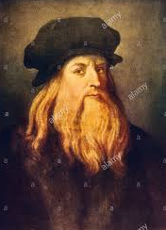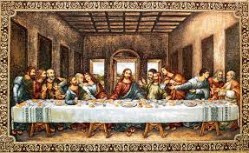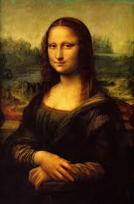

**Leonado da Vinci Last Supper Monalisa**

* He was a sculptor, musician and architect from Florence in Italy.
* He painted a portrait of the **Last Supper** on a wall of monastery in Milan.
* He painted the **Monalisa** **(the Virgin Mary).**
* He designed a **flying machine (helicopter), a submarine and an armoured tank**

1. **MICHELONGELO (1474-1564)**

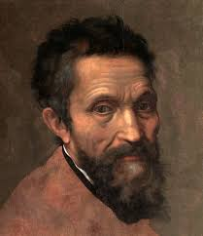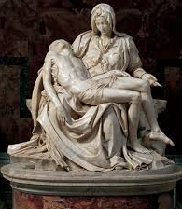

**Michelangelo The Pieta**

* He was a painter and a sculptor who was employed by the Pope to paint the **Last Judgement** on the mural of the Vatican Palace**.**
* Below the last judgement painted by Michelangelo**.**
* He designed the uniform for the Pope’s Swiss Guards
* He painted the statute of the **Blessed Virgin Mary with the dead body of Jesus Christ on her lap (the pieta)**

1. **RAPHAEL OR RAFFAELLO SANZIO (1483-1510)**

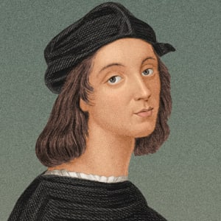

* He was born in Italy at Urbino and was a student of Michelangelo and Leonardo da Vinci.
* He painted the **School of Athens** with Plato and Aristotle surrounded by their students in Greece.

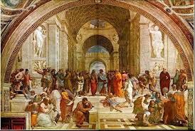 School of Athens

* He was employed by **Pope Julius 11** and **Pope Leo X** to paint the **Madonna (Virgin Mary) i**n Rome just as Michelangelo did.
* Below is the paintings of Virgin Mary (Madonna) painted by Raphael in Rome.

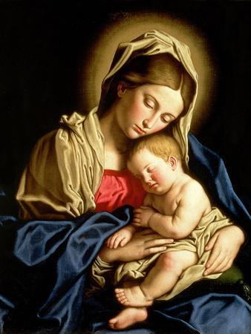 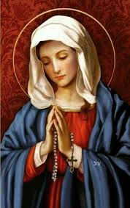

1. **PETER BRUEGHEL (1529-1569)**

* He painted pictures that **portrayed peasant life**

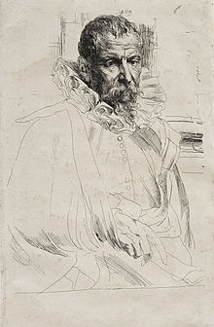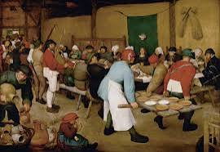 **Peasant life**

**Peter Brueghel**

**SCIENTISTS**

1. **NIChOLAUS COPERNICUS (1473-1543)**

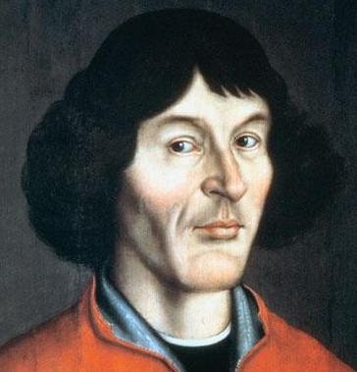

* He was a Polish Priest who said that the sun is the centre of universe.
* He opposed the theory of Ptolemy that the earth is static but the sun, moon and stars rotate around it.
* He proved that the sun was fixed but the earth, the moon and stars around it.

1. **GALILEO GALILEI (1564-1642)**

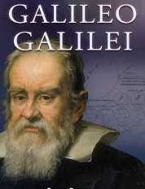

* He was an Italian who invented the **telescope** using optical lenses in 1610 AD.
* He proved that the sun was fixed but the moon, stars and planets rotated I (the Copernican Theory).
* The Catholics condemned his ideas and was tried by a body of church leaders called the Inquisition.
* Galileo Galilei was tried by Inquisition because they condemned his teachings as they were against the application of church beliefs on the laws of nature. His teachings were considered as a heresy (false teaching). Therefore he was to be sentenced to death but he withdrew his position to save his life.

1. **JOHANN GUTENBURG (1400-1460)**

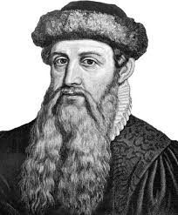

* He was a German and first person who invented the Printing Press in 1455 in Germany.

**WHY IS THE INVENTION OF THE PRINTING PRESS IMPORTANT TO THE MODERN WORLD?**

* Importance of the Printing Press invented by **Johann Gutenberg**

1. Hundreds of copies of books were produced within a short period of time even for an ordinary person to use.
2. It led to fast spread of knowledge as people could read on their own.
3. Learning was boosted as people could read and acquire new skills.
4. The printing of the Bible known as Gutenberg Bible enlightened people and enabled them to think deeply and question the teachings of the Catholic Church (Reformation).
5. **ISAAC NEWTON**

* He was an English lecturer of Mathematics who proved that the movement of the planets around the sun is caused by the Gravitational Force of the Earth.
* He was the renaissance character who disapproved Aristotle’s theory that the bodies fall at different speeds according to their weight.

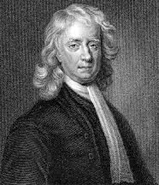 Isaac Newton

**RESULTS OF THE RENAISANCE**

1. It led to the inventions and discoveries of new items such as the Magnetic Compass and the Telescope that made travelling easier. They led to voyages of discoveries.
2. The printing of more books promoted literacy and the spirit of asking questions about things they were not clear.
3. Education was promoted in colleges and universities due to the scientific discoveries and the presence of abundant books that enabled learners to acquire new knowledge easily.
4. It led to the Reformation of the Church as people became unhappy with some bad church practices and teachings and wanted to change.
5. It led to development in science. For example, people tested old beliefs with scientic evidence. Nicholaus Copernicus was the chief proponent of the fact that the sun was the centre of the universe, leaving the earth and other planets revolving around it.
6. It preserved culture through art ( sculpture, painting) and writing (poetry, playwright)

**CHANGES THAT TOOK PLACE BETWEEN 15TH AND 16TH CENTURIES IN THE WESTERN**

1. **Political changes**

* Large empires were disintegrating and were replaced by national states, regions and free cities. These Free states fought for their independence from the Papal rule.

1. **Social changes**

* Feudal systems ended in Europe. Farmers (peasants, serfs) who by then controlled by the rich, fought for their independence from the cruel masters who exploited them.

1. **Economic changes**

* Barter trade was replaced by the use of money as a medium of exchange, industrial production began and cities became centres of commerce.

1. **Cultural changes**

* The ancient Greek and Roman literatures were studied. Painting, sculpture, architecture and learning revived the ancient civilizations of the Greeks and the Romans that were destroyed by the Barbarians during the Dark Ages period.

1. **Spiritual changes**

* The rebirth of learning and science made the Frankish and German empires to reduce the Papal influence over states. The ideas from science and humanism made lay people to criticize church claims on salvation and sacraments, simony, immorality and indulgencies, hence the era of reformation in the church.

**CHAPTER SEVEN: THE REFORMATION**

**Define the term “reformation” and “reformers”.**

* Reformation was a period of great religious change that took place in Europe due to the malpractices of some of the leadership of the Roman Catholic Church between 1517AD and 1648AD.
* Reformers are people who denounced the false teachings and the immorality in the church.

**CAUSES OF THE REFORMATION**

1. **Corruption in the church leadership**

* The Popes/Bishops became more materialistic which made them to forget about spiritual leadership. For example, church posts were being sold. Pope Alexander V1 is a good example of such corrupt leaders.

1. **Improper training of priests**

* Some people became priests through inheritance and simony (selling or buying a church benefice); some were appointed after serving the church faithfully for a number of years.

1. **The sale of indulgencies**

* Indulgencies were papers or certificates that were sold to sinners for the remission (forgiveness) of their sins without really repenting.
* The money was used in building part of St Peters Basilica in Rome, Many enlightened people criticized it because salvation could not be bought or sold as it is God alone who forgives and saves.

1. **Mixing of political and spiritual interests by church and state.**

* The supremacy of the church over the state during the middle Ages made the Pope to accumulate political powers in the Roman, Frankish and German empires. The birth of states from these empires during the Renaissance period challenged the Papal authority politically.

1. **Accumulation of wealth by the church leaders.**

* Most church leaders became very rich at the expense of the poor through abuse of church collections and offerings thereby leading an extravagant life. Secular life promoted immoral behavior and eroded the spirituality. People rebuked the malpractices of greed and secularism among church leaders.

1. **The idea of Celibacy**

* Celibacy is a Catholic teaching among priests that upon being ordained as a minister, one should not marry or engage in any marital related affair. Believers felt cheated upon realizing that some priests had wives and children which was against their vows.

1. **The invention of the printing press.**

It led to the printing of the Bible that made people to appreciate the arguments unscriptural conduct, for example Desiderius Erasamus. The Printing press facilitated the fast spread of skills and secular literature among people (humanists) who questioned a lot about church affairs.

1. **Renaissance**

* Educated people of the renaissance began to question the authority of the church on all aspects of life. For example, it became clear that there was a difference between religion and science as more scientific ideas seemed to clash with church practices or beliefs.

**CONNECTION BETWEEN RENAISSANCE AND REFORMATION**

Renaissance had great influence on Performance and these included:

1. **Renaissance produce scientific ideas which sparked the reformation**

* The Renaissance scientists such as Nicolaus Corpenicus, a Polish Priest and Galileo Galilei provedbeyond doubt the law of nature against church belief.
* Scientific ideas challenged the naïve faith of people and enlightened them to follow the truth by going against some of the unclear church teachings. This acted as a raw material for the Reformation.

1. **Printing press**

* It led to the printing of the Bible that made people to appreciate the arguments unscriptural conduct, for example Desiderius Erasmus. The Printing press facilitated the fast spread of skills and secular literature among people (humanists) who questioned a lot about church affairs.

1. **Need for separation of powers between church and state**

* The Pope had accumulated so many powers that he controlled both the church and state during the Middle Ages. Renaissance gave birth to city states that existed independently from crumbling kingdoms of Europe.

**WHY REFORMATION STARTED IN GERMANY**

Reformation started in Germany due to the following reasons:

1. **Loss of the Pope’s authority over the Habsburg-German Empire**
2. At first, the Pope enjoyed political power over the Habsburg-German Empire which constituted of the following states: Belgium, Italy, France, Austria-Hungary and Germany. The independence of these states empowered the German-speaking people from these states to highly respect their kings and defy some of the church orders.
3. German princes such as Fredrick of Saxony defended as well as protected the reformers such as Martin Luther from being killed by the church. They spoke boldly against the church without fear.
4. **Emergence of educated German elite**

* Renaissance promoted learning in Germany which produced many educated people like Martin Luther in Germany. Martin Luther wrote a lot and spoke against some of the evils in the church.
* Martin Luther became the first person to openly criticize the church in the footsteps of earlier reformers.

1. **The effects of the printing press**

* The Printing Press was invented by Johann Gutenberg in Germany in 1455.
* The Printing Press facilitated reformation by

1. Enabling the reformers to translate the Bible into German language. This exposed the masses to the Bible and allowing them to understand on their own what the Bible says about some things.
2. Widening the public use of the Bible. This made a lot of people to become interested in understanding even question the church doctrines.

**MARTIN LUTHER AND REFORMATION IN SAXONY, GERMANY**

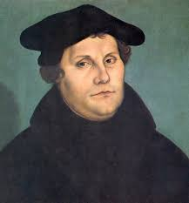 **Martin Luther**

* Martin Luther was born on 1oth November, 1483 to John Luther and Margaret in the Province of Saxony in Germany**.**
* He was graduated as a Doctor in Theology in 1512 when he went to Rome.
* Martin Luther is said to the reformer in Germany.
* While in Rome, Martin Luther was upset by the evil behavior and lack of spirituality among priests. He became critical of the sale of indulgencies.
* In 1517, Pope Leo X sent John Tetzel, a Dominican Friar 9Monk) to sell indulgencies in Germany.

**LUTHER’S ACTIONS TOWARDS THE MALPRACTICEES OF THE CLERGY**

* On 31st October, 1517, **Martin Luther** wrote against and nailed the **95 theses** on the door of the **Wittenberg Cathedral** explaining why indulgences were a bad practice.

**Pope Leo X**

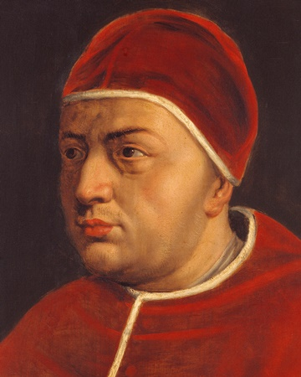 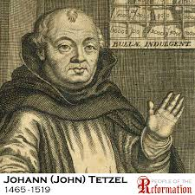

* Martin Luther nailed the **95 These** on the door of the Wittenbeg Cathedral in 1517 because he was against the **sale of Indulgences** in Germany which he said were bad practices.
* Martin Luther also challenged the Catholic Church to reform from its malpractices that were not biblically instituted.
* **Examples of the arguments in the 95 theses**

1. The church hierarchy should be dissolved are achieved as all believers are priests by virtue of baptism. The Pope is not the head of the church but Jesus Christ.
2. Man’s righteousness and justification are achieved through faith and grace.
3. The Pope has no power to forgive sins but God alone.
4. There are only two sacraments that are Biblical instituted namely: baptism and the Holy Communion.
5. Baptism has no powers to remit sins.
6. There is no bodily presence of Jesus in the Eucharist.
7. The Holy Roman Mass is not a sacrifice but a memorial of the **Last supper**.
8. Priests should marry to avoid immorality.
9. Monasticism should end as it led to corrupt practices of the Clergy and enabled them to accumulate riches and power during the medieval period.

* Apart them the 95 theses, in 1520AD, Martin Luther also wrote three books namely

1. To the Christian Nobility of the Germany Nation
2. On the Babylonian Captivity of the Church
3. About the Freedoms of Christians

**THE CATHOLIC CHURCH’S IMMEDIATE RESPONSE TOWARDS MARTIN LUTHER’S PROTESTS**

**The Church took a stiff stand against Martin Luther**

1. **A letter of condemnation from the Pope Leo x to Martin Luther**

The Pope Leo X issued a Papal bull (Letter) to Martin Luther describing him as someone who bent on bringing confusion in the church.

The Poe condemned Martin Luther’s writings and deeds. He declared that Luther’s writings were heretical (false teachings). Luther burnt the papal bull publically to show that he was firm on his stand of correcting the church.

1. **Martin Luther’s trial by the Church and the state**

The Catholic Church tried Martin Luther who was condemned as a heretic by Cardinal Cajetan in 1520. Martin Luther refused to retract his teachings unless he was to be Biblical proven wrong.

In 1521AD, the Holy Roman Emperor **Charles V** summoned Martin Luther to appear before the **Diet of Worms Council (the German General Assembly) in** the city of Worms to answer his charges. At the Diet of Worms, Martin Luther refused to retract his words and he said**, “**I neither can nor retract anything; for it cannot be either safe or honest for a Christian to speak against his conscience. Here I stand; I cannot do otherwise; Gold help me! Amen”.

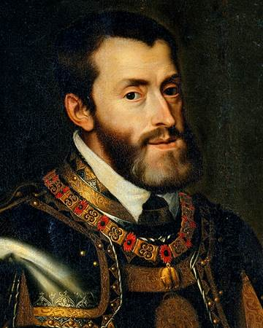 **Emperor Charles V**

1. **The ex-communication of Martin Luther in 1521.**

At the Diet of Worms, the Catholic Church brought charges against Martin Luther. The Catholic Church ex-communicated Martin Luther from the church.

But Fredrick the Wise (The Prince of Saxony) protected him and hid him in the Castle of Wartburg where Martin Luther changed his name to Jorg to disguise himself from his enemies.

**LUTHER’S REACTION TO THE EX-COMMUNICATION**

**How did Martin Luther react to the charges that were brought forth to him by the Diet of Worms?**

Though Luther’s actions were disapproved by the Church, this did not make him change his mind and he continued with his work.

1. He translated the Bible and religious scripts into German to sell out his ideas to lay people.
2. He bitterly criticized the Catholic Church in order to let it reform its malpractices.
3. He established the Lutheran Church since the Roman Catholic Church condemned him. It started in Saxony and it further spread to Denmark, Sweden and Norway.
4. He became a married person, a sign of detaching himself from the Catholic Church and priesthood. His wife was Catherine von Bora.

**THE SPREAD OF THE REFORMATION TO OTHER PARTS OF EUROPE**

1. **IN SWITZERLAND BY HULDRYCH ZWINGLI (1484-1531)**

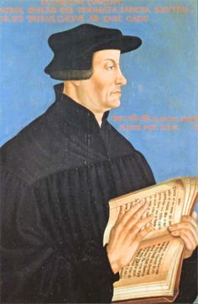

* He is said to be the reformer in Switzerland.
* He was born on 1st January, 1484 in Switzerland.
* He was inspired by Desiderius Erasmus, a Biblical humanist to judge culture and faith in line with the Bible.
* He was ordained as a Catholic Priest in Rome at Glarus.
* He was transferred to Einsiedein and Zurich in Switzerland.
* In 1529, Zwingri and Martin Luther met at Marburg under the infuence of Bucer to promote the reformation in Europe.
* He became a reformer in Switzerland after he was disappointed by **the sale of the indulgencies b**y a monk, **Samson,** in Switzerland and the **worship of Mary as a link between Christ and believers.**
* **The main arguments of Zwingri include the following**

1. A person is justified by faith alone
2. The Bible has a supreme authority not the church.
3. No bodily presence of Jesus in the bread and wine at the Lor’s Supper.
4. Jesus is Holy and his holiness sanctifies believers (no private confessions to a priest).
5. Infant baptism was rejected. Since he opposed infant baptism, his followers were called **Anabaptists**.
6. **IN FRANCE BY JOHN CALVIN**

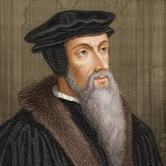 John Calvin

* He was born in July, 1509 in France
* He studied law in 1532 in 1532 in Orleans and Bourges.
* He was influenced by Martin Luther and Zwingri and he was converted in 1533AD.
* In 1533AG, Nicolas Cop, the Rector of Sorbonne University influenced King Francis 1 to persecute all Lutherans as a move of ending reformation in France.
* John Calvin being afraid of being arrested or killed he left for Geneva where in 1536, he started to promote protestantism after printing his book titled the **Institutes of the Christian Religion.**
* **His argument against the Catholic Church included**

1. He stressed that the Bible is the only source of truth just as Luther and Zwingri.
2. He believed in the predestination (God had already elected people who could be saved in heaven and those who would go to hell)
3. No bodily pleasures should be allowed to attain purity.
4. A person is justified by faith and grace.
5. The church should not be subordinate to the state.
6. The church hierarchy was to be abolished and both priests and Christians should be represented by a Council of Church.

* He established a **University at Geneva** and his church he founded was called the **Calvinist Church**.
* The Calvinist Church spread from **Geneva in Switzerland** to **France, Netherlands, Scotland and England.**
* In France, the Calvinists were called the **Huguenots;** **Presbyterians** in Scotland, the **Dutch Reformed** in Netherlands and the the **Puritans** in England

1. **IN SCOTLAND BY JOHN KNOX**

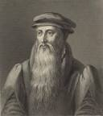

* He is said to be the **Scottish Reformer** who founded the Presbyterian Church in Scotland.
* He attained his education at Glasgow University and taught and preached at St Andrews in Scotland.
* John Knox had studied under Calvin in Geneva and became influenced by the religious doctrines of Calvinism.
* Although **Mary Stuart**, the widow of King James was determined in helping the papacy in the fight against Protestants, John Knox preached boldly and established the **Presbyterian Church in Scotland.**
* By the time of the death of Mary Stuart in 1560 Presbyterian was officially established as a religion of Scotland.
* His arguments included the following:

1. Christ and not a human being, is the head of the church.
2. All believers are priests by virtue of Baptism; they are therefore to be entrusted with the church administration.
3. The celeb ration of the mass is idolatry as believers kneel before the Eucharist
4. The Bishops b had an oppressive authority over believers
5. Believers should maintain the purity of the body and soul.

**CONTRIBUTIONS OF JOHN KNOX**

1. He founded the Presbyterian Church in Scotland in 1560AD.
2. He wrote the **Book of Common Order** **(the Book of Geneva)** which acted as a Presbyterian Order for church life.
3. He also wrote the **Book of Discipline** to regulate the life of church members and the preaching itself.
4. He established the **Glasgow University** for the training of the Reformed ministers.
5. **IN ENGLAND BY KING HENRY V111**

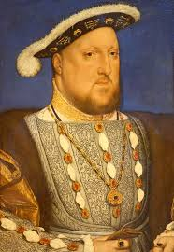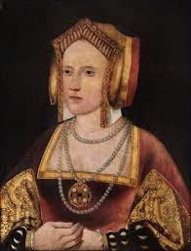

**King Henry VIII Catherine**

* The Church in England was formed on a divorce question when King Henry VIII was in power between 1509 and 1547.
* King Henry VIII succeeded his brother in 1503AD.
* King Henry VIII defended the Pope when Martin Luther had attacked the church. The Pope, therefore, called King Henry VIII the **Defender of Faith.**
* However, a dispute arose between Henry VIII and the Catholic Church when he wanted to divorce his wife, **Catherine of Aragon**, who bore him daughters only. He wanted to marry Anne Boleyn with a hope of having male children with her as future heirs to the throne.
* The Pope**, Clement VIII**, refused to nullify the first marriage because he was put in a difficult position: **Charles V, head of the Holy Roman Empire, was a nephew of Catherine,** the wife of Henry VIII.
* King Henry VIII therefore broke away from the Catholic Church because the Pope refused to nullify his marriage with Catherine of Aragon.

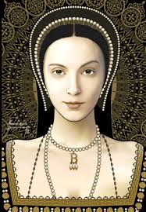**Anne Boleyn**

* He married **Anne Boleyn** after divorcing Catherine and appointed the **Archbishop of Canterbury** to be the head of the church in England.

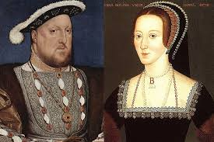

King Henry III with Anne Boleyn

* In 1533, the Parliament supported King Henry VIII and he printed English Bibles to let believers understand the Word of God. He ended the monasteries and most of the monastic land was sold to nobles and merchants which resulted into creation of a new class of landowners.
* Therefore, King Henry VIII is said to be the reformer in England.
* In 1562, **Queen Elizabeth 1** renamed the Church of England to be known as **Anglican Church**.

**Why did the Pope call King Henry VIII of England the “Defender of faith?”**

King Henry VIII defended the Pope when Martin Luther had attacked the church.

**REASONS FOR THE SUCCESS OF THE FORMATION**

The Reformation was successful in Europe despite the persecutions among the reformers because

1. The worldliness of the clergy had upset many people who pressed for a general reform within the Catholic Church.
2. Powerful kings in Europe looked upon religious rebellion as a means of increasing their own political power since for a long time they had been dominated by the church.
3. Many faithful Christians believed Christianity to be less formal than being more personal in terms of the church hierarchy that oppressed them with church rules.
4. The translation of the Bible into different languages enabled Christians to judge for themselves the falsity of some church practices that were not Biblically supported.
5. The invention of the printing press led to mass production of Bible and Christian literature that helped in the spread of ideas of reformation throughout Europe.
6. New learning (humanism) weakened the traditional sentiment of reverence by which many of the beliefs, traditions and customs of the Roman Catholic Church had long been supported.

**DESCRIBE THE IMPACT OF THE REFORMATION ON THE CATHOLIC CHURCH AND PEOPLE AT LARGE.**

The main effect of the reformation led by protestant leaders on the Catholic Church was the **Counter-reformation movement** within the church.

The counter-reformation was an attempt by the Catholic Church to defend itself from the reformers by doing away with some of its practices that had led to reformation.

**Define the term “counter-reformation”.**

The counter-reformation was an attempt by the Catholic Church to defend itself from the reformers by doing away with some of its practices that had led to reformation.

**WHY DID CATHOLIC CHURCH STAGE THE COUNTER-REFORMATION BETWEEN 1545 AND 1563?**

1. To remove abuses that were smeared on the Catholic Church by Protestants.
2. To stop the spread of Protestantism.
3. To win back Christians into the Catholic Church.

**THE COUNCIL OF TRENT (1545-1563)**

The Catholic Church responded to the protestant reformation by inviting the leading priests and scholars to a general meeting at **Trent** on the boarders of Italy and Austria.

The **Council of Trent** which was called by **Pope Paul III**

**WHICH TERMS WERE DISCUSSED DURING THE COUNCIL OF TRENT?**

1. Strict rules for the work and conduct of priests.
2. **Priests were to be highly learned and trained.**
3. The Pope’s authority was increased so that he had a final say on matters pertaining to faith and morals. No one was allowed to question the church because it cannot error as it is guided by the Holy Spirit. If Rome speaks therefore, no one has to question **“Roma locuta causa finite”**
4. Clarifications were made on the church beliefs and doctrines against the protestants e.g. on the mass, sacraments etc.
5. The authority of the tradition of the church besides the scripture was clarified and verified.
6. The mass is a sacrifice and Jesus is bodily present in the Eucharist. It is a firm Catholic belief that priests do invoke the Holy Spirit at the Mass to change the bread and the wine into the body and blood of Jesus Christ.
7. New religious orders developed in the church, for example, **the Jesuit Society of Jesus.**

**The Jesuit Society of Jesus (Order of Jesus) was founded by Ignatius Loyola (1491-1596)**

1. Many Jesuit missionaries worked secretly in predominantly protestant countries like Germany; France and England to dilute Protestantism. Others went to the new world (America, Africa and the East).
2. Abuses such as sale of indulgencies of high church posts were ended.
3. Catholics were forbidden to read protestant books.
4. The Inquisition, which was a special court from the Middle Ages, was brought back. It was responsible to remove false teachings.

**WHY WAS COUNTER-REFORMATION SUCCESSFUL?**

1. The Jesuits worked tirelessly in winning back Christians through preaching and education.
2. By putting into practice the terms of the Council of Trent, for example, no tolerance to Protestantism.
3. Divisions among protestant reformers paved way for Catholicism to spread out rapidly.

**IMPACTS (EFFCTS/RESULTS) OF THE REFORMATION**

1. The unity of the Christian church was broken and many different Christian denominations emerged as Presbyterians, Lutherans and Anglicans.
2. Different Christian denominations brought in different doctrines that brought in divisions and hatred among people of the same nation, race or family.
3. It led to a series of civil wars in Europe and the creation of independent protestant countries like Holland.
4. The significance of Latin as an angelic language during religious services declined as people began to worship in their own vernacular languages.
5. The church changed some of its malpractices and false teachings.
6. The Church influence over states decline as people were more liberal to criticize it and heads of states declined the papal authority.
7. People had no freedom of worship as we see today as the battle of denominations forced them to join a church by birth or race.
8. People’s faith and sincerity were deepened because printed matter was easy for them and understand the church doctrines.

**CHAPTER EIGHT: THE INDUSTRIAL REVOLUTION**

**DEFINE THE TERM “INDUSTRIAL REVOLUTION”**

* Industrial revolution is a period of change in the development of human societies when the domestic system of production changed to a factory system of production after the invention of power driven machines.
* The Industrial Revolution started in **England** by 1750AD.

**WHY THE INDUSTRIAL REVOLUTION STARTED IN ENGLAND?**

Industrial Revolution started in England because of the following reasons:

1. **A good geographical location**

* As an Island, England enjoyed cheap transport to import goods from abroad.
* It was also well secured with natural protection of the water body.

1. **It was a rich nation**

* England had rich merchants who utilized their available resources in purchasing expensive machinery that boosted up the Industrial Revolution.

1. **Trade**

* Trade with other countries like Netherlands and North American colonies made England to produce a lot of goods. The wealth accumulated from trade made England to be **Super Power**.

1. **Rich natural resources**

* England had a lot of natural resources like coal which was used as fuel and iron ores for the production of the machines that were used in industries.

1. **New scientific ideas**

* The discoveries such as heavy machines allowed people to manufacture goods through mass production.

1. **Prosperity and increased population**

* Population explosion provided England with a good labour reservoir in industries and fields that facilitated a swift development of England.
* The population explosion also led to the growing demand for goods and services with the increased population.

1. **An effective political administration**

* There were no struggles for political power that created a peaceful environment among people to devote themselves wholeheartedly towards the development of their nation.
* Peace enabled people to move freely in search of employment opportunities.

**How did England’s geographical location assist her to take a lead in the Industrial Revolution?**

* As an Island, England enjoyed cheap transport to import goods from abroad.
* It was also well secured with natural protection of the water body.

**CHANGES IN THE TEXTILE INDUSTRY**

1. **JOHN KAY**

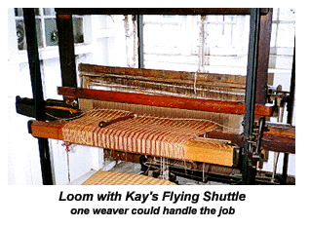 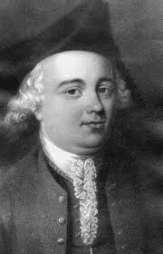

* **John Kay** invented **Flying Shuttle** in 1733.
* Flying Shuttle was a piece of wood that was attached to a weft of thread when weaving cloths manually.
* It was operated by pulling strings at the end.
* The new machine saved the weaver from passing the shuttle from hand to hand. This could make more length of cloth could be weaved within a short period.

1. **JAMES HARGREAVES**

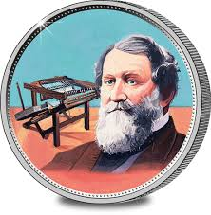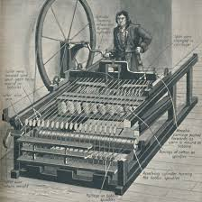

* **James Hargreaves** invented the “**Spinning Jenny”** in 1764.
* Spinning Jenny was the first machine that was used to make cloths after spinning and weaving sixteen threads at once.
* It was time consuming
* Its setback is that the thread produced was coarse and lacked strength.

1. **RICHARD ARKWRIGHT**

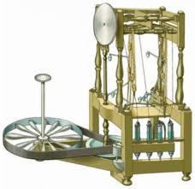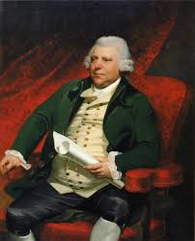

* Richard Arkwright invented the “Water Frame” in 1769.
* The Water Frame was a weaving machine that used water power to spin.
* Coarse and strong thread was made by spinning the cotton threads in pairs.

1. **SAMUEL CROMPTON AND MULE**

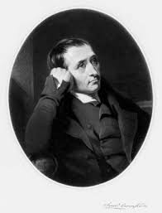 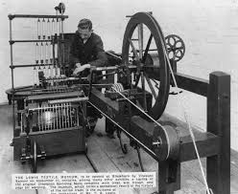

* Samuel Crompton invented the “Mule” in 1779 after combining the “Spinning Jenny” and the “Water Frame”.

**RESULTS OF MECHANISATION IN THE TEXTILE UINDUSTRY**

1. Abundant cheap goods were produced to support the increasing population.
2. Mechanization in the Textile Industry led to the growth of factories that replaced the production of goods by hand. This was made possible because of the use of power on machines.
3. The birth of industries forced people to migrate to urban areas as a move to look for employment opportunities.
4. It boosted trade among people and states due to the availability of the abundant industrial products.

**INVENTIONS IN THE AGRICULTURAL SECTOR**

1. **JETHRO TULL AND THE SEED DRILL**

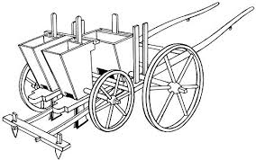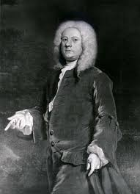

* Jethro Tull invented Seed Drill.
* He was of Berkshire in England.
* Seed Drill replaced the system of sowing seeds through the broadcasting method. It comprised rotating drills or runners that would plant seeds at a et depth.
* The machine was pulled by horses.
* The figure below shows the seed drill pulled by the horse.

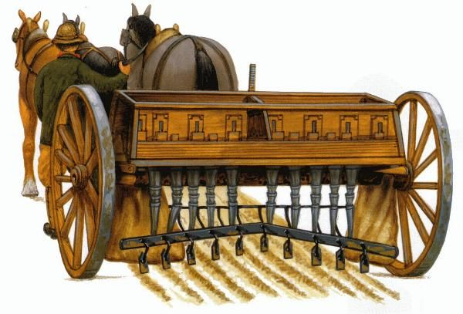

1. **LORD TOWNSHEND AND THE FOUR-YEAR CROP ROTATION**

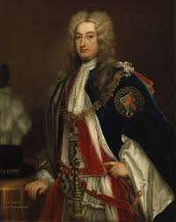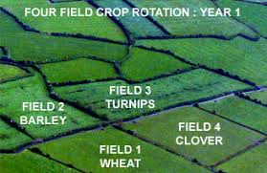

* Lord Townshend introduced the Four-Year Rotation.
* He demarcated his land into four portions where he planted wheat, clove, barley and turnips.
* He was nicknamed “Turnip Townshend” because he was the first person to introduce turnips as a vegetable to supplement people’s diet.

1. **THOMAS COKE**

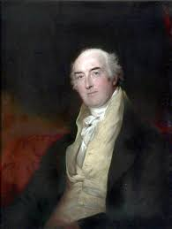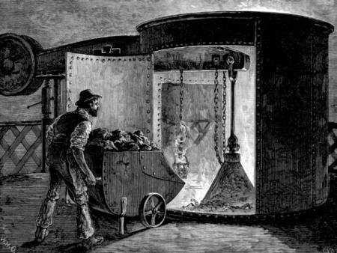

* **Thomas Coke** mixed sandy soil with **marl (clay soil)** to enrich the fertility of the land.

1. **ROBERT BAKEWELL**

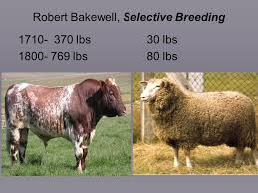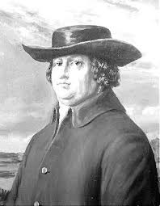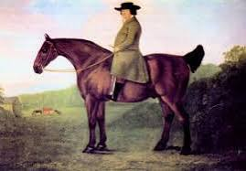

* Robert Bakewell selected healthy animals that were cross bred for the production of giant off springs that were resistant to diseases.

**RESULTS OF AGRICULTURE REVOLUTION**

1. The new farming practices led to the abundant production of cheap food.
2. The fallowing and crop rotation practices reduced pests, diseases and soil erosion.
3. The new system of breeding cattle and sheep led to the availability of cheap meat and milk in all seasons.
4. The rich began to lease and fence their land.
5. The poor lost their land to the rich when they failed to lease it.
6. The poor began to migrate in order to be employed in farms and industries.

**THE CHANGES THAT TOOK PLACE IN THE ROAD TRANSPORT DURING THE INDUSTRIAL REVOLUTION**

* The constructions of good roads, canals and the introduction of locomotives that ferried people and evenly distributed the industrial products.
* The constructions of good roads, canals and the introduction of locomotives were followed by developments of fast means of communication.

**INVENTIONS IN THE INVENTION OF THE TRANSPORT SECTOR**

1. **James Watt and The Steam Engine (1769)**

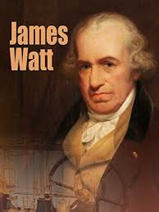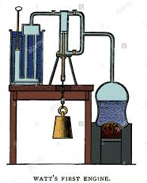

**James Watt**

* James Watt invented **Steam Engine**
* Steam Engine previously used coal to boil water that in turn produced steam that set the gears in the machine in motion.
* James Watt invented it in orderto replace the use of water force in spinning machines.

1. **Richard Trevithick and Locomotives**

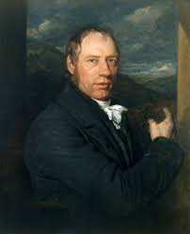 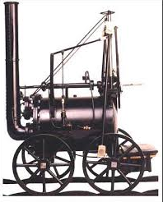

* In 1801 **Richard Trevithick f**ixed James **Watt’s Steam Engine** **on a frame fixed wheels a**s shown by the diagram above.
* The Steam engine now could drive the wheels or the machine now called the **Locomotive. It operated on roads.**

1. **William Symington and Locomotive**

* In 1804, William Symington fixed the Steam Engine on boats to operate in water ways.

1. **George Stephenson and The Rocket**

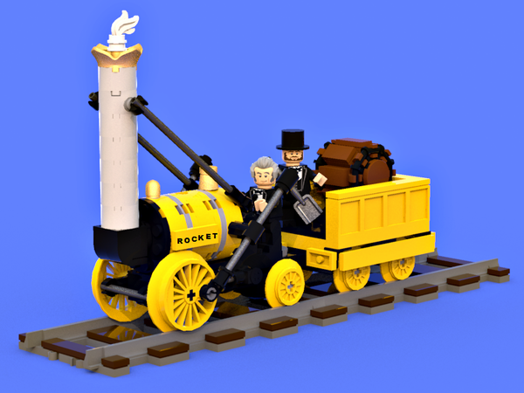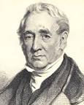 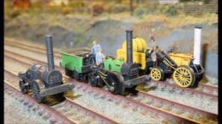

* George Stevenson introduced a locomotive called the **Rocket.**
* The Rocket operated on rails between Liverpool and Manchester cities.
* His contribution marked the beginning of a national rail transport in England.

1. **John Blind Metcalf**

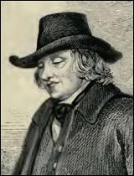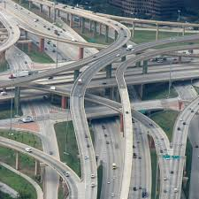

* He is the first person to plan a good road network that joined Yorkshire and Lancashire.

1. **John Macadam and Tarmac Roads**

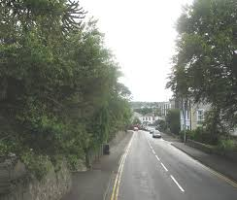

* He is the first person to make tarmac roads in England during the 20th Century.
* He made tarmac roads by applying tar on the fine stone surfaces of the roads.
* His roads were named in his honour and were called **tar-macadamized** roads or the **tarmac roads**.

1. **Thomas Telford**

* He constructed good roads that joined Scotland and England.

1. **JAMES BLINDLEY AND CANALS (1759-1761)**

* Canals were constructed in order to accommodate the transportation of heavy goods like coal and iron from mines to factories.
* Duke of Bridgewater was the first person to construct the canal in England.
* James Bindley was the first engineer who constructed canals that link cities of Manchester, Liverpool, Lancashire, Birmingham, Hull, London and Bristol.
* In 1869, Suez Canal was built linking Africa, Asia and Europe through Egypt. It is 160 km long.

1. **Samuel Morse and Electric Telegraph**

* Samuel Morse invented Electric Telegraph in 1844.
* He linked the cities of Baltimore and Washington with Electric Telegraph in the USA
* By 1866, he managed to connect Britain and America through a Trans-Atlantic cable.

1. **Alexander Bell and Telephone**

* He invented Telephone in 1876.

1. **Guglielmo and Radio**

* He was an Italian who invented Radio in 1896.

1. **Orville and Wilbur Wright**

* There were the two American brothers who made the first aeroplane in 1908**.**

**RESULTS OF CHANGES IN TRANSPORT AND COMMUNICATION**

1. The invention of the Steam Engines and Locomotives led to the even distribution of goods and resources among people.
2. It enabled the transportation of heavy goods of which people could not manage to pull or push to distant places.
3. Promoted trade between Europe and other continents.
4. It led to a high demand for iron and steel for the building of rails, engines and stations.
5. It lessened the distance and communication barrier among people and nations.
6. It intensified employment among people in industries, ships, trains and mines.

**MAJOR CHANGES THAT TOOK PLACE IN THE IRON AND STEEL SMELTING PROCESSES AND THEIR IMPACT ON PEOPLE’S WAY OF LIFE**

1. **ABRAHAM DARBY AND SMELTING IRON USING COAL AND COKE**

* Abraham Darby introduced a new method of smelting using iron and coke in 1735.
* This method of smelting of iron using iron and coke reduced deforestation and led to the production of high quality iron.

1. **HENRY BESSEMER AND THE BLAST FURNACE**

* Henry Bessemer introduced the **Blast Furnace**.
* Blast Furnace was a device that smelted pig iron into steel after blowing very hot air into the furnace.
* The smelted steel was used in building engines and railway lines.

**RESULTS OF CHANGES IN IRON AND STEEL INDUSTRIES**

The production of quality iron and steel brought in the following results

1. Strong locomotives, bridges and industrial machines were made.
2. It led to the employment of people in industries.
3. Construction of high-rise buildings, the skyscrapers as steel proved to be much stronger as compared to iron.

**RESULTS OF INDUSTRIAL REVOLUTION**

**Positive effects**

* Transport and communication became easier with good roads, railways, canals and vehicles.
* The establishment of industries and the building of fine houses led to urbanization.
* People were easily employed in farms and industries.
* Mass production of goods by machines slashed down the prices of goods.
* Literacy was highly improved and promoted as schools were built closer to workplaces.
* Fallowing and crop rotation practices in agricultural practices reduced soil erosion, pests and diseases.
* Trade was intensified among continents e.g. Europe, Africa, Asia and America.
* It led to tight security among nations as soldiers safeguarded goods and passengers from pirates and robbers.
* Skills were swiftly spread among people due to trade and improved communication systems.
* Trade unions were formed to defend the rights of workers and abolished child labour.
* It led to the birth of a new class known as the ‘middle class”.

**Negative effects**

1. The fast growth of industries led to deforestation as more charcoal as well as trees for fuel and furniture making and building.
2. Urbanization attracted people to seek employment in towns led overcrowding in their locations and places of work.
3. Migration of people from rural to urban areas led to overpopulation which depleted resources such as water, sewers and houses etc.
4. Working conditions were bad in industries
5. Overcrowding and congestion led to outbreaks of epidemics such as cholera, typhoid and diphtheria.
6. It led to moral degradation due to effects of technological development and the interaction of people with different cultural backgrounds.
7. Riches led to the birth of a middle class of people that exploited the poor.
8. Development of technologies led to unemployment as single machine could do the work of a group of people.
9. It led to environmental pollution especially in industries centres.
10. It led to partition of Africa among the European states who wanted to acquire industrial raw materials in the colonized lands.

**CHAPTER NINE-VOYAGES OF EXPLORATION/DISCOVERY**

**WHY DID EUROPEAN EXPLORATION BEGIN TO FLOURISH IN THE 1400S?**

* **To find new trade routes to Asia.** By the 1400s, merchants and Crusaders had brought many goods to Europe from Africa, the Middle East, and Asia. Demand for these goods increased the desire for trade.
* **Europeans were especially interested in spices from Asia.** They had learned to use spices to help preserve food during winter and to cover up the taste of food that was no longer fresh.
* **Trade with the East, however, was difficult and very expensive.** Muslims and Italians controlled the flow of goods. Muslim traders carried goods to the east coast of the Mediterranean Sea. Italian merchants then brought the goods into Europe. Problems arose when Muslim rulers sometimes closed the trade routes from Asia to Europe. Also, the goods went through many hands, and each trading party raised the price.

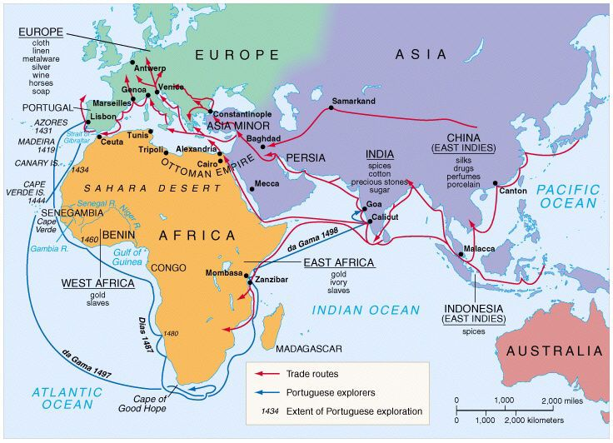

* **European monarchs and merchants wanted to break the hold that Muslims and Italians had on trade.** One way to do so was to find a sea route to Asia. Portuguese sailors looked for a route thatwent around Africa. Christopher Columbus tried to reach Asia by sailing west across the Atlantic.
* **Many people were excited by the opportunity for new knowledge. Explorers saw the chance to earn fame and glory, as well as wealth.** As new landswere discovered, nations wanted to claim the lands’ riches for themselves.
* **The desire to spread Christianity beyond Europe.** Both Protestant and Catholic nations were eager to make new converts. Missionaries of both faiths followed the paths blazed by explorers.
* **Advances in Knowledge and Technology. There were new scientific discoveries like telescope, magnetic campus, fine ships and maps that made it easier for explorers to venture into the unknown.**
* **An improved ship design also helped explorers.** By the 1400s, Portuguese and Spanish shipbuilders were making a new type of ship called a caravel. These ships were small, fast, and easy to maneuver. Their special bottoms made it easier for explorers to travel along coastlines where the water was not deep. Caravels also used lateen sails, a triangular style adapted from Muslim ships. These sails could be positioned to take advantage of the wind no matter which way it blew.
* **Along with better ships, new navigational tools helped sailors travel more safely on the open seas.** By the end of the 1400s, the compass was much improved. Sailors used compasses to find their bearing, or direction of travel. The astrolabe helped sailors determine their distance north or south from the equator.
* **Finally, improved weapons gave Europeans a huge advantage over the people they met in their explorations.** Sailors could fire their cannons at targets near the shore without leaving their ships. On land, the weapons of native peoples often were no match for European guns, armor, and horses.

**THE PORTUGUESDE VOYAGES OF EXPLORATION**

* Portugal was the first European country to start the voyages of exploration.
* It was promoted by Prince Henry the Navigator
* The Portuguese were the first Europeans to make an attempt in finding a sea route to India by sailing along the West Coast of Africa in the Atlantic Ocean,

**WHY PORTUGAL LED IN VOYAGES OF EXPLORATION BY 15TH CENTURY AD**

1. **Portugal had good geographical position**. Being close to the Atlantic Ocean and the Mediterranean Sea exposed them to navigation. Besides being close to Africa assured them of finding a sea route to India.
2. **The Portuguese ship builders made strong ships which could sail in deep waters**. Their ships known as **Caravels** resisted strong winds of the oceans.

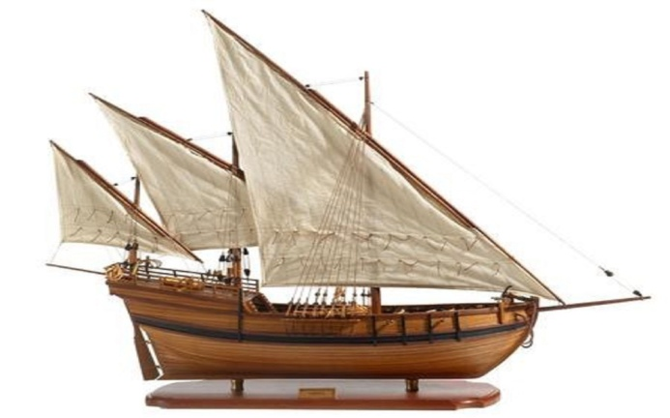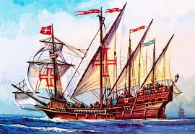

Caravels

1. **There was peace in Portugal** that enabled it to carry out its activities effectively unlike Spain which was fighting against the Muslim Turks. France and England too were involved in the Hundred Years war that blocked them from participating in the exploration.
2. Portuguese **explorers had the support from Prince Henry the Navigator**, the son of King John 1 of Portugal who financed the sailors and trained them for the navigation.

**PRINCE HENRY THE NAVIGATOR**

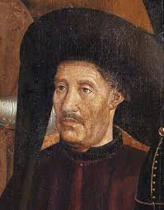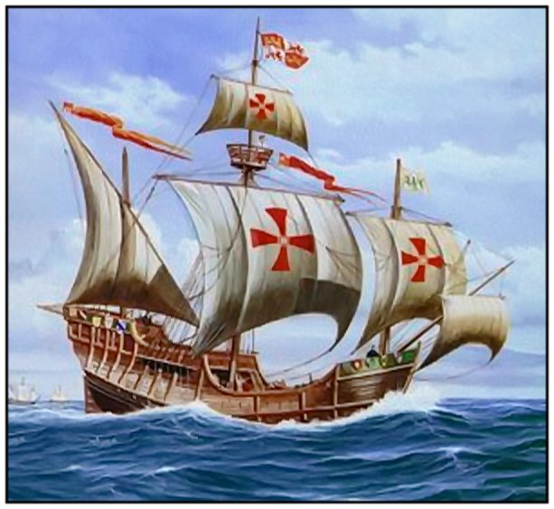

**WHY DID PRINCE HENRY THE NAVIGATOR START THE VOYAGES OF EXPLORATION?**

1. To develop trade with other countries in order to enable Portugal accumulate riches than before.
2. To discover new lands and satisfy his curiosity about the world whether it was round or has a bottomless edge.
3. To spread Christianity by getting rid of pagan religions and Islam.
4. To gain more lands for Portugal that could provide her with the industrial raw trade materials.
5. To find a sea route to India because it was difficult to travel by land in Eastern Europe after the Muslims had conquered Constantinople and part of Europe.

**HOW DID PRINCE HENRY THE NAVIGATOR PROMOTE THE NAVIGATION IN PORTUGAL?**

* He established a school of navigation at Sagress in Portugal where sailors were trained to use maps and campass when at sea, in preparation to sail around the world.
* He spent much of his wealth and time in planning for the voyages, for example, ship building, employed cartographers who drew beautiful coloured maps for all known coastal lines.
* He collected information, maps, charts, mariner’s compass, the quadrant 9an instrument that is used to measure the angle of stars at night) as a preparation for the voyages.
* He funded and commissioned his men to find a sea route to India.

**PRINCE HENRY THE NAVIGATOR’S EXPLORATION**

* The Portuguese made their first attempt in finding a sea route to India by sailing along the West Coast of Africa.
* In 1415, the Portuguese defeated the Moslems in Morocco when they captured Ceuta and the Canary Islands.
* In 434, they visited Cape Bojador 9the Swelling Cape) and the Rio de Ore where they obtained gold dust and slaves.
* They reached the Cape Verde (Green Cape0 in 1446.
* In 1460, Prince Henry the Navigator died before the sea route to had had been discovered.
* The Portuguese sailors continued with their exploration despite the death of Prince Henry. By 1471, they reached the Gulf of Guinea where they sailed up to Ogowe River. The map shows Prince Henry the Navigator’s route.

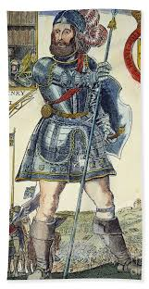 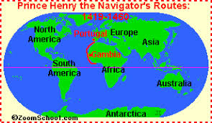

**WHICH PROBLEMS DID THE PORTUGUESE FACE IN THEIR ATTEMPTS TO FIND A SEA ROUTE TO INDIA?**

1. The absence of safe and accessible harbours in the West Coast of Africa.
2. Ocean currents delayed their voyages to India.
3. Untimely death of Prince Henry the Navigator who funded the sailors.
4. Storms that led to ship wrecks and deaths of sailors.

**DIEGO CAM (1482)**

* In 1482, Diego Cam, the Portuguese Captain reached Congo.
* He was the first explorer to cross the Equator and proved Ptolemy’s legend of the scorching sun heat to be untrue.
* Diego Cam left behind four Franciscan Monks to make allies with the Congo ruler as well as spread Christianity.
* **Portugal began to trade with Congo in gold, ivory and slaves.**

**DIEGO CAM**

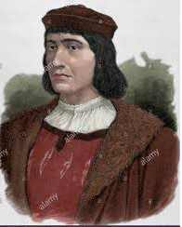

* On his way back to Lisbon, Diego took several Africans who were trained as interpreters and tour guides.

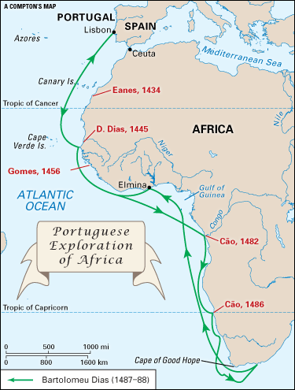

**BARTHOLOMEW DIAZ (1486-1487)**

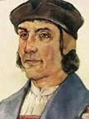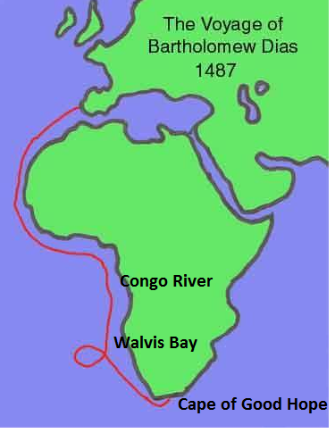

* He was the Portuguese explorer who left Lisbon in 1487 and sailed up straight to **River Congo.**
* With a pre-knowledge from previous sailors, he reached the **Walvis Bay** (Namibia) and **Cape of Storms** in South Africa.
* Due to strong storms, scarcity of fresh water and food, the sailors were forced to go back to Portugal.
* Upon arrival in Portugal, the Portuguese King John 11 renamed **Cape of Storms** to be **Cape of Good Hope** **because it gave them hope that one day they would reach India.**
* The voyage of Bartholomew Diaz marked the first attempt by a European to sail to the Southern tip of Africa.
* Therefore, Bartholomew Diaz was the first European explorer to reach the Southern tip of South Africa in 1488.

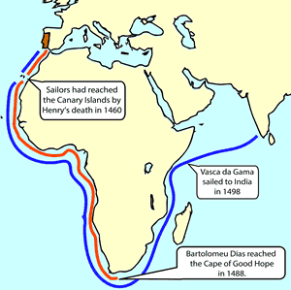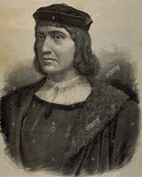

**WHAT STOPPED BARTHOLOMEW DIAZ’S VOYAGE AT THE CAPE OF GOOD HOPE IN 1487?**

There were strong storms, scarcity of fresh water and food that forced the sailors to go back to Portugal.

**VASCO DA GAMA**

* 1497 **Vasco da Gama** reached Calicut, India but he was badly surprised by the presence of Arab trade bases in eastern Africa and Arab controlled trade with India. Because of this the King of Portugal decided to send 13 ships and army to get the trade bases and trade under Portuguese control

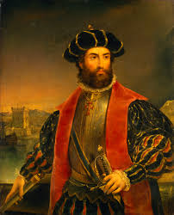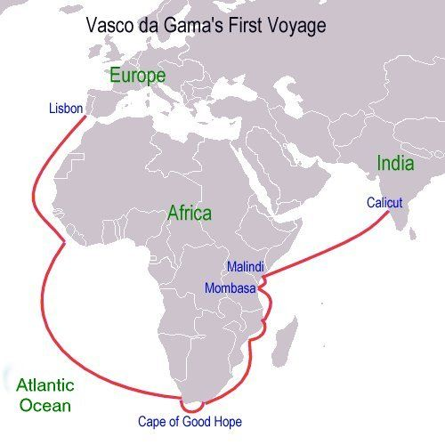 **PETER BRUEGHEL**

* He was the marine Portuguese explorer whose main objective was to finish the work of Bartholomew Diaz in finding a sea route to India.
* He left Lisbon on 8th July, 1497 with three ships, namely: **St Gabriel, St Raphael and Berrio.**
* He sailed through Atlantic Ocean for Ninety -Six days when he finally reached **St. Helena, Cape of Good Hope and the Mosel Bay on Christmas day of 1497**. He named the place **Natal**, a Portuguese word foe ‘birth’. This is still the name of the current South African Province of **Kwa Zulu-Natal**.

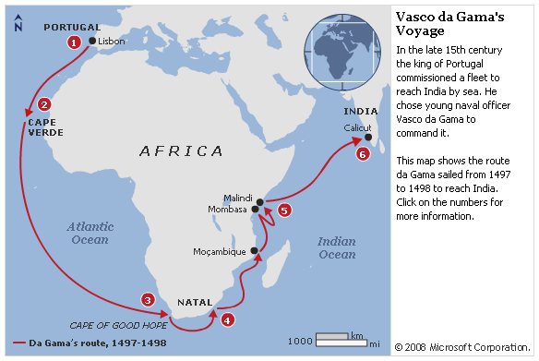

* In March, 1498, the sailors reached Mozambique where they were astonished with the riches of the city states due to trade with India. The trade items included **silk, porcelain and cotton.**
* The Portuguese were disappointed after realizing that the Arabs who controlled the area promoted Islam. This then made Vasco da Gama and his crew to leave Mozambique for Kilwa where an Arab pilot, **Ahmed bin Majid** led them out to **Calicut** in India on **20th May, 1498. The Monsoon winds gave them a swift sail to India.**

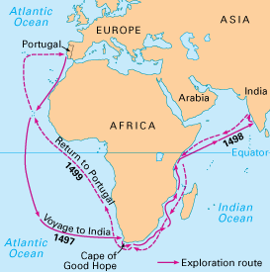

* The king of Calilcut titled **Zamorin** was a Hindu who gave the sailors a cordial welcome.
* While in India, Da Gama bout spices such as cinnamon, pepper, ginger and cloves which he sold back home in Portugal.
* He returned and reached back Portugal in 1499.
* Therefore, Vasco da Gama was the first European Explorer to sail across the Indian Ocean to the Far East in 1498.
* In other words, Vasco da Gama was the first Portuguese explorer to discover the sea route to India in 1498.

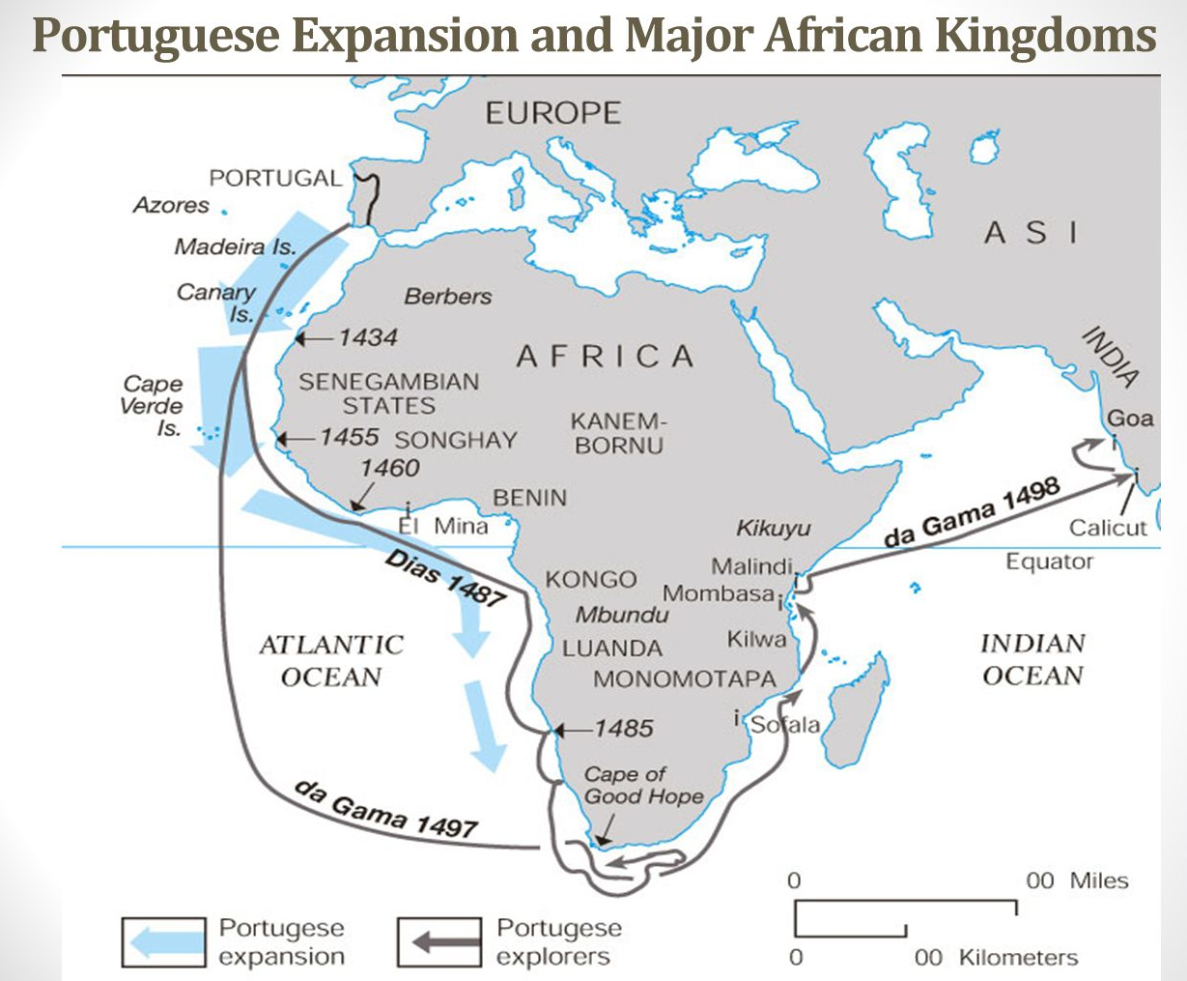

**PEDRO ALVARES CABRAL**

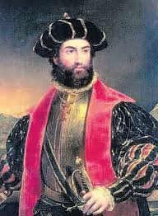

* He was a Portuguese sea captain who set off from Portugal to India in 1500AD but was brown off by the wind from the Cape of Good Hope to an undisclosed continent of South America (Brazil)
* In 1500AD Cabral conducted the first substantial exploration of the northeast coast of South America and claimed it for Portugal.

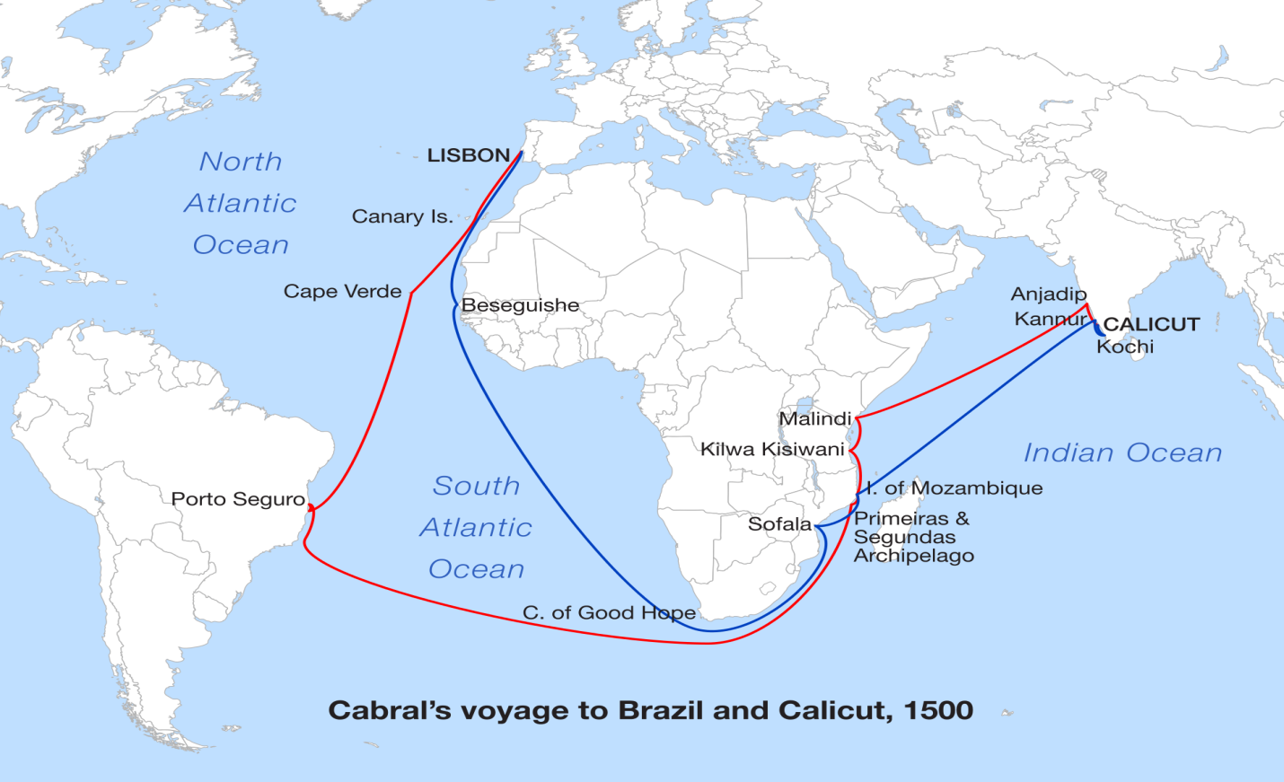

**RESULTS OF THE PORTUGUESE VOYAGES OF EXPLORATION**

The voyages made by the Portuguese had both the positive and negative results for Portugal and the areas they had visited.

**Positive results**

1. A sea route to India was discovered that created an alternative route since the land route was blocked in Eastern Europe by the Muslim Turks.
2. The Portuguese extended their trade with the East Coast of Africa, India and China by sea.
3. The accumulation of wealth by Portugal through trade which made it to become the one of most powerful states in Europe.
4. It led to the spread of Christianity in the East Coast of Africa.
5. It led to the settlement of the Portuguese in the interior of Africa as well as along the East Coast.
6. It led to the discovery of some unknown lands in Africa, Asia and South America.

**Negative results**

1. The Portuguese promoted slave trade in West and East Coasts of Africa.
2. They destroyed the Arab civilization in the East Coast (the Land of Zanj) after conquering the coastal states.
3. Exploited Africa and Asia of their resources such as gold, ivory, spices and slaves.
4. They promoted conflicts among the indigenous people that lead to hatred and tribal wars due to presence of guns they had paid in exchange for goods.

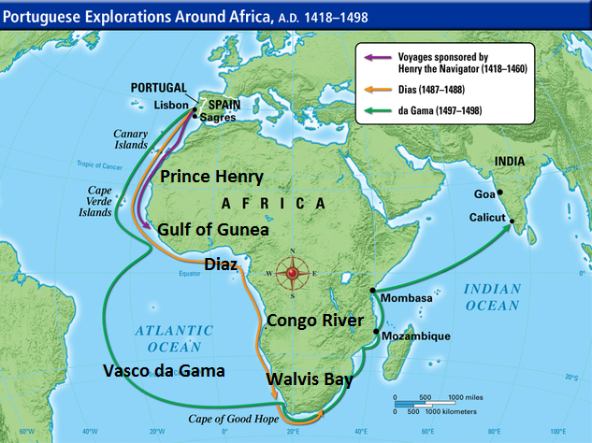

**THE SPANISH VOYAGES OF EXPLORATION**

* Spain was the second European country to carry out the voyages of exploration after Portugal.
* To avoid conflicts with the Portuguese, they intended to find a sea route to India via the West.

**CHRISTOPHER COLUMBUS**

** Christopher Columbus**

* He was born in Italy in the city of Genoa.
* He studied navigation in Portugal but the Portuguese refused to sponsor his voyage because of his plan of sailing westwards as a move to reach India. The idea to sail westwards came to him after he studied an Old Italian map which did not show any land mass between Europe and Asia.
* Christopher Columbus intended to sail westwards to avoid a long Journey around Africa. He therefore asked the Spanish Government for a sponsorship. The Spaniards delayed in giving him aid as they were at war with Moslems at Granada in Southern Spain.
* After realizing a need in finding a sea route of their own and avoid conflicts with Portugal, King Ferdinand and Queen Isabella of Spain assured Columbus of support in his voyages. They wanted to use him in establishing islands and main lands for Spain.
* **King Ferdinand V and Queen Isabella I** were the rulers of Spain at the time and finally agreed to finance Columbus' voyage because it could severely boost Spain's economy, bring in gold, jewels, spices and slaves. **Therefore Christopher Columbus was sent and financed by King Ferdinand V and Queen Isabella I** of Spain to go on voyages of discovery in 1492.

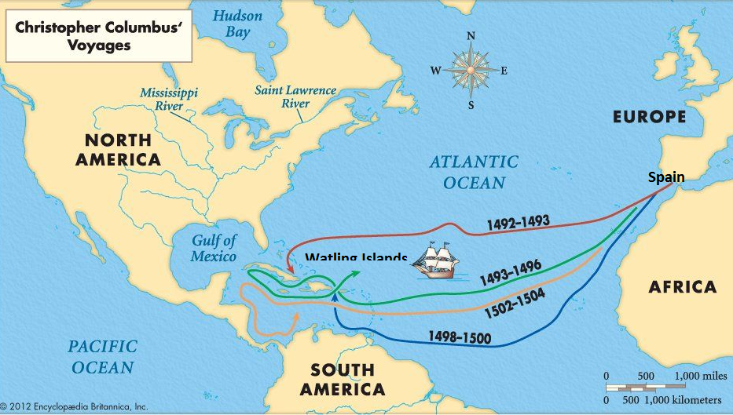

* Also, since all of the new land would be claimed for Spain and Columbus would discover the route (for Spain), the queen and king of Spain would have complete control of the trade route, making them even richer.

**FIRST JOURNEY OF CHISTOPHER COLUMBUS (1492-1493)**

* On 2nd August, 1492, Columbus and his ninety two men set out from Palos in Spain sailing westwards to reach India. Christopher Columbus began a journey across the ocean with three ships: **The Nina, Pinta and Santa Maria**
* He made for the Canary Islands and sailed for more than two months without sighting land. His crew threatened him with mutiny.
* On 12th October, 1492, the crew reached the San Salvador (the Watling Islands) in the Bahamas in South America. He sailed on and explored a number of other islands including Cuba and Haiti which he thought lay to the West of India. He called the Islands West Indies and its inhabitants were called Indians. Columbus named the people he encountered **Indians**, since he thought he was in the Indies.
* He went back to Spain in March, 1493.

**SECOND JOURNEY OF CHISTOPHER COLUMBUS (1492-1493)**

* The Spanish Government ordered Christopher Columbus to organize the second trip.
* He made his trip between 1493 and 1496

**THIRD JOURNEY OF CHISTOPHER COLUMBUS (1502-1504)**

* On his third voyage, he visited Trinidad, Antigua and Guadeloupe. In all his voyages, Columbus carried back items such as gold, copper and gold objects.
* Columbus thought he had reached the East Indies of Asia, and began a rapid search for the gold Marco Polo had described.
* Columbus' voyages across the Atlantic Ocean began a European effort at **exploration** and **colonization** of the American continent. While history places great significance on his first voyage of 1492, he did not actually reach the mainland until his third voyage in 1498.
* He died in 1506 with a belief that the place he had explored was close to India.
* He did not know that he had discovered a new continent of America.

**AMERIGO VESPUCHI**

* He was an Italian mechant from Florence (Italy).
* He claimed that he reached the North American mainland before any other explorer during his voyage between 1497 and 1498.
* He explored Central America in 1499,
* By 1500 with the help of a Spanish Soldier Alonso de Ojeda, he had explored parts of South America. His name was given to the land in his honour hence the name of America.
* The map below shows the routes followed by Amerigo Vespucci.

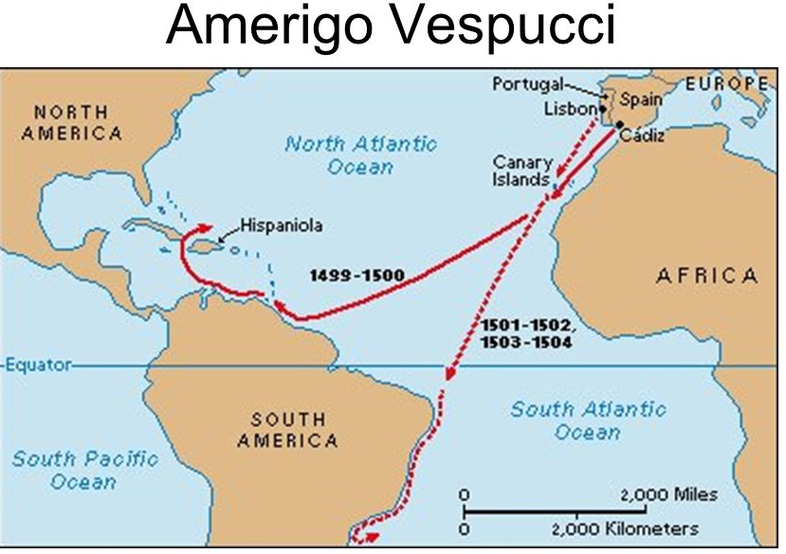

* The initiative to call the new world America was made by the German geographer and cartographer Martin Waldseeuller. With certain, he mentioned that Amerigo was the first European explorer to point out that America was a new continent.

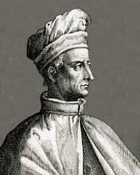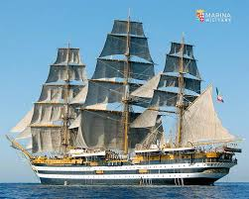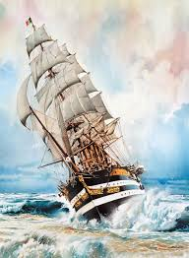

**VASCO DE BALBOA**

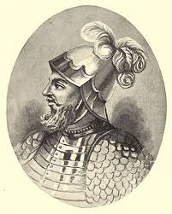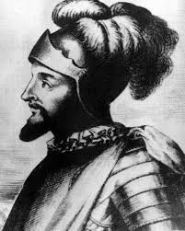

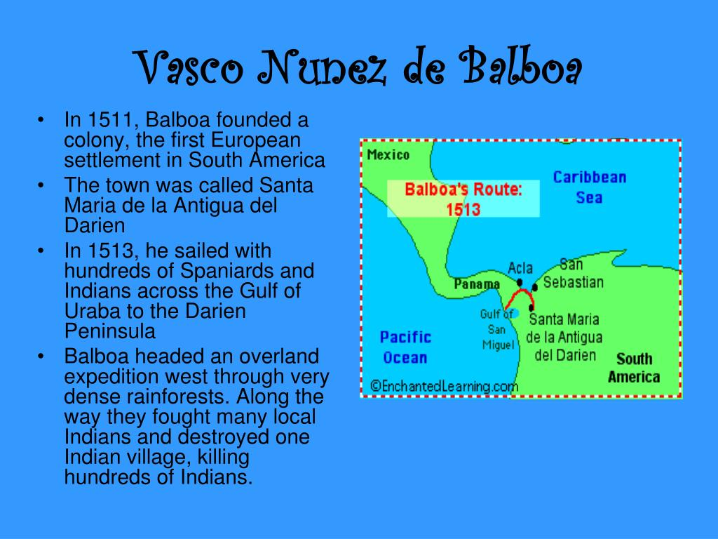

* In 1513, the Spanish explorer, Vasco Nunez de Balboa became the first European to see the Pacific Ocean the Isthmus of Panama.

**FERDINAND MAGELLAN (1519-1522)**

* He was a Portuguese navigator who carried out his explorations under Spain.
* Magellan and his crew started off at Seville in Spain, on 20th September, 1519.
* He had five ships with 265 men who were geared to discover the western route to the East Indies. The ships included the Victoria, Santiago, Conception, Trinidad and San Antonio.

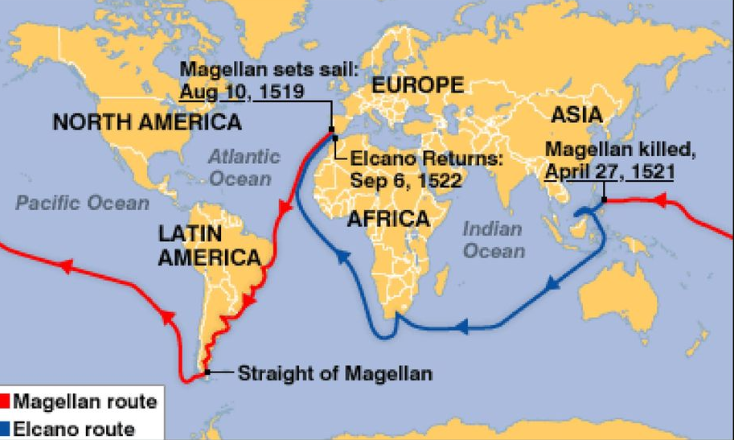

* He sailed directly to the South West of Brazil where he replenished his ships with fresh food and water on 29th November, 1519.
* He further sailed to the South where he explored the Mouth of River Plate on 6th February, 1520. The crew went against as it tired of navigating.

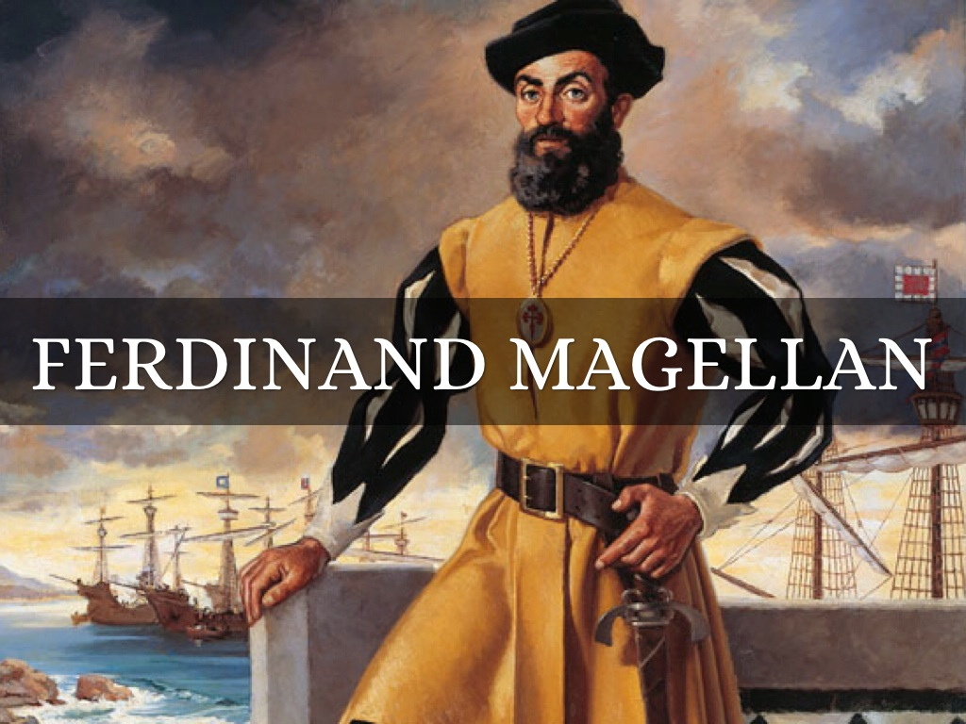

* On 21st October, 1520, the Santiago hit a rock and sank but all men survived. This made the San Antonio, one of the ships to desert and return to Spain.
* Ferdinand Magellan discovered the Straits at the Southern tip of South America. They were very narrow, twisty, had high cliffs and dangerous underwater rocks which were later on named the **Straits of Magellan.**
* He realized that the ocean he was sailing through to America was calm. He called it the **Pacific Ocean (Peaceful Ocean).**
* In March, 1521, the group reached **Ladrones Islands** where it also renewed its supplies.
* Magellan and his crew sailed further from Ladrone Islands to the **Phillippine Islands where Magellan was killed** **by the hostile tribes** as he was assisting one of the local chiefs in a tribal war after being provided with food and fresh water.

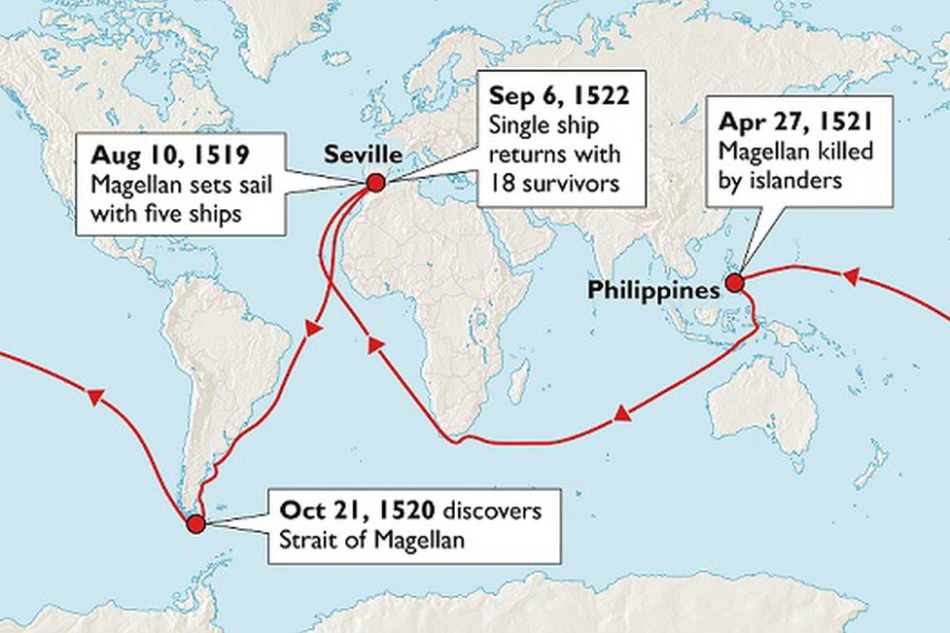

* Sebastian Del Cano took over the leadership by guiding the remaining crew members back to Spain via Borneo, Moluccas Islands and Cape of Good Hope. By this time, only one ship remained, the **Victoria**, and it had between 15 and 18 survivors who completed the first voyage around the world.
* They returned to Spain on 6th September, 1522 which was three years after starting off.
* The journey of Magellan proved beyond doubt that the world is round.
* The route was unprofitable in terms of trade because it was too long.

**PROBLEMS FACED BY MAGELLAN’S CREW DURING THE VOYAGE**

Ferdinand Magellan’s crew faced the following problems

1. Shortage of fresh water and food supplies that forced the crew to depend on rats that infested their ships.
2. Diseases due to starvation and untreated water.
3. Unnavigation water mass that led to ship wrecks.
4. Strong winds that instilled a strong fear among sailors.
5. Hostility from the Philippine Islanders that led to the death of some crew members including Magellan himself.

**HERNANDO CORTES ANS THE AZTEC EMPIRE**

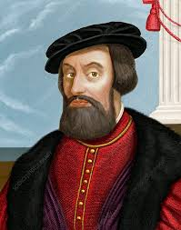 **Hernando Cortes**

* The Aztecs was one of the indigenous groups of Americans that resisted the Spanish occupation.
* To deal with the Aztecs who resisted the Spanish occupation, Spain Hernando Cortes with some 350 who conquered the Aztecs and claimed Mexico for Spain in 1520.

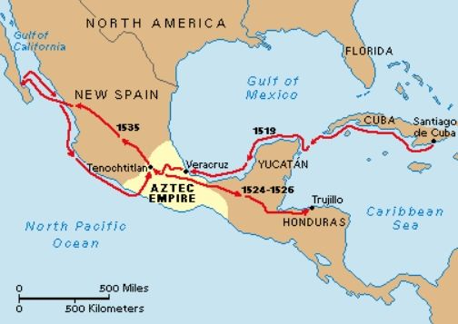

**PRANCISCO PIZZARO**

* He led the Spanish forces in 1530 and conquered Inca kingdom in Peru. The Inca were hostile to the foreigners.

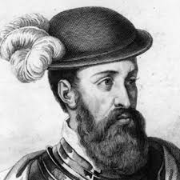 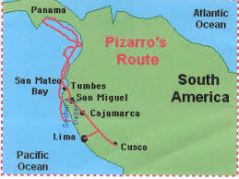

**TREATY OF TORDESILLAS (1494)**

* Spain and Portugal quarreled over the control of the new world.
* The Portuguese made a claim that they had full control of South America, the new world because they were the first ones to discover it through the voyage of Captain Cabral who was blown off in a storm across the Atlantic Ocean to Brazil.
* The Spaniards too made a similar claim of claim of ownership of the new world because it was discovered by explorers such as Christopher Columbus, Amerigo Vespucci, de Balboa and Ferdinand Magellan.
* Being Catholic countries, they referred their dispute to **Pope Alexander VI** for a peaceful and fair division of land according to their explorations.

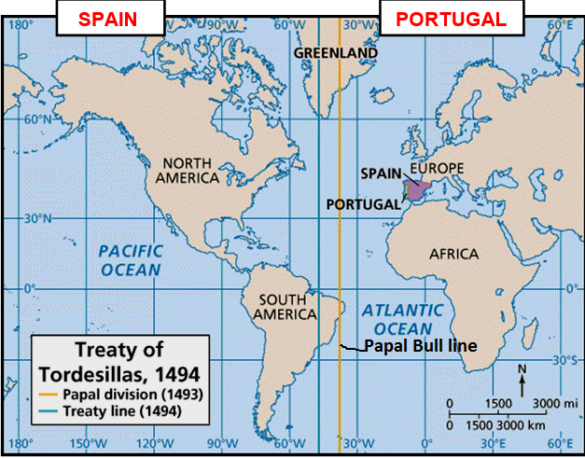

**Pope Alexander VI**

* The Pope during the **Treaty of Tordesillas, Spain** in 1494 drew an **imaginary line on a** world map, dividing the world outside Europe between Portugal and Spain.
* The imaginary line passed through the North- South Meridian west of the Cape Verde Islands $\left({{46}^{o} 37}^{'}W\right)$.
* By Tordesillas Treaty, the lands to the east belonged to Portugal whereas Spain took the lands that lied to the West of the Papal Line.
* However, in 1530, Spain conquered Portugal and defied the Papal Line.

**THE ENGLISH VOYAGES OF EXPLORATION**

* The English wanted to find a new sea route to India using the Northern Passage. This could using either the North East Passage or North East Passage
* North East Passage was a sea route that was intended to reach India from England via the Arctic Coast and Asia.
* The North East Passage was undertaken by the following English explorers
* The North West Passage a sea route from England to India through the water ways of the Atlantic Ocean and Pacific Ocean off the Northern Canada and Alaska.

**ENGLISH EXPLORERS**

1. **JOHN DAVIS**

* John Davis made three voyages to find a sea route to India using the North- West Passage in 1558, 1586 and 1587.
* He was the English Explorer who explored the West Coast of Greenland; Falkland Islands and the Baffin Island.
* He invented a navigational device called the Davis Quadrant used to find latitudes.

1. **RICHARD WILLOUGHBY AND JOHN CHANCELLOR**

* These two English Explorers who acted as pioneers of the North-East Passage by 1553.
* Richard Willoughby sailed northwards till he reached Russia. He failed to India due to the vastness of Russia and the Presence of very cold northern seas.
* John Chancellor visited Norway where he discovered the White Sea. He also opened trade links between Russia and England.

1. **MARTIN FROBISHER**

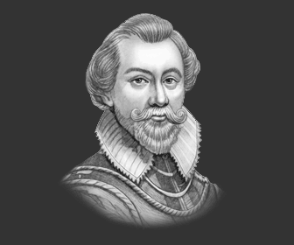

* He wanted to find the North- West Passage to India.
* He reached the Arctic Coast of North America including Canada and Alaska

1. **JOHN HAWKINS**

* English sailors mainly battled for the North-East and North-West Passages to India in order to avoid any Portuguese conflict in the West and East Coasts of Africa.
* John Hawkins became the first English sailor to use the Portuguese Eastern route to India via Africa.

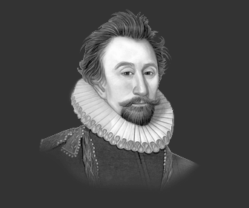

1. **JAMES LANCASTER**

* He was the first Englishman to sail through the Cape of Good Hope and establish the East Indies Company in India.

1. **SIR FRANCIS DRAKE**

* He was the first English explorer to go around the world using the Magellan’s route between 1577 and 1580AD.

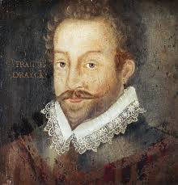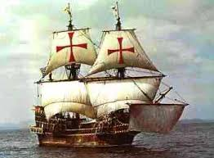

* Francis Drake was the first English sailor to sail around the world between 1577 and 1580AD.
* The map below the Francis Drake’s route.

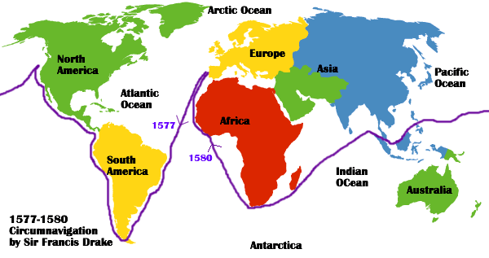

1. **SIR HUMPHREY GILBERT**

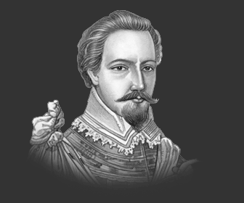

* He searched for the North-East Passage in 1583.
* He reached foundland where he established the first English Colony in America in the city of St.Johns.

1. **HENRY HUDSON**

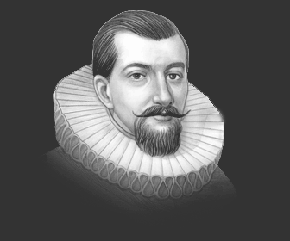

* He was one of the English sailors who searched for the North-West Passage.
* He discovered the **Jan Mayen Islands o**ff Norway and became the first English explorer to discover the Hudson River and Hudson Bay in North East Canada.

**HOW THE ENGLISH GOT INVOLVED IN THE VOYAGES OF EXPLORATION**

1. Through the initiative of King Henry VII of England

* In 1497, King Henry V11 sent John Cabot to find new lands westwards. He left the city of Bristol in a ship Known as **the Matthew**.
* He reached Cape Breton Islands where he discovered the rich fishing grounds of the Newfoundland and the mainland of Novascotia.
* Cabot’s voyage enlightened the English on the need to find a new sea route to India through the North.

1. **Through the initiative of Queen Elizabeth 1**

* Queen Elizabeth 1 sent explorers to compete with the Portuguese and Spaniards peacefully using the Northern Route to India.

**RESULTS OF THE ENGLISH VOYAGES OF EXPLORATION**

* The English attempts to find the North-East and North-West passages yield the following results

1. North trade routes were discovered in North America, Asia and the Northern Hemisphere that were unknown during the Portuguese and Spanish voyages.
2. New trade routes were discovered that linked Europe with North America and Asia, for example the North East and North-West Passages.
3. Trade was promoted between England and Russia.
4. Some English explorers sailed round the world, for example, Francis Drake.
5. By discovering the Northern passages, England avoided the conflicts with the Portuguese who established their sea routes along the coasts of Africa.
6. It led to the discovery of the navigational instrument called Davis Quadrant that assisted sailors in finding out latitudes when travelling. It was invented by John Davis.
7. Important improvements were made in ship construction and rigging. This was done by John Hawkins.

**THE RESULTS OF THE VOYAGES OF EXPLORATION**

1. European countries that were close to the Atlantic Ocean for example Spain, Portugal, France and England became the leading states of Europe.
2. European states began to colonies the newly discovered lands in order to acquire trade raw materials and promote European civilization.
3. It led to the spread of Christianity in America, Africa and Asia.
4. Ne crops such as potatoes, maize and tobacco were introduced in Europe and Africa.
5. Trade with Africa, America and India led to the establishment of European forts in those countries.
6. Slave trade began between West African states and European colonies in America.
7. Sea routes became cost saving and convenient than the land routes that were blocked by wars.
8. It led to the depletion of resources in Africa, Asia and America for the European industries.
9. The world became well known and sped up the art of drawing of fine maps.

**CHAPTER TEN :THE FRENCH REVOLUTION**

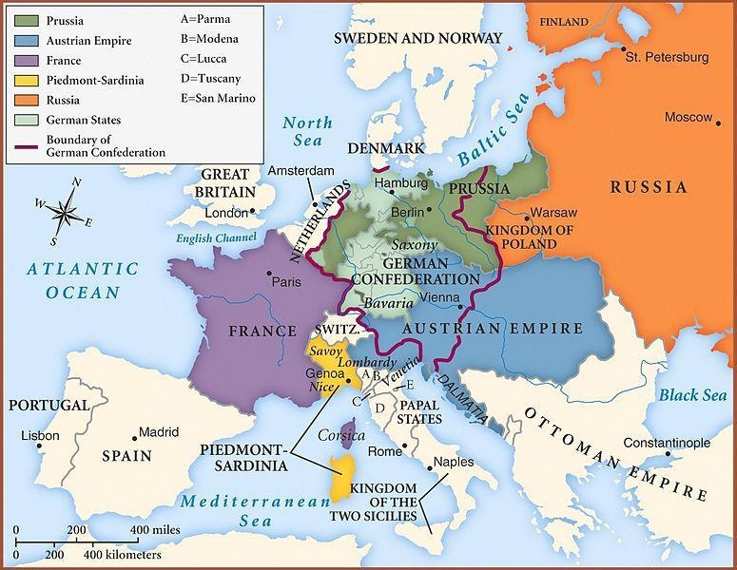

France was divided into one of **three estates**, or social classes.

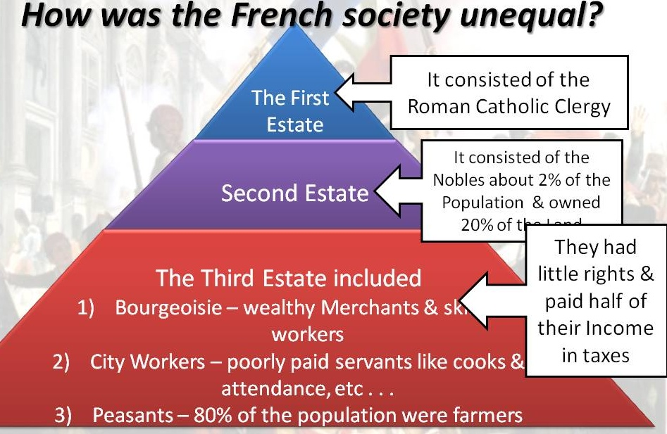

1. . **1st Estate – Royalty and Clergy**

* The First Estate was made up of the clergy- Catholic Church leaders (Bishops, abbots and priests (0.5%)
* They exercised control over the church and state to some extent
* They possessed monopoly in education, poor relief and shared in censorship of printed material
* They owned 10% of the land
* They were exempted from the main and direct tax of France called “taille” taken by the lord from the subjects

1. . **2nd Estate – Nobles and Aristocrats**

* The Second Estate was made up of the nobility- military & government leaders, large landowners (1.5%)
* It owned about 25-30% of the land
* It held leading positions in the government, military, courts and held church offices
* It was exempted from the taille (direct taxes) and the obligations for road
* It was not allowed to form organized body
* It was subject to the poll-tax and twentieth taxes which were based on income
* It sought to keep their control over positions in the military, the church and the government.

1. **3rd Estate – Everyone Else**

* The Third Estate comprised the vast majority of the population (98%) -
* The Third Estate included

1. Bourgeoisie (boor zhwah ZEE) (Middle Class)

* The middle class people included Prosperous Bankers, Merchants, Manufacturers, Lawyers, Doctors, Journalists and Professors
* The middle class were unhappy with the privileges held by the nobles.
* The wealthy middle class individuals could enter the ranks of nobility in the 18th century- thousands of new nobles were created.
* They were drawn to the new political ideas of the Enlightenment
* They were against the monarchical system full of privileges and a rigid social order.

1. **City workers**

These were poorly paid workers such as cooks and attendants in urban areas.

1. **The peasants (80%) of the population were the farmers.**

* They owned 35-40% of the land.
* They were subjected to payment of fees for the village facilities to their local landlords.
* They were subjected to make contributions to the church in form of the tithe.
* They were paying taille on their produce and gabelle or tax on salt. These were the indirect taxes hated by peasants.

**CAUSES OF THE FRENCH REVOLUTION**

1. **Inequalities in French Society**

* French society was divided into three estates. The first estate consisted of the clergymen, the second estate consisted of the nobles and the third estate consisted of the common people most of whom were peasants.
* While the peasants comprised about 90% of the French population, only few owned land. 60% of the land was owned by the members of the first two estates.
* One of the many reasons why the revolution broke out was because only the members of the third estate paid taxes to the state. The members of the first and second estates were exempted from paying any taxes to the king.
* The nobility and the clergy enjoyed many privileges in French society. The nobles extracted feudal dues from the peasants. The latter were also compelled to provide services to the noblemen by working in his fields and house. They also had to serve in the army.
* The church also collected religious taxes from the people known as ‘**tithes’**. The members of the third estate had to pay direct tax to the state known as ‘**taille’**. Indirect taxes were imposed on tobacco, salt and many other everyday items. Thus, the third estate was seething with financial difficulties.

1. **The Rise of the Middle Class**

* There was the rise and emergence of many social groups in France in the eighteenth century. They were traders, businessmen, lawyers and teachers. The traders and businessmen had acquired wealth through overseas trade.
* The administrative officials, lawyers and teachers were educated and believed that no group should be given special privileges merely on the basis of birth. They believed that the members of the first two estates should also pay taxes to the state.

1. **The Enlightenment (Age of Reason)**

* The middle class in France was inspired by the writings of social thinkers and philosophers. John Locke and Jean Jacques Rousseau were two such thinkers who rejected the idea of the divine right of the king. Rousseau propounded that the Government should be based on a social contract drawn between the people and the Government.
* These ideas of philosophers were discussed everywhere—in coffee shops and in salons—and spread among the common people. Inspired by these ideas, people began to oppose the special privileges enjoyed by the members of the first and second estates.

1. **The American influence**

* The educated youth in France were inspired by the rights of liberty and equality which were ensued in the American Revolution.

1. **Economic Troubles**

* High taxes and rising costs damage economy by 1780s
* King **Louis XVI** and his wife **Marie Antoinette** known for extravagance



* Louis doubles nation’s debt; banks refuse to lend more money

1. **A Weak Leader**

* Louis’s poor decisions and lack of patience add to France’s problems
* He calls **Estates-General**—meeting of representatives from all three estates

1. **The American War of Independence**

Following the humiliation at the hands of Britain and its ally Prussia, the French government dreamt of revenge. The opportunity came when Britain became involved in a bitter quarrel with its thirteen North American colonies, who rebelled against British rule.

In the resulting American War of Independence (1776–83), France intervened on the side of the rebels, providing both financial and military support, including the Marquis de Lafayette (see profile on page_79). The intervention of France in

1778 was decisive and helped to bring about the defeat of British forces and the creation of the United States of America.

Although France was unable to recover most of the territory lost during the Seven Years’ War, the Treaty of Versailles (1783) did satisfy French honour.

Few at the time, however, could foresee what the real cost of the war would be: revolution in France. The war cost a great deal of money and in the short term worsened the already weak financial situation of the Crown. French soldiers who had fought in the war had been exposed to ideas such as liberty and democracy and many, on their return home, demanded similar rights for the people of France.

1. **Financial crisis**

The main short-term cause of the French Revolution was the financial crisis. By far the most important aspect of this was the huge deficit that the government was building up. On 20_August 1786 **Calonne**, the Controller-General, told Louis_XVI that the government was on the verge of bankruptcy. Revenue for 1786 would be 475_million *livres*, while expenditure would be 587_million *livres*, making a deficit of 112_million – almost a quarter of the total income. A much more detailed and alarming picture of the situation is provided in the Treasury account of 1788, which has been called the first and last budget of the monarchy

**EVENTS OF THE FRENCH REVOLUTION**

1. **Meeting of the Estates General (The Three Estates)**

* The king called this meeting at Versailles on 5th May, 1789 to try to fix the economic challenges especially to resolve the taxation issue.
* Still under pressure to reform, Louis XVI calls a meeting of the Estates General -all 3 Estates prepare cahiers-notebooks listing their grievances for the meeting in May 1789 -voting problem
* Each estate would meet separately and vote as a group
* Each estate had one vote
* The first & second estate would always outvote the third estate 2 to 1
* The third estate wanted to meet together as a single body with votes counted by head
* When the king called the meeting of an assembly of the Estates Generals to pass proposals of new taxes at Versailles on 5th May, 1789, the members of the third estate walked out from the meeting demanding that every person in the Assembly should have one vote contrary to the existing practice of one estate having one vote. New voting procedure rejected
* Claiming they represented the people of France the third estate declared themselves the national assembly
* Delegates from the first & second estate are invited to join the national assembly

1. **Tennis Court Oath, June 20th 1789**

Fearing that the King planned to dismiss them, the delegates moved to a nearby indoor **tennis court.** The National Assembly finds its meeting hall locked

* The members of the third estate assembled in the indoor tennis court on 20 June 1789 determined to draft a Constitution (French Constitution) which would limit the powers of the king.
* As curious spectators looked on, the delegates took their famous **Tennis Court Oath**
* They swore “never to separate and to meet wherever the circumstances might require until we have **drafted a sound and just constitution for France**” In other words, they took a promise not to disband until they have a written constitution for France. The Third Estate had taken a peaceful first step in a revolution that would transform France!!

When reform-minded clergy and nobles joined the Assembly, Louis XVI grudgingly accepted it. But royal troops gathered around Paris, and **rumors spread** that the king planned to dissolve the Assembly and attack the peasants that did not cooperate

1. **Storming of the Bastille, 14th July, 1789**

* Louis XVI did not actually want a written constitution
* When news of his plan to use military force against the National Assembly reached Paris on **July 14, 1789**, people stormed the **Bastille**
* The Bastille was a royal prison and a symbol of the oppression of the king and royal order. It held gun powder and arms as well as six or seven prisoners.
* When the king ordered his troops to move into Paris, Many fear he planned to dissolve the National Assembly. Commoners saw Louis’s attempts to interfere with the National Assembly as a direct attack on their rights
* The French Citizens attacked Bastille & demanded weapons and gunpowder believed to be stored there to protect themselves.
* An agitated crowd stormed into the prison of Bastilles and liberated its prisoners.
* Commander Marquis de Launay was killed and his head carried in the air to show triumph through the streets of Paris.
* The King’s authority collapsed as the troops could no longer be trusted to enforce the king’s will since some of them easily defected and helped in taking down of the Bastille.

**Results of Storming of the Bastille**

* Peasant uprisings and the **storming of the Bastille** stampeded the **National Assembly** into action. Special privilege ends (1st moderate reform)
* On august 4, in a combative all-night meeting, nobles in the **national assembly** voted to end their own privileges
* They agreed to give up their old manorial dues, exclusive hunting rights, special legal status, and exemption from taxes

1. **Declaration of the Rights of Man and the Citizen**

* The document was modeled in part on the **American Declaration of Independence**, written 13 years earlier
* All men, the French declaration announced, were “born and remain free and equal in rights”
* “Men are born, and always continue **free and equal in respect of their rights.** Civil distinctions, therefore, can be founded only on **public unity**
* The Slogan of the **French Revolution.** “**Liberty, Equality, Fraternity**”
* **The Declaration of the Rights of Man** met resistance
* Uncertain and hesitant, **Louis XVI** did not want to accept the reforms of the **National Assembly**
* Nobles continued to enjoy Gala Banquets while people were starving
* By Autumn, anger again turned to action….

1. **Women March on Versailles (October 5-6,1789):**

* On October 5, about Six Thousand women marched 13 miles in the pouring rain from Paris to Versailles “Bread!” they shouted. They demanded that the price of bread and food be brought down and that people who were unpatriotic towards the revolution be punished. They were armed with broom sticks, swords, spears, pistols and muskets. They demanded to see the king. Much of the crowd’s anger was directed at **Marie Antoinette.** This event showed that women played a fundamental role in the French Revolution.
* **The women refused to leave Versailles until the king returned to Paris and addressed the famine issues of the people.**
* Not too happily, the **King Louis** agreed after a commander of the National Guard, Marqui de Lafayette persuaded him to accept the demands of the marchers including agreeing to the decrees made by the National Assembly such as that of Declaration of Rights. The next morning, the crowd, with **King Louis** and his family in tow, set out for the city (Paris)
* At the head of the procession rode women perched on the barrels of seized cannons. They told bewildered spectators that they were bringing **King Louis**, **Marie Antoinette**, and their son back to Paris
* Crowds along the way cheered the King, who now wore the tricolor
* In Paris, the royal family moved into the **Palace of Tuileries.** For the next three years, **King Louis** was a virtual prisoner



**Palace of Tuileries**

**Changes under the National Assembly**

* Abolishment of guilds and labor unions
* Abolition of special privileges
* Constitution of 1791
* Declaration of the Rights of Man
* Equality before the law (for men)
* Many nobles left France and became known as **émigrés** Reforms in local government
* Taxes levied based on the ability to pay

**Declaration of the Rights of Woman**

* Journalist **Olympe de Gouges** argued in her Declaration of the Rights of Woman that women are equal citizens and should benefit from governmental reforms just as men did.
* **Madame Jeanne Roland** also served as a leader in the women’s rights movement, and was able to heavily influence her husband (a government official).
* Women did gain some rights during the French Revolution, but these were designed for purposes other than liberating women.
* Women could **inherit property**, but only because doing so weakened feudalism and reduced wealth among the upper classes.
* **Divorce** became easier, but only to weaken the Church’s control over marriage.

**End of Special Privileges**

* Church lands were seized, divided, and sold to peasants
* **Civil Constitution of the Clergy** required that Church officials be elected by the people, with salaries paid by the government –2/3 of Church officials fled the country rather than swear allegiance to this
* All feudal dues and tithes were eradicated
* All special privileges of the First and Second Estates were abolished

1. **Flight to Varennes, June 20-21,1791**

* The Royal family attempted to escape revolutionary France to Austria (the birthplace of Marie- Antoinette-the Queen of France), where they were promised a safe retreat.
* King Louis XVI was not happy with the number of changes and reforms wanted by the Assembly. He planned to form a counter-revolutionary army to take back France.
* His plan failed as the royal army was captured in Varenes, a few miles away from the Austrian border.

On August 27, 1791, the Austrian and Prussian monarchs, fearing the revolution would spread to their countries, invited other European monarchs to use force to reestablish the French monarchy.

* Insulted by this threat, the Legislative Assembly declared war on Austria on April 20, 1792.
* The French fared badly in the initial fighting.
* Defeats in war, coupled with economic shortages in the spring led to renewed political demonstrations, especially against the king.

In August 1792, radical political groups in Paris took the king captive.

* They then forced the Legislative Assembly to suspend the monarchy and call for a national convention to decide on the future form of government.
* Representation was to be on the basis of universal male suffrage.
* With this the French Revolution entered a more radical phase.

1. **SEP 1792 – SEPTEMBER MASSACRES**

Sep 1792 – **September Massacres,** Austrian army almost in Paris, enraged mob entered prisons and killed about 1000 political prisoners (mostly monarchists)

July 17, 1791 **Massacre on the Champ de Mars** radicals demanding the dethronement of Louis were met by the National Guard – about 50 radicals were killed

August 1791 **Austria** and **Prussia** issued a joint memorandum – **the Declaration of Plinitz –** stating that restoration of order (= return to absolutism) is a common interest to all sovereigns of Europe.

April 20, 1792 the **National Assembly** declared war on **Austria** and **Prussia**

**OPPOSITION TO THE NEW ORDER**

On August 27, 1791, the Austrian and Prussian monarchs, fearing the revolution would spread to their countries, invited other European monarchs to use force to reestablish the French monarchy.

* Insulted by this threat, the Legislative Assembly declared war on Austria on April 20, 1792.
* The French fared badly in the initial fighting.
* Defeats in war, coupled with economic shortages in the spring led to renewed political demonstrations, especially against the king.

In August 1792, radical political groups in Paris took the king captive.

* They then forced the Legislative Assembly to suspend the monarchy and call for a national convention to decide on the future form of government.
* Representation was to be on the basis of universal male suffrage.
* With this the French Revolution entered a more radical phase.

Sep 1792 – **September Massacres,** Austrian army almost in Paris, enraged mob entered prisons and killed about 1000 political prisoners (mostly monarchists)

In September 1792, the newly elected **National Convention** began its sessions.

* It was dominated by lawyers and other professionals.
* Two-thirds of its deputies were under 45, and almost all had gained political experience as a result of the Revolution.
* Almost all distrusted the king.
* On September 22, 1792, the **Convention** met for the first time
* The Convention’s first step on September 21 was the abolish the monarchy and establish a republic.

On January 21, 1793, the king was executed, and the destruction of the old regime was complete. However, the execution of the king strengthened the resistance of the old enemies of the Revolution and created new ones both at home and abroad.

**REIGN OF TERROR: SEPTEMBER 5, 1793-JULY 27, 1794**

* Despite military successes, the Convention continued to face problems domestically
* **Danton** and his **Jacobin** political party came to dominate French politics
* **Committee of Public Safety** –Headed by **Danton** (and later **Robespierre**)
* Those accused of treason were tried by the Committee’s **Revolutionary Tribunal**
* Approximately 15,000 people died on the **guillotine** •**Guillotine** became known as the “**National Razor**”
* Including innovative thinkers like **Olympe de Gouges** and **Madame Jeanne Roland**

**END OF THE REIGN OF TERROR**

* Members of the **Girondist** political party tried to end the **Reign of Terror** initiated by the **Jacobin** political party –This opposition to the **Committee of Public Safety** caused many Girondists to be tried and executed for treason
* Eventually, even **Georges Danton** wanted to end the executions –This resulted in Danton being tried and executed for treason
* **Maximilien Robespierre** became leader of the Committee of Public Safety –He continued the executions
* Convention came to blame Robespierre for the Reign of Terror
* **Thermidorean Reaction** –July 27, 1794 – ended the Reign of Terror
* Convention sent Robespierre and other members of the Committee of Public Safety to the guillotine •Robespierre was guillotined on July 28, 1794

**ROLE OF NAPOLEON BONAPARTE IN THE FRENCH REVOLUTION**

1. Restoration of peace in peace.
2. Comcordat- peace with the Catholic Church
3. The codification of the laws
4. A new system of government administration
5. Spread of the revolution to other parts of Europe

**IMPACT/CONTRIBUTION OF FRENCH REVOLUTION FRANCE**

1. It put an end to absolute monarchy and paved the way for a republican government.
2. It upheld the theory of popular sovereignty and laid the foundation of the most important democratic principle, i.e., government should be based on the consent of the governed
3. The slogans of equality, liberty, and fraternity became the watchwords of freedom loving and inspired people all over the world.
4. Feudalism and serfdom were also abolished.
5. The French Revolution provided new laws granting liberty and equality to the people.
6. The Declaration of Rights of Man and Citizen provided for equality of all before law.
7. Burden of taxes was to be borne by all and the people were guaranteed religious freedom.
8. The right to vote and right to revolt were given to the people.
9. It brought the introduction of the metric system.

**TOPIC ELEVEN**: **THE ENLIGHTENMENT**

* Enlightenment refers to the period in history when influential people were inspired by a common belief in the possibility of a better world through application of human reason and knowledge**.**
* Enlightenment was a period of desire for human affairs to be guided by rationality rather than by faith, superstition or revelation; a belief in the power of human reason to change society and liberate the individual from the restraints of custom or absolute authority.

**FACTORS LEADING TO DVELOPMENT OF ENLIGHTEMENT**

1. **The Scientific Revolution**

* During Scientific Revolution, European thinkers corrected some of the mistake “scientific beliefs” established in earlier years. As a result, scientific discovered the method used in science known as the scientific method**.** They wanted to understand all aspects of life through the application of the scientific method which involves experiments.

1. **Exploration and Imperialism**

* The explorers returned to Europe stories of people and cultures never previously known.
* Some explorers brought visitors to Europe which introduced common people who would not otherwise be able to travel to the foreign countries. The foreign culture associated with the visitors to Europe provided Enlightenment -era thinkers with the inspiration and desire for change

1. **The declining Influence of the Church**

The tensions created by the Protestant Reformation which split the Catholic Church were very important towards Enlightenment. During reformation, the Catholic Church was corrupt, and often ruled using intimidation, fear, false knowledge and was violently intolerant towards opposition. When Enlightenment thinkers came along praising liberty and self-empowerment, they found willing ears.

1. **The Thirty Years’ War**

This war broke out in 1618 when Bohemian Protestants revolted against their incoming Catholic king. The ensuing battle between Protestants and Catholics spread into Germany and over the course of the next thirty years, nearly a third of the German population was killed. The violence that the German endured over those three decades inspired some leading European thinkers and writers to question the necessity of war. They placed emphasis on the equality of human beings by stating that “**we are all citizens of one world, we are all of one blood”.**

**THE MAIN CENTRES OF THE ENLIGHTENMENT**

1. **London in England**

* London became the centre of wealth and civilization since it was a great trading metropolis as well as administrative, political and legal centre of England. Coffee-houses were very popular at that time. People met there to discuss latest news, to drink tea or coffee which became very popular as common drinks. This made coffee-houses to become centres of political life. The poets and literary men attended coffee-houses to read their creations.

1. **Paris in France**

* France is traditionally regarded as the main centre of the Enlightenment. The ideas of Enlightenment spread to take firm hold of the thinkers of France who came to be known as the **Philosophes.**
* Philosophe means Philosopher and it is the name given to the leading thinkers of Enlightenment in France.
* In Paris, Enlightenment ideas were first developed in **Salons**
* Salons were elegant rooms in houses of the wealthy upper class which brought writers and artists together with aristocrats, government officials, and wealthy middle -class people.

1. **The United States of America**

* The main advocates were Thomas Jefferson and Benjamin Franklin**. When sent to** France on a diplomatic mission, Benjamin Franklin became so popular as an example of the Enlightenment that he was the first person in European history of whom figurines were made and sold as souvenirs.

**OUTSTANDING PERSONALITIES OF ENLIGHTENMENT**

1. **Baron de Montesquieu**

* He wrote the book known as **Spirit of Laws** in 1748.
* In his book, **Spirit of Laws**, he developed the study of governments through the use of the scientific method.
* He tried to find the natural laws that govern social and political relationships.
* He identified three basic kinds of government namely

1. The Republics, suitable for small states
2. Despotism, appropriate for large estates
3. Monarchies, suitable for moderate-size estates

* He used England as an example of a monarchy comprising of three branches

1. The executive- monarch
2. The Legislative- parliament
3. The Judiciary- the courts of law.
4. **Francois-Marie Arouet (Voltaire)**

* He is said to be the greatest figure of Enlightenment.
* He wrote many pamphlets, novels, plays, letters, essays and histories which brought him fame and wealth.
* His famous book was the **Philosophical Dictionary**. In this book, his main contributions to the Enlightenment included freedom of speech, press and religion and opposition to monarchy and dictatorship as well as slavery.
* He believed that progress and change could only be brought about by a monarchy advised by philosophers like himself. This influenced the French Revolution although it was very brutal. This made the 18th Century as the **“Century of Voltaire”**
* He fought against religious intolerance in France.
* In 1763, he wrote his **Treatise on Toleration** in which he reminded governments that **“all men are equal before God”.** He said a good religion is the one which teaches morality more than dogma **(system of beliefs).**
* He criticized Christianity because of its intolerance between Catholics and Protestants which led to a Catholic massacre of the Protestants on Saint Bartholomew’s Day on 23rd August, 1572. He declared that the massacre was a terrible demonstration of violence and inhumanity. Thus he proposed that availability of many religious would give way to peace and happiness in societies.
* He promoted deism. This was an 18th Century religious philosophy based on reason and natural law. He said that God the clockmaker, had created it, set it in motion, and allowed it to run without his interference according to natural laws.

1. **Denis Diderot**

* **H**e is famous for the book he wrote known as **Encyclopedia** between 1751 and 1772**.** This book was the collection of different subjects ranging from science and technology, politics, art, religion, trade, social and humanitarian issues.
* The purpose of **Encyclopedia** was to change the general way of thinking**.**
* Encyclopedia was very useful because any one was able to access Encyclopedia including doctors, clergymen, teachers and lawyers.

1. **Jean-Jacques Rousseau**

* He was a Swiss-born French philosopher, write and educator.
* His main ideas were built on three areas of freedom, education and women affairs.
* He wrote a famous book called **“The Social Contract”** in 1762. He said in this book that individual freedom is achieved by being forced to follow what is best for the “general will”. This general will represents what is best for the whole community. In other words, he was trying to reject absolute power by rulers as was the case in those days.
* He wrote a book known as “**Emile”** in form of a novel which gives a general discussion on education.
* He explained that the main aim of education should be the promotion of children’s natural instincts and not restrict them. Education should be a means of opening up natural abilities.
* He argued for a balance between the heart (emotions) and mind (reason).
* He believed that women are naturally different from men. He said that, “To fulfill her functions…. a woman needs a soft life…. How much care and tenderness does she need to hold her family together?”

1. **Mary Wollstonecraft**

* She is considered as the founder of both European and American movements for women’s rights.
* She became a leading voice for the improvement of conditions for women during the 18th century.
* She wrote a book called a **Vindication of the Rights of Women** where she argued that the power of men over women was equally wrong.
* She declared that women should have equal rights in education, politics as well as in economic life.

**CONTRIBUTIONS OF THE ENLIGHTENMENT TO MODERN WORLD**

1. It inspired the American Revolution which produced the world’s greatest democracy. The great personalities of the revolution were Benjamin Franklin and Thomas Jefferson.
2. It led to the end of absolute monarchy. It introduced the process of electing leaders and replacing the unjust rule of the un-elected kings or queens.
3. It promoted the idea of human rights. It led to the Declaration of the Rights of 1789 during the French Revolution. This was fully translated in the Universal Declaration of Human Rights passed by the UNO after the Second World War on 10th December, 1948.
4. Promoted the rights of women. **Mary Wollstonecraft** wrote a book called a **Vindication of the Rights of Women** where she argued that the power of men over women was equally wrong. She declared that women should have equal rights in education, politics as well as in economic life.
5. It led to the advancements in the practice of medicine, mathematics, and physics and chemistry, development of biology and a new understanding of magnetism and electricity.
6. It led to the promotion of education and especially female education
7. It led to the birth of new religious movements such as Methodist Church in England initiated by John Wesley

**CHAPTER TWELVE: NATIONALISM & INDEPENDENCE MOVEMENTS IN AFRICA**

Nationalism is a feeling held by the people of a particular territory or nation that they should be able to form their own country and run their own affairs.

**THE FACTORS THAT LED TO NATIONALISM IN MOST COUNTRIES OF AFRICA**

1. **Education**

Education made Africans to become more curious about the world and wanted to change things they saw as being wrong. It also made Africans to realize that it possible for them to rule themselves.

1. **Urbanization**

Urbanization produced a group of people known as working class which was open to political ideas that promised to improve their lives, for example, nationalism**.**

1. **Pan-Africanism**

Pan-Africanism refers to the idea that encouraged Africans to unite across barriers of language and politics to improve their lives.

Pan -Africanism influenced most first presidents of independent African countries such as Kwame Nkrumah of Ghana and Hastings Kamuzu Banda of Malawi**.**

1. **The Second World War between 1939-45**

It increased the pace of urbanization as more people came to cities to work in war production units or to fill the jobs of men who went to serve overseas.

The war exposed African soldiers to different cultures and societies and allowed them to sea the way other countries were government.

1. **The United Nations Organisation**

UNO pushed increased pressure on European colonial powers. The UNO Charter contains a clause that affirmed the right of self-determination.

1. **The Cold War**

This was overshadowed by the rivalry between USA and Russia. It reached the point whether you are with the side of the Western Bloc or the Eastern Communist Bloc led by Russia. These two superpowers had no colonies but they influenced the way power was demonstrated among European powers.

**GHANA**

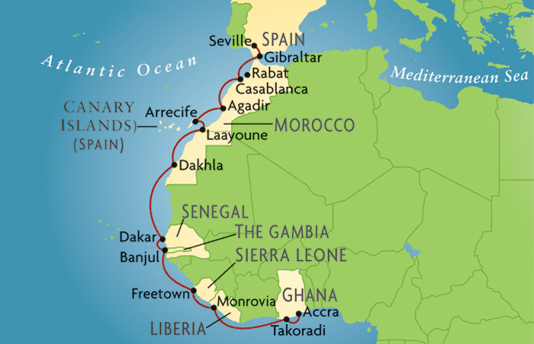

* Originally Ghana was called Gold Coast due to its gold deposits it had. It took the ancient name of Ghana kingdom.
* Ghana was the British colony

**FACTORS THAT CONTRIBUTED TO NATIONALISM OF GHANA**

1. **Effects of Western Education**

The British promoted civilization in the Gold Coast by erecting schools, for example, Achimota College, where James Kwegyir Aggrey, an American-educated Ghananian educationalist 91875-19270 taught. He awakened the Africans politically in his lessons that they should be self-determined and do away with any European dominion.

Western education contributed to nationalism in Ghana in the following ways:

1. Provided the local masses with the educated future African Leaders who went against colonialism. Examples of these educated African Leaders in Ghana
2. John Mensah Sarbah- a legislator by 1888
3. Dr Joseph Danquah - founder of the United Gold Coast Convention (UGCC) in 1947
4. Casely Hayford -Lawyer and the proprietor of the Gold Coast Leader newspaper 1917-1930)
5. Kwame Nkrumah - Founder of the Convention Peoples Party in 1949 and Ghana’s first president in 1975.
6. Western ideologies inspired educated Africans to appoint out the weaknesses of the colonial government and enabled the leaders to propose ideal solutions to the problems of the masses.
7. The building up of more schools in the Southern Province (Accra) than in other province and discriminatory and intentionally hoped to develop one province and cripple the others. Africans, therefore, revolted against the system.
8. **Impact of the Second World War (1939-1945)**

* The Second World War between the Allied Powers (Britain, France, Russia and USA) and Axis Powers/Central Powers (Germany, Italy and Japan) influenced Nationalism in Ghana. The European powers enticed their colonies in Asia and Africa to join the war with the hope of overwhelming their aggressors.

The elements of nationalism came as follows

1. The ex-servicemen (war veterans) got enlightened on the social and political matters that forced Britain to wage war against Germany between 1939 and 1945.For example the self-determination policy of the 1919 Versailles Treaty forbade major countries to control weaker states. It stressed that the rights of the minority groups should be respected. On their return to Gold Coast, the ex-servicemen enlightened their fellow Africans to resist colonialism.
2. The ex-servicemen were frustrated as the colonial government did not support them economically after the Second World War. They were jobless and lived in dire poverty. They began to support the ideas of political freedom that were propagated by the 1945 Manchester Pan African Congress to end colonialism in the Gold Coast.
3. The war weakened European countries economically and militarily to put down revolts in their colonies. This paved way for the nationalist movements to hold riots against them as a move in liberating their state from the foreign rule.
4. The war expenses in buying the war weapons, feeding the soldiers paying back war loans to the creditors and putting up fine structures that were destroyed by the war led to inflation worldwide. The inflation led to the high prices of goods for an ordinary person to purchase. This forced Africans in the Gold Coast to rise against the British colonial rule.
5. The independence of India in 1947, the former British colony, influenced the nationalist movements in the Gold Coast to press for independence.
6. **Impact of the economic wealth**

* Britain economically exploited Africans in Gold Coast. Minerals such as gold, Manganese and bauxite were drilled for British industries. At the same time industries established in Gold Coast benefited Africans in an insignificant way, for example. The United Africa Company bought a lot of cocoa seeds, palm oil and palm kernels but for manufacturing industries in Europe and banked all the proceeds in Britain or Europe.
* Economic exploitation contributed to nationalism in Ghana in the following ways

1. Establishment of industries made many Africans to migrate to urban to urban areas for employment. The internal labour migration shaped the Africans politically by exposing the local masses to the town life and revolutionary activities through newspapers, cinemas and western education. This made Africans to awaken their fellow Africans on how to deal with issues of nationalism and self-determination when they returned to rural areas.
2. The British regulated the cocoa prices at the market to the disadvantage of Africans who often were poor villagers. Hence the African farmers became frustrated and hated the colonial government that exploited them economically.
3. The cocoa plants were affected with the swollen root disease. To get rid of the disease, farmers were advised to cut down all the affected plants. The affected farmers, whose economically depended on the crop felt helpless and hated the oppressive policies of the colonial government.
4. **Political dominion of the British Colonial Government over Africans in Ghana**

* From 1850 to 1957, the African representation in the legislative council was low. It was dominated by the colonialists. Laws ere therefore made to favour the British and oppressive the natives. This marginalization of Africans in the administration of their country forced them to rebel against the colonial government.

**NATIONALIST MOVEMENTS IN GHANA**

1. **THE UNITED GOLD COAST CONVECTION (UGCC)- 1947**

* It was the first nationalist movement formed in Ghana in 1947.
* The founder of the United Gold Coast Convection was Dr Joseph Danquah
* Dr Joseph Danquah formed UGCC together with George Grant with a wealthy business man F.A. Awoonor Williams in 1947
* Dr Kwame Nkrumah became the Secretary General of UGCC.

**Aims of United Gold Coast Convection**

1. To foster nationalism among natives constitutionally.
2. To fight for self-government in the Gold Coast within the shortest period of time.
3. To urge the colonial government reduce the rising costs of goods after the Second World War.

**Factors that made United Gold Coast to be popular among people in the Gold Coast**

1. Nkrumah’s radical moves in pressing the colonial government to grant Gold Coast an immediate independence. He also associated the party to the local mass who began to support the UGCC as a weapon to end colonialism in the country.
2. It was supported by the ex-servicemen, who rioted against the poor economic policies of the colonial government on 28th February, 1948.
3. The colonial policy of cutting down the affected cocoa plants aroused anger amonger farmers who began to hate the colonial government and supported the UGCC.
4. The control of trade by the Europeans reduced the selling price of farm produce. It also raised the cost of European made products that forced African chiefs under Chief Nii Kwabena III to hold riots in Accra. The riots made the colonial government infamous.
5. **The Convention People’s Party-1949**

* The founder of the Convention Peoples Party was Dr.Kwame Nkrumah iin 1949.

[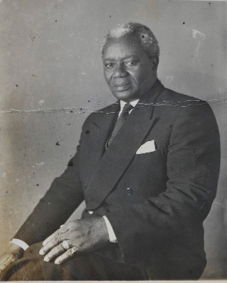](https://mobile.ghanaweb.com/GhanaHomePage/people/person_photo.php?id=31280066) [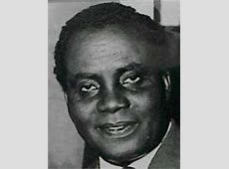](http://rulers.org/botsi.jpg) [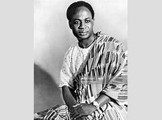](https://media.gettyimages.com/photos/dr-kwame-nkrumah-of-newly-independent-ghana-ghana-mid-to-late-1950s-picture-id146126958)

Kojo Botsio Kwame Nkumah

Dr Danguah

* Kwame Nkrumah found the CCP with Kojo Botsio and K.A. Gbedenah.
* Convention People’s Party was the first mass political party which was fomed as a UGCC breakaway after Kwame Nkrumah had a misunderstanding with some UGCC officials.

**Aims of the Convention People’s Party**

1. To fight for an immediate independence of Ghana. Unlike the UGCC, Nkrumah promised the natives self-government now, employment opportunities and economic growth. This was the main sign of Nkrumah’s radical stand as he wanted speedy reforms through his slogan**-“Self-government now”,** which showed desire to have Africans rule themselves.
2. To foster nationalism in a non-violent way (the positive Action). The Positive Action was a non-violent way Nkrumah and his supporters used to force the British Colonial government change its policies and give the Gold Coast self-government now by disobeying the law through strikes and boycotts.
3. To promote unity among people
4. To let Gold Coast develop its own socio-economic and political systems.

**Why did Kwame Nkrumah breakaway from the UGCC in Gold Coast?**

1. Misunderstanding between Nkrumah and the UGCC officials

**The UGCC members were mainly town people who were highly**

1. The sidelining of Nkrumah in the Coussey Committee

In 1949, an all African committee headed by an African lawyer, Judge Heneley Coussey took place in the Gold Coast to give Africans more powers in the administration of their country. Among its 38 African members, Nkrumah was not invited. He felt that UGCC members wanted to suppress him; an influential African. He, therefore, broke away from UGCC and formed a rival political party.

**How did UGCC differ from the CPP in their approach to Nationalism in Gold Coast?**

1. The UGCC membership was based on educated people (lawyers) and businessmen whereas the CPP involved all sectors of life: the ex-servicemen, poor cocoa farmers, school leavers and the educated radicals who wanted to force the colonial government change some of its policies.
2. The UGCC was conservative and constitutional in attaining serf rule, it cooperated with the colonial government whereas CPP was radical (militant) in forcing the colonial government to step down from ruling the Gold Coast.
3. UGCC believed in attaining the independence in a distant future whereas CCP believed in immediate independence.

**How did Kwame Nkrumah manage to win the support of the masses in Gold Coast?**

[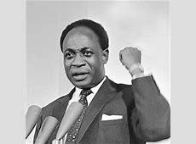](http://cdn.ghanasoccernet.com/2016/03/Kwame-Nkrumah.png)

1. He established party branches countrywide
2. He formed youth groups in Accra and nationwide.
3. He promised boycotts, violence and strikes to force the colonial government change some of its policies (Positive Action).
4. His demand for self government now
5. His stand on criticizing the colonial government poor policies.
6. His demand for a constitutional review to allow Africans have a universal vote and occupy key positions in the government.

**What were the impacts of political parties in fostering nationalism in Gold Coast (1947-57)?**

1. Provided the masses with leadership that guided people to resist the colonial rule.
2. They acted as a mouthpiece of the masses against the oppressive colonial policies and demand for serf rule.
3. They promoted solidarity among people to resist colonialism through riots and strikes
4. The 1948 riots and State of Emergency on 8th January, 1950 led to the death of innocent Africans and the arrest of six UGCC top officials including Danquah and Nkrumah. This act by the colonial government urged Africans to press further for self rule as people’s grievances were not taken into consideration.

**THE WATSON COMMISSION**

It was appointed by the colonial government to find out the causes of the riots and other disturbances that led to the State of Emergency.

**FINDINGS OF THE WATSON COMMISSION**

1. The educated Africans were irritated by being sidelined in the administration of their country.
2. The educated African leaders especially Nkrumah dismissed the Burns British Constitution that supported African chiefs to act as instruments of the British policy against Africans. The Burns Constitution was seen as inadequate to address the needs of the people. It therefore contributed to nationalism in Gold Coast.
3. Africans were infuriated by the rising cost of items and a delay in attaining self rule.

**RECOMMENDATIONS OF THE WATSON COMMISSION**

Gold Coast should have a responsible government, a government that could fulfill people’s needs and aspirations. This was to be done by enlarging the legislative council with an African representation in majority and by making the African members of the Executive Council to be involved in formulating government policies and be responsible to the legislature**.**

The Watson Commission’s report was accepted. Its main result was that it led to the appointment of an all African committee: the Coussey Committee.

**WHY WAS THE COUSSEY COMMITTEE SET UP IN 949 IN GOLD COAST?**

It was appointed by the British colonial government to study the findings and recommendations of the Watson Commission in the Gold Coast.

**THE COUSSEY COMMITTEE (OCTOBER, 1949)**

* It was appointed by the British colonial government to study the findings and recommendations of the Watson Commission in the Gold Coast.
* It was attended by the Africans themselves with no European interference.
* It was chaired by an African lawyer, Judge Heneley Coussey. It had thirty eight African participants from all parts of the country. However, it only had conservative members. The radical members like Dr Kwame Nkrumah and his companions were not invited.

**RECOMMENDATIONS OF THE COUSSEY COMMISSION IN OCTOBER 1949**

1. The Legislative Council was to have an African majority membership. Members were to be elected and not appointed.
2. The Governor was to have a final say in all decisions
3. Africans in the Executive Council were to accumulate powers in policy making in particular departments.
4. To introduce a two chamber legislature in the Gold Coast.

**CONTRIBUTIONS OF COMMISSIONS OF INQUIRY TOWARDS INDEPNDENCE OF GOLD COAST**

1. They channeled people’s grievances to the colonial government and policies were changed to empower Africans for self-rule.
2. The commissions led to the constitutional talks between the British colonial government and Africans to bury their differences and hold the elections in 1956 that enabled Africans in the Gold Coast to attain self-rule.

**GENERAL ELECTIONS AND INDEPENDENCE OF GOLD COAST**

* Sir Charles Arden Clarke became the colonial governor of Gold Coast.
* General elections were held in 1951 and CPP of Kwame Nkrumah won the elections with 34 seats out of 38. The UGCC won three seats only and the remaining seats were won by the independent candidates.
* The majority won by the CPP in 1951 led to the immediate release of Dr Kwame Nkrumah from prison to lead the Gold Coast to independence.
* In the multi-party election that took place in 1956, CPP won with a majority vote of 71 out of 104 seats. Apart from CPP, other parties that contested in the 1956 multi-party elections were UGCC, the National Liberation Movement of Ashanti and the Muslim Association of Kumasi.
* Gold Coast attained its independence on 6th March, 1957 with Dr Kwame Nkrumah as its first president.
* The name Gold Coast ceased and Ghana was adopted from “the ancient Kingdom of Ghana. The name was proposed by Dr Joseph B. Danquah, a lawyer and historian of Ghana.
* Ghana became the first country in the Sub-Saharan African to be independent.
* Ghana became a Republic in 1960.

**CHATER 13:NATIONALISM AND INDEPENDENCE MOVEMENTS IN MALAWI**

* Malawi (Nyasaland) was a British Protectorate between 1891 and 1907.
* The following were the bad policies against the African majority between 1891 and 1953

1. **Land**

Most land was occupied and controlled by the Europeans which led to land problems among Africans in Thyolo, Mulanje, Blantyre, Chikwawa, Chiladzulu and Zomba. The Africans were deprived of huge productive land. The displaced Africans migrated to other areas. Those who remained were exposed to Thangata in order for them to continue staying in the plantations.

1. **Taxation**

The British colonial government introduced taxation in Nyasaland in 1901. Africans were forced to pay hut tax for married people and pole tax for the unmarried males.

The tax was introduced with the intention of forcing Africans who by then had no sources of generating income to work under the white settlers. Secondly, the money was needed for the administration of Nyasaland. Lastly it was meant to compensate slave traders after ending slave trade in Nyasaland. Africans who defaulted in paying tax were tortured, imprisoned or had their houses set abraze.

1. **Labour**

The white settlers used Africans as their workers which caused labour migration. For example, the Tonga from Nkhata Bay migrated to Blantyre to work as clerks under the whites. Labour migration caused overpopulation and overcrowding in Southern Region. Introduction of taxation forced Africans to migrate to Northern Rhodesia and Southern Rhodesia to work in mines.

**FACTORS THAT LED TO NATIONALISM IN NYASALAND**

1. **Impact of British colonial policies on land, labour and taxation**

British colonial policies which made Africans to hate colonial government and wished for self-government included the following

* The Africans lost their land to the White settlers forcing the Africans to migrate to infertile areas
* Introduction of Thangata system on European estates. The Africans hated it because the African workers on the plantations discharged their labour for free and were ill-treated.
* High taxations imposed on Africans and their effects on their defaulters. The Africans hated taxation because Africans were highly taxed and the defaulters were being tortured or their wives and children were taken as hostages.

1. **Impact of African instituted Churches**

African churches formed, run and controlled by Africans promoted nationalism in the following ways

* They acted as spokespersons for the masses against the harsh colonial policies on land, labour, taxation and the administration of Nyasaland.
* They provided leadership to the masses during a period of colonial oppression e.g. the 1915 John Chilembwe uprising against the colonial rule in the history of Malawi.
* They united Africans in their provinces to stand against the Europeans in order to safeguard their pre-colonial interests.
* They inspired Africans’ resistance which made Africans to take courage in 1958 and 1959 to wage war against colonialism.
* They fostered patriotism and solidarity among Africans that led to formation of Voluntary Associations and mass political movements such as the Nyasaland African Congress formed in 1944 and Malawi Congress Party formed in 1959
* They staged the uprisings through which Africans and Europeans realize a need to settle their differences in a constitutional manner. This led to a change of some policies that allowed Africans to earn self-rule.

Examples of the African Instituted Churches that fostered nationalism in Nyasaland are

1. **The Watch Tower Movement of Elliot Kmwana**

This was formed in 1908 and was based in Nkhata Bay. This church was formed to preach against taxation and segregation.

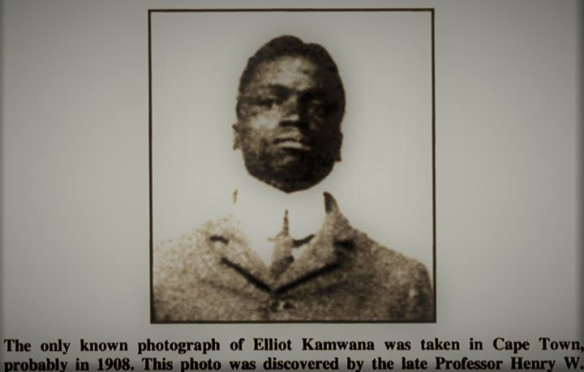

1. **Eklezia Lawanangwa of Charles Domingo**

This was formed in 1934 among the Ngoni of Mzimba district. This was formed to preach against European exploitation and ill-treatment of Africans in estates.

1. **Providence Industrial Mission of John Chilembwe**

It was established at Mbombwe in Chiradzulu District in 1908.

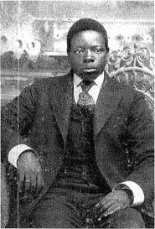 John Chilembwe

1. **Impact of Western Education on Africans in Nyasaland**

The Protestant and Catholic Mission schools led to the birth of educated Africans in Nyasaland. Som of the Africans who received education from these schools were James Fredrick Sangala, John Chilembwe, Elliot Kamwana, Charles Domingo Chinula, Levi Ziliro Mumba, Orton Chirwa, Masauko Chipembere and others.

**Western educated Africans contributed to Nationalism in Nyasaland in the following ways:**

1. They exposed the weaknesses of colonial rulers to the masses and press them for a reform that enabled Africans to be involved in the administration of their country.
2. They formed mass political parties such as the Nyasaland African Congress and the Malawi Congress Party that awakened the conscience of Africans to fight for their independence.
3. They trained their fellow Africans who later rose against the colonial rule.
4. **End of the Second World War (1939-1945)**

The Malawian men who served as armed forces abroad under Kings African Rifles expanded their experience were eager to bring changes that they witnessed in North Africa and the Far East to fight for self-rule in Nyasaland**.**

1. **Imposition of Federation of Rhodesia and Nyasaland (1953-1963)**

* The British colonialists formed the federation of Southern Rhodesia, Northern Rhodesia and Nyasaland in 1953 with Sir Godfrey Huggins as its first Administrator of governor. Sir Godfrey Huggins was succeeded by Sir Roy Welensky in 1956.

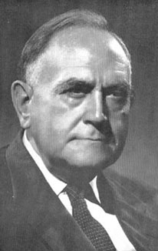 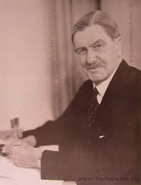

Roy Welensky Godfrey Huggins

* Sir Welensky was the Governor of the federation of Southern Rhodesia, Northern Rhodesia and Nyasaland until it was dissolved in 1963.

**Reasons why the federation was imposed in Central Africa**

1. To gain and utilize resources from Central African territories e.g. Zimbabwe (gold, coal and asbestos), Zambia (copper, zinc, lead) and Malawi (Manual labour)
2. To create a powerful economic union by attracting a large scale investment.
3. To neutralize the power of the Boers of South Africa with whom they were competing not to invade Central Africa.
4. To promote the British Commonwealth in Central Africa and develop it through the provision of social service institutions.

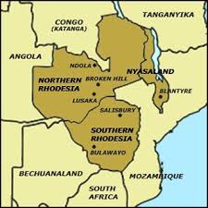

**How the Federation of Rhodesia and Nyasaland contributed to nationalism**

1. It angered African Chiefs who were about to lose their power to the white settlers.
2. It made the crown or the Queen to oppose the amalgamation of the three African states to avoid the importance of the apartheid system of government in Central Africa from South Africa.
3. The amalgamation forced Africans from Northern Rhodesia and Nyasaland to press the colonial government to grant them independence to avoid racial segregation as was the case in Southern Rhodesia.
4. **Pressure from outside nationalist bodies**
5. The independence of India on 15th August, 1947 and Ghana on 6th March, 1957 from the British colonial rule forced African nationalists from Nyasaland to ask for immediate independence from Britain.
6. Pan-Africans supported nationalist movements in Africa to rise against colonialism. This gave birth to Nyasaland African Congress and the Malawi Congress Party in Nyasaland that united Africans against the colonial rule.
7. The 1941 Atlantic Charter supported the self-determination policy among all states worldwide.
8. The Nyasaland migrant workers in South Africa learned revolutionary activities from the African National Congress (ANC).Upon their arrival in Nyasaland, they awakened their fellow Africans politically on how to fight for independence in Nyasaland e.g. Levi Ziliro Mumba.

**VOLUNTARY ASSOCIATIONS**

* Voluntary associations were early political associations among Africans that were formed to resist oppressive European rule and safeguard their welfare.
* They were not mass political parties but pressure groups that were based on district or regional level to support the natives.
* The Voluntary Associations were also known as the Native Associations or African Welfare Societies.

**FOUNDING MEMBERS OF VOLUNTARY ASSOCIATIONS IN NYASALAND**

* The first person to form a Native Associations in Nyasaland was Simon Chiukepo Mhango in Karonga in 1912. He borrowed this idea from members of the South Africa Native National Congress of South Africa.
* Levi Ziliro Mumba is recognized as the father of Native Associations since went further by assisting other Africans in Nyasaland to form associations in Central and Southern Regions of the country.

**WHAT WERE THE ACTIVITIES OF THE NATIVE ASSOCIATIONS?**

1. They were encouraging people to keep their villages clean and be free from diseases.
2. They discussed the evils of labour migration especially that it led to slow development of Nyasaland.
3. They were dealing with issues of thangata system especially in the Shire Highlands.
4. They advocated for the increase in prices of crops at the produce markets.
5. They were enlightening the government on the problems of taxation and education on the Africans.

**WHAT WERE THE AIMS OF VOLUNTARY ASSOCIATIONS FORM DURING THE INTER-WAR PERIOD (1919-1939)?**

1. To inform the colonial government on the pressing needs of the natives.
2. To speak out against the oppressive policies of the colonial government.
3. To let the natives be aware of the newly introduced laws by the government and their objectives.
4. To deal with particular problems in each and every district for example labour migration, taxation, education etc.

**EXAMPLES OF NATIVE ASSOCIATIONS IN NYASALAND (1912-31)**

**Why levi ziliro mumba is honoured as the father of Native associations**

1. He led the establishment of all other native associations in the Central and Southern regions.
2. He also influenced the formation of an umbrella body to unite all native associations. It was called the **Representative Committee of the Northern Province Native Associations**.

**HOW DID THE NATIVE ASSOCIATIONS CONTRIBUTE TO NATIONALISM IN NYASALAND?**

1. By letting Africans to run their own affairs at district or regional level, they were trained to be self-reliant and awakened the desire to control Nyasaland by themselves.
2. The solidarity among Africans in the Native Associations acted as the basis for the development of mass political parties in Nyasaland e.g. NAC and MCP.
3. By sensitizing Africans to resist some of the oppressive colonial policies on land, labour and taxation turned the masses to be patriotic and got united to foster Nationalism in Nyasaland.

**WHAT WERE THE WEAKNESSES OF THE NATIVE ASSOCIATIONS?**

1. They confined themselves to districts or regions which led them to concentrate on local problems rather than national issues.
2. They never spoke with one voice to the government as they were too divided.
3. Members mainly came from the educated class. This means the associations lacked the much needed support of the masses.

**THE NYASALAND AFRICAN CONGRESS**

* The founder of the Nyasaland African Congres was James Fredrick Sangala to unite Africans and foster African interests.
* The other leading figures were Lewis Mataka Bandawe and Levi Ziliro Mumba.
* Nyasaland African Congress was formed on 20th May, 1944 with Levi Ziliro Mumba as its first President.
* James Fredrick Sangala declined to become an active leader of the Congress because he was a civil servant.

|  |  |
| --- | --- |
| The Chairman/President | Levi Ziliro Mumba |
| The Vice Chairman | Charles J. Matinga |
| The Secretary General | Charles Mlanga |
| The Vice Secretary General | John Dickson Phiri |
| The Second Vice Secretary | Harry Tung’ande |
| The Treasurer General | Isaa Macdonald Lawrence |
| The Assistant Treasurer General | H.B. Dallah |

**FACTORS THAT LED TO THE FORMATION OF NYASALAND AFRICAN CONGRESS**

1. The imposed amalgamation of Rhodesia and Nysaland in 1937 which promoted racial segregation
2. A failure by Native Associations to address African grievances.

**AIMS OF THE NYASALAND AFRICAN CONGRESS**

1. To be mouthpiece of Africans by presenting their views and needs to the colonial government.
2. To resist the imposition of Federation of Rhodesia and Nyasaland
3. To foster nationalism in Nyasaland

**PROBLEMS FACED BY THE NYASALAND AFRICAN CONGRESS**

1. It had no clearly objectives on the attainment of independence, therefore it lost mass support.
2. Poor leadership due to the untimely deaths of leaders such as Levi Mumba and Issa Lawrence in 1945.
3. Financial problems for its operations due to the embezzlement and mismanagement of funds.
4. Tribalism that created divisions among NAC members. Charles Matinga was tribalistic who replaced Levi Mumba.
5. It was highly dominated by the educated Africans who sidelined the local masses.
6. It lacked full time employed staff as the Congress was mainly organized by civil servants.

**FACTORS THAT STIMULATED THE NAC TO POLITICAL ACTIVITIES IN THE 1950S**

1. Radical nationalists in South Africa, the ANC influenced Nyasaland migranbt workers and the educated elites such as Henry Masauko Chipembere and Murry William Kanyama Chume to use violence in asking the colonial government t for immediate independence.
2. The arrival of Dr Hastings Kamuzu Banda in 1958 stimulated the political activities of the NAC through his funds and nationwide tours.

[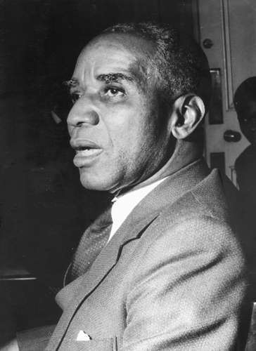](https://cdn.britannica.com/99/76399-050-4C82E6F4/Hastings-Kamuzu-Banda-1960.jpg) Dr Hastings Kamuzu Banda

1. By involving the local mass nationwide, the NAC came to be a mass political party that was very effective to bring about change in Nyasaland.
2. The establishment of party branches nationwide and the adoption of a party slogan-Kwacha have the followers a hope and support for immediate independence.

**ACHIEVEMENTS OF NYASALAND AFRICAN CONGRESS**

1. It acted as the mouthpiece for the local mass
2. It fostered patriotism among Africans to fight against the colonial rule.
3. It promoted unity among Africans through meetings, party symbol and slogan.
4. It resisted the thangata and the malimidwe system.
5. It resisted the Federation of Rhodesia and Nyasaland.

**WHY NYASALAND AFRICAN CONGRESS ASKED DR HASTINGS KAMUZU BANDA TO RETURN TO NYASALAND?**

1. To head and revive the collapsing Nyasaland African Congress after the deaths of its leaders e.g. Mumba and Lawrence.
2. To free Nyasaland from the colonial rule.
3. To assist the members in ending the Federation of Rhodesia and Nyasaland.

**DR HASTINGS KAMUZU BANDA**

* He was born in Kasungu District in 1898.
* He did his primary school at Chilanga Mission Station, a branch of the Livingstonia Mission.

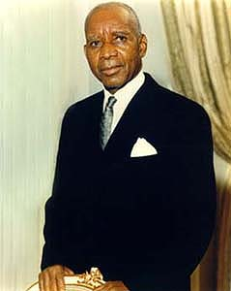Dr Hastings Kamuzu Banda.

* He graduated as a Medical Specialist in USA at Meharry Medical College in 1927.
* In 1939, he graduated at the Royal College of Physicians and Surgeons in London.
* He began to run his own medical services in Liverpool, London and Northumberland in a period between 1941 and 1953. It was from this period that Dr Hastingsd Kamuzu Banda had a chance of attending Pan- African meetings in Manchester where he was well exposed to some African nationalists including Mzeee Jomo Kenyatta of Kenya and Kwame Nkrumah of Ghana.
* He began to fund the Nyasaland African Congress in 1946.
* When the Federation of Rhodesia and Nyasaland was imposed in 1953, Dr Hastings Kamuzu Banda left Britain and went to Ghana to practice surgery in Kumasi. He learned nationalist tendencies in a radical way from Dr Kwame Nkrumah and his Convection People’s Party.
* With the problem of leadership in the Nyasaland African Congress, Henry Masuko Chipembere who formed the Young Turks that promoted violence to scare the colonialists in order to grant Africans immediate independence, invited Kamuzu Banda to reurn to Nyasaland to revive the collapsing NAC.
* The leaders of NAC included Dunduzu XChisiza who became Secretary General of the NAC while Rose Chibambo organized nationwide women activities to foster nationalism under NAC Women’s League.
* Dr Hastings Kamuzu Banda came back to Nyasaland after landing at Chileka Airport on 6th July, 1958.
* When he arrived, Dr Kamuzu Banda demanded the federal government to withdraw Nyasaland from the federation; united the NAC members and the mass to foster Nationalism; toured the whole country and addressed meetings with his emotional speeches starting with his slogan- **Kwacha!**; established party branches nation-wide to promote patriotism and win the mass support and employed the full time staff and organizing secretaries in each and every district.
* In August, 1958, Dr Hastings Kamuzu Banda was made the President of Nyasaland African Congress at a meeting that took place in Nkhata Bay.

**RESULTS OF DR HASTINGS KAMUZU BANDA’S ACTIVITIES**

1. Members of the NAC clashed with government security forces more especially in Karonga, Rumphi, Nkhata Bay, Mangochi and Lilongwe.
2. Members of the NAC intensified boycotts and strikes to force the colonial government grant immediate independence. This led to bloodshed throughout Nyasaland.
3. Sir Robert Armitage, the Governor of Nyasaland declared the State of Emergency known as Operation sunrise on 3rd March, 1959. The police shot dead people and detained some as political prisoners.

**RESULTS OF THE STATE OF EMERGENCY DECLARED ON 3RD MARCH, 1959**

1. Deaths and injuries of innocent Africans in the countrywide.
2. Operation sunrise was declared by government to stop violence
3. The NAC members were detained. Dr H.Kamuzu BANDA WAS DETAINED AT Gweru Prison where Chipembere, Dunduzu Chisiza and Qabaniso Chibambo were at Khami Prison in Zimbabwe.
4. The NAC was banned and whoever was found uttering the slogan **Kwacha** was arrested.
5. Setting up of the Commission of Inquiry, the Delvin and Mockton Commssions, that pointed out the real grievances of the Africans to the government. These led to a constitution review that provided Africans with a self rule.

**MALAWI CONGRESS PARTY (MCP)**

* On 30th September, 1959, Orton Chirwa formed Malawi Congress Party to replace the banned Nyasaland African Congress whose leaders by then were in prison after the State of Emergency.

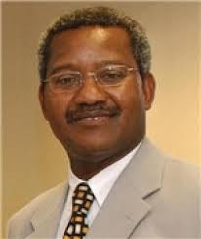 Orton Chirwa, founder of MCP

* Aleke Banda was its General Secretary. The party was formed constitutionally by obtaining permission from the government and agreed to follow non- violent means in attaining self- rule.
* **Reasons for the formation of Malawi Congress Party**

1. To fight for the release of the detained NAC members after the State of Emergency.
2. To ask the government end the State of Emergency
3. To foster the nationalism in Nyasaland
4. To resist the Federation of Rhodesia and Nyasaland
5. To act as the mouth piece of the local masses before the government.
6. To fight against the racial segregation between Africans and Europeans in Nyasaland.

**DELVIN COMMISSION**

* It was a commission of inquiry that was set up by the British to find out the real causes of the disturbances in Nyasaland that led to the State of Emergency.
* It was set up in April, 1959 and was chaired by a High Court Judge Lord Patrick Delvin.
* The following were its findings

1. Africans demonstrated in Nyasaland after the frustration of being sidelined in running their own country. They were fighting for self-rule.
2. It disclosed that Dr Kamuzu Banda was not directly involved in such plots of killing Europeans.
3. It reported that Nyasaland African Congress had a radical unit known as the Young Turks eager to speed up the attainment of self rule through whatever means convenient to them.
4. Most politically influential people in Nyasaland were members of the NAC.

**THE MONCKTON COMMISSION (FEBRUARY, 1960)**

* It was the Commission of Inquiry to make an inquiry on reasons Africans in Nyasaland and Northern Rhodesia were against the Federation. It was empowered to find out the constitution the constitutional changes and the life span of the Federation.
* Its chairman was **Sir Viscount Monckton.**
* The following were the findings and recommendations of the Monckton Commission

1. The federation was hated by the Africans even the same itself had recommended to change name Federation for Africans to like it.
2. If the Federation was to continue its lifespan was to be specified three years only-then each territory was to be free to abandon it.
3. Africans wanted to be in the Legislative Council; therefore, their representation was to be in equated to that of the Europeans.
4. The voter qualification was to be revised and be open to all adults.
5. Racial segregation was to be abolished.

* On 1st April, 1960**, Ian Macleod**, the Colonial Secretary released Dr Hastings Kamuzu Banda from Gweru Prison. Orton Chirwa handed over the Leadership of Malawi Congress Party to Kamuzu Banda so as to foster nationalism in a constitutional way.
* From 25th July to 4th August, the First Constitutional Talks took place at Lancaster House in London and was chaired by the British Colonial Secretary, Ian Macleod.
* The four political movements from Nyasaland that attended the Lancaster House Conference were

1. Malawi Congress Party led by **Kamuzu Banda**
2. The United Federal Party led by **Mr. Michael Blackwood**
3. The Congress Liberation Party led by **Mr. Thamar Dillon T. Banda**
4. Christian Liberation Party led by **Chester Katsonga**

* The Lancaster Conference made the following constitutional changes that contributed to the independence of Nyasaland:

1. An agreement to form a new constitution and a government that was composed of a Governor, the Executive Council of ten members and the Legislative Council of 28 elected non-officials.
2. The introduction of the two voting rolls of which members were to be voted directly i.e. 8 members in the upper roll and the remaining 20 in the lower roll.
3. A date for the first multiparty general elections in Nyasaland was fixed and was **15th August, 1961**. MCP won all the lower 20 seats and the two upper roll seats. The UFP won the 5 upper seats.

* In May, 1963, Dr Hastings Kamuzu Banda became Prime Minister and the Legislative Council became Legislative Assembly. This after the Second Constitutional Talks that took place at Marlborough House in London in November, 1962.
* In September, 1963, **the Third Constitutional Talks** known as **Banda- Buttler Conference** took place between Dr Kamuzu Banda and Richard Austen Butler, a Minister responsible for the Central African Affairs. They set a date for the General Elections and it was to be in April, 1964.
* Malawi Congress Party won the general elections of 1964 and Dr Hastings Kamuzu Banda became the Prime Minister of the Country. The Governor, Sir Glyn Jones still led the government.
* Nyasaland was attained her independence on 6th July, 1964. Nyasaland became Malawi (flames), a name of one of the ancient kingdoms that was established in the Central and Southern parts of Malawi.
* On 6th July, 1966, Malawi became a Republic with Dr Hastings Kamuzu Banda becoming its President and Britain stopped to rule the territory directly. Sir Glyn Jones left the country.

**CHAPTER FOURTEEN**: **ORGANISATION OF AFRICAN UNITY**

**Pan- Africanism**

* Pan- Africanism can be defined as an idea and movement that encouraged the solidarity of Africans worldwide in order to achieve social, economic as well as political progress.
* Pan-Africanism was associated by William **Edgar B. Du Bois** (an African American originally from Ghana), **Marcus Garvey** (a Jamaican businessman) and Henry **Sylvester Williams** (a West Indian Lawyer).
* The three, who were Africans in diaspora, appealed for unity and solidarity among Africans to resist ill-treatment from the Europeans and other groups. They wanted to promote African interests. They also wanted to liberate Africa from colonial rule by urging Africans to strive for political and economic independence. Lastly, they wanted to integrate African countries into a large body that could have a stronger voice in world affairs.
* Attempts to develop the idea of Pan-Africanism led to the formation of Organisation of African Unity.

**STEPS TOWARDS THE FORMATIAN OF ORGANISATION AFRICAN UNITY**

1. **THE 1945 MANCHESTER PAN-AFRICA CONFERENCE**

* Pan-Africanism attracted African leaders in 1945 when the fifth Pan- African meeting took place in Manchester in Britain. It was chaired by Dr Du Bois and Kwame Nkrumah of Ghana as its secretary
* Other leaders attended the 1945 Manchester Pan-African Conference include

1. Mzee Jomo Kenyatta of Kenya.
2. Obafemi Awolowo of Nigeria
3. Sekou Toure of Guinea
4. Dr Hastings Kamuzu Banda of Nyasaland.

* Some members of African political movements attended the conference in 1945 in Manchester included

1. African National Congress of South Africa.
2. The National Council of Nigeria and Cameroon
3. The Nigerian Youth Movements
4. The Nyasaland African Conference of Nyasaland.-Nyasaland

**AIMS OF THE 1945 MANCHESTER PAN-AFRICAN CONFERENCE**

1. To promote Nationalism in Africa.
2. To support nationalist movements in African countries striving to get rid of colonialism and develop them.

**TERMS OF THE 1945 MACHESTER PAN-AFRICAN CONFERENCE**

1. To put into practice at once the principles of the 1941 Atlantic Charter especially the self-determination policy.
2. To implement the land reforms in Africa
3. To end racisms and all other discriminatory laws in Africa.
4. To let Africans exercise their freedoms e.g. of speech, association and assembly.
5. To revisit the tax policies in mandated territories including civil and criminal codes.
6. To introduce free meals, books, school equipments and no compulsory school uniform to pupils to the age of 16.
7. To grant Africans of 21 years of age a right to vote and be voted into public positions.
8. To foster the availability of medical health and welfare services to all.
9. To abolish forced labour and introduce a policy of an equal pay for equal work.
10. **CONFERENCE OF INDEPENDENT AFRICAN STATES-1958**

* It took place in April 1958 in Accra, Ghana and was chaired by Dr Kwame Nkrumah to promote the ideas of Pan-Africanism.
* It was attended by African countries which by then had already attained independence.
* The eight members of Conference of Independent African States included Ghana, Guinea, Liberia, Libya, Ethiopia, Morocco, Tunisia and Sudan.
* This was the first Pan-African Conference to attract the Arab states of North Africa to come into a union with the black states of Sub-Sahara Africa and discuss issues of their common interest.

**TERMS OF THE CONFERENCE OF INDEPENDENT AFRICAN STATES-1958**

1. To promote unity and solidarity among African independent states by forming a union of African states.
2. To foster nationalism in African countries struggling for independence, for example Algeria and South Africa.
3. To let member states solve their differences through dialogue.
4. To let member states form an African common market.
5. To let Presidents from member states meet once in every two years to discuss issues of their common interests.
6. **ALL-AFRICAN PEOPLE’S CONFERENCE-1958**

* It took place in December, 1958 in Accra-Ghana and was chaired by Dr Kwame Nkrumah to call for a union of African countries and have a common say beforenon-Africans.
* It was attended by the 28 member states of which some of them were independent whereas others were still under colonial rule. Leaders from the non-independent states included Tom Mboya of Kenya, Patrice Lumumba of Congo and Holden Roberto of Angola.

1. **TERMS OF ALL-AFRICAN PEOPLE’S CONFERENCE-1958**
2. To free all African colonies from foreign rule through supporting the nationalist movements morally and economically.
3. To promote African dignity by ending racism and discriminatory laws that were promoted by Europeans in Southern Rhodesia, South Africa and Portuguese territories.
4. To end the political and economic exploitation of Africans by the colonialists.
5. To set up an organization with Accra as its headquarters to represent an African voice before the Europeans and international organizations such as the UNO.
6. **EFFECTS OF THE TERMS OF THE** **ALL-AFRICAN PEOPLE’S CONFERENCE-1958**
7. It led to the formation of a regional organization, the Union of Independent African States in 1959 by **Nkrumah** and **Sekou Toure** of Guinea. It was formed to foster independence and unity among African states.
8. It led to the introduction of a Charter known as the **Sanniquellie Declaration** by Nkrumah and the Liberian president William Tubman.

**IMPORTANCE THE SANNIQUELLIE DECLARATION OF 1959**

1. To form an African Organization to be known as the Community of Independent African States.
2. To let Africans adopt the self-determination policy according to the UN Charter and end colonialism.
3. To let member states not interfere in domestic affairs of another member country.
4. To let all African states join the formulated international body upon attaining their independence.
5. To let the newly formulated body create agencies that could look into the economic, cultural, scientific and research affairs.
6. **A SPLIT WITHIN PAN-AFRICANISM -1960**

In 1960 member states of All-African Peoples Convention took place to urge African countries form an international body and since there were different opinions on what form, two groups of African countries were formed namely

1. **The Casablanca Bloc**
   * This was set up on 24th December, 1960 and was led by Dr Kwame Nkrumah.
   * Its members states met at Casablanca in Morocco to formulate policies on how to operate the group.
   * The members of Casablanca Bloc included Ghana, Guinea, Mali, Egypt, Algeria, Libya and Morocco.

**TERMS OF THE CASABLANCA BLOC**

* It organized itself through the need of establishing a strong political unification of African states to end colonialism.
* They agreed that it must be a must for African states to form a federation whereby each state had to give up some of its independence to a central government by way of a **“United States of Africa”.** Thus a non-alignment policy was to be followed whereby all neo-colonial links with colonizers were to be rejected.

1. **The Monrovia Bloc**

* It was set up in May, 1961 in Monrovia in Liberia among member states of the French colonies.
* Monrovia Bloc was led by **Leopold Senghor** of Senegal and **Felix Houphouet Boigny of Cote d’Ivoire.**
* The member states of Monrovia Bloc include Togo, Dahomey(Benin), Senegal, Malagasy(Madagascar), Chad, Burkina Faso (Upper Volta), Central African Republic, Congo, Gabon, Ethiopia, Liberia and Cote d’Ivoire (Ivory Coast).

**TERMS OF THE MONROVIA BLOC**

* They agreed to have gradual unity of African states through economic cooperation and not forced federation. Economic progress was to be attained through cooperation in areas such as foreign affairs, economy, cultural affiliations, health and education before launching a united political organization. Western/European states had to be treated as allies and not immediately removed.

**DIFFERENCES BETWEEN THE MONROVIA AND CASABLANCA BLOCS**

1. The Casablanca bloc was more radical in fostering nationalism whereas the Monrovia bloc was more moderate and opted for cooperation with Europeans to fully attain political and economic independence.
2. The Casablanca members were mostly former British colonies whereas the Monrovia bloc was dominated by former French colonies.

**REASONS THAT MADE IT DIFFICULT TO FORM A SINGLE INTERNATIONAL ORGANISATION BY 1960 IN AFRICA.**

1. Member states had different attitudes towards formation of the organization.
2. Most states in Africa were still under their colonial masters.
3. Civil wars widened the gap between member states. For example, Congo OR DRC- Zaire attained its independence on 30th June, 1960 with Patrice Lumumba as the Prime Minister and Joseph Kasavumbu as President. However, when Moise Tshombe declared Katanga a province of Congo, as an independent country, it divided the Pan- African members. The Monrovia group supported the independence of the Katanga Region while the CVasablanca group did not want se Congo broken up.

**THE RESOLUTION OF RIVARLY BETWEEN THE CASABLANCA AND MONROVIA BLOCS**

* In 1963, the Ethiopian Leader, Emperor Haile Selassie invited members of the Monrovia and Casablanca blocs to a meeting in Addis Ababa in Ethiopia.
* The two blocs buried their differences and agreed to form a Pan-African movemen t known as Organization of African Unity (OAU) with 34 member countries.
* Morocco withdrew from the OAU in 1984 after being frustrated by the OAU resolutions of supporting and recognizing the Western Sahara as a separate state of Sahrawi Arab Republic.
* In 1994, the OAU membership comprised of 53 countries out of the 55 countries.
* By 1994, South Africa was not eligible to join because followed the dictatorial apartheid government that supported the rights of the white minority and sidelined the Africans.

**AIMS FOR THE FORMATION OF THE ORGANISATION AFRICAN UNITY-OAU**

1. To co-ordinate and promote co-operation among states in Africa.
2. To improve the living standards of people in Africa.
3. To end all forms of colonialism in all African countries.
4. To defend the sovereignty, integrity and independence of all African countries
5. To defend human rights**.**

**PRINCIPLES FOLLOWED BY OAU MEMBER STATES**

1. To honour border demarcations among African countries those were inherited at independence to avoid international conflicts.
2. Equality of all states in Africa despite their social, political and economic status.
3. To follow the non-alignment policy among member states in world affairs.
4. To let member states solve their disputes through mediation, negotiation and arbitration.
5. To let member states defend their independence and sovereignty.
6. To let member states liberate African countries from colonization.

**THE ORGANISATION STRUCTURE OF OAU**

1. **Heads of States and Governments**

* It consists of all heads of states and government from member states
* They meet once annually in different countries
* Decisions are reached at after 2wo-third majority.

**Functions of Heads of States and Governments**

1. To admit new members to the body.
2. To discuss and make decisions on international problems referred to it by Council of Ministers
3. To elect members of the Council for mediation, Conciliation and Arbitration**.**
4. **Council of Ministers (Foreign Ministers)**

* It is made up of Foreign Ministers of member states who meet twice annually at a convenient time.
* **Functions of the Council of Ministers**

1. To prepare the agenda for the meetings by Heads of States.
2. To approve the annual budget of OAU.
3. To prepare conferences of assembly
4. To co-ordinate inter-African co-operation.
5. **Secretariat**

It is headed by the Secretary General and its headquarters is in Addis Ababa**.**

**Functions of Secretariat**

1. To coordinate the activities of the OAU in all its agents and commissions.
2. To summon member states to meetings
3. To prepare agenda for meetings
4. To prepare and present an annual budget to the Council of Ministers for approval.
5. **Specialized Commissions and Agencies**

**Functions include**

1. To promote African culture trough education and cultural visits among member states.
2. To improve people’s living standards through good health programmes and by uprooting root causes of socio-economic problems**.**

**SUCCESSES OF OAU**

1. It helped to liberate African countries from the colonial rule
2. The establishment of the African Development Bank in 1964 to foster economic and social development of African countries.
3. It assisted in the repatriation of the refugees under the United Nations High Commissioner for the Refugees (UNHCR)
4. The OAU managed to Isolate South Africa and put pressure on her to end apartheid rule and introduce democracy.
5. It helped to settle disputes among African countries e.g. between Algeria and Morocco from 1964-1965 and Somalia and Ethiopia border disputes in 1965 etc
6. It represented African interests worldwide through the UNO and Secretaries-General like Boutross Boutros Ghali of Egypt between 1992 and 1997 and Kofi Annan of Ghana between 1997 and 2009.
7. Fostered the Human Rights among Africans if infringed by the non- Africans worldwide.

**THE FAILURES OF OAU**

1. It has no army of its own to enforce its decisions and solve conflicts in Africa.
2. A failure to end civil wars and massacres as member states are barred by OAU Charter that prohibits them from interfering in the internal affairs of another country.
3. It has been overruled by the rich African countries like Libya, Morocco and Nigeria who always chose to vetoes some of its decisions.
4. It fails to operate its offices and activities due to lack of funds
5. It fails to enhance unity among member due to a wide membership and different cultural affiliations.
6. Members of office bearers of the OAU are not elected by ordinary people into their offices but are rather appointed. As it is then, they do not fully represent people’s views but safeguard their own interest.

**FACTORS FOR FAILURES OF THE OAU**

1. Lack of funds for its operations
2. Lack of permanent army to enforce order among African countries
3. Cultural differences among member states
4. Divisions among themselves in dealing with problems in Africa
5. The formation of regional groupings. It was threatened by regional groupings such as the Arab League to which many North African states belong.

**OAU CHANGED TO AAFRICAN UNITY**

* OAU changed to African Unity on 9th July, 2002 in Durban South Africa and key leader for the change to African Union was former Libyan leader Colonel Muamar Gadaffi.
* The reason for the change from OAU to African Unity was the need to have a new approach in solving continental problems. African Union has to intervene in a member state in case of a crisis or conflict.
* The membership of African Union is still all African countries except Morocco which is not a member.
* South Sudan is the newest member of the African Union; joining on 28th July, 2011 which was soon after being established as an independent country from Sudan.

**REGIONAL GROUPINGS IN AFRICA**

1. **ECONIMIC COMMUNITY FOR WEST AFRICAN STATES(ECOWAS)**

* It was formed in 1975
* The following were aims of ECOWAS

1. To promote trade with an element of Free Trade Area status.
2. To promote cooperation with visa and entry permit requirements for EOWAS nationals being abolished and an ECOWAS passport has been adopted.
3. Promotion of self-reliance

* The member states of ECOWAS include Benin, Burkina Faso, Cape Verde, Cote d’Ivoire, Gambia, Ghana, Guinea Bissau, Liberia, Mali, Niger, Nigeria, Senegal, Sierra Leone, and Togo.

1. **SOUTHERN AFRICAN DEVELOPMENT COMMUNITY**

* It was first formed as Southern African Development Coordination Conference (SADCC) IN 1980 and changed to SADC on 17th August 1992. The SADC Treaty was amended on 14th August 2001.
* The following were the aims of SADC

1. To achieve economic growth and development
2. To promote peace and security.
3. To enhance the standard and quality of life of people of Southern Africa
4. To reduce poverty
5. To support the socially disadvantaged
6. To promote self-sustaining projects which will enhance self-reliance.

* The member states of SADC include Angola, Botswana, Malawi, Zambia, South Africa, Zimbabwe, Mozambique, Namibia, Lesotho, Mauritius, Seychelles, Tanzania, Swaziland and Democratic Republic of Congo.

1. **EAST AFRICAN COMMUNITY**

* It was originally founded in 1967 but it collapsed in 1977. It was revived on 7th July, 2000.
* The aims of East African Community include

1. To promote trade among member states
2. To promote cooperation with an EAC passport being adopted on 1st April, 1999.
3. To reduce poverty
4. To enhance political stability in the region with an aim of establishing an East African Federation.

* The member states of EAC include Burundi, Kenya, Rwanda, Tanzania and Uganda.

1. **COMMON MARKET FOR EAST AND CENTRAL AFRICA**

* The COMESA Treaty was signed 5th November, 1993 in Kampala, Uganda and was adopted by member states a year later in Lilongwe, Malawi on 8th December, 1994.
* The aims of COMESA included

1. To promote trade, investment and economic development through the Free Trade Area element.
2. To promote cooperation by enhancing peace, security and stability.
3. To promote solidarity and collective self-reliance.
4. To attain sustainable growth and development.

* The member states of COMESA include Angola, Burundi, Comoros, Eritrea, Ethiopia, Kenya, Madagascar, Malawi, Mauritius, Namibia, Rwanda, Tanzania, Uganda, Zambia and Zimbabwe.

**BENEFITS OF REGIONAL INTEGRATION**

1. Increased trade and investment
2. Regional stability
3. Stimulation of domestic innovation
4. Economic growth of regions

**CHALLENGES FACING AFRICAN UNITY AND REGIONAL GROUPINGS**

1. Poverty
2. HIV and AIDS
3. Failure to build appropriate human resource at all levels
4. Corrupt leadership unconcerned for the welfare of ordinary citizens and huge external debts.
5. A long tension between Morocco and Western Sahara created as the OAU recognized Western Sahara leading to Morocco’s withdrawal from it**.**